Maglev Trains Engineering Design Worksheet

Introduction
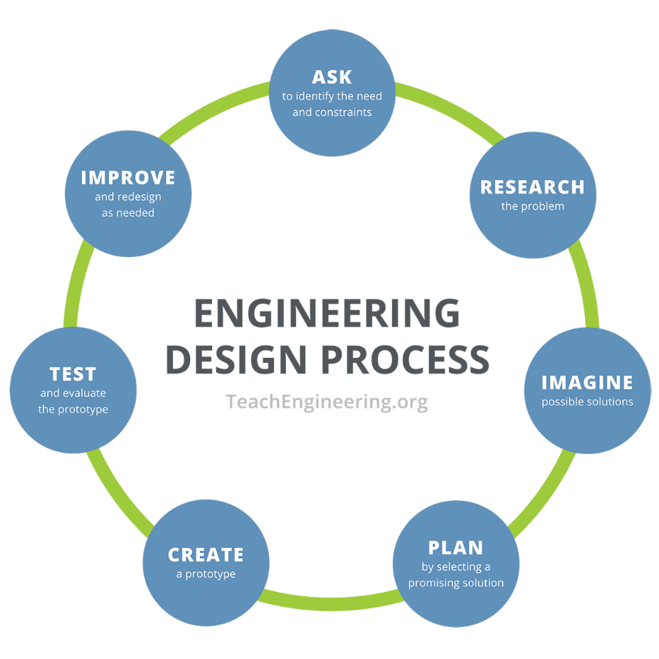
Objective: You will use the engineering design process to design and build a maglev train prototype.

Ask
Your challenge (what you are asked to do): Each group will make a “train” car levitate above a magnet strip “track” so that it can freely move back and forth above the track. You will try to hold the most weight on your train prototype.

What are the constraints of the challenge?

Research
Phenomenon: As you watch the video about the fastest train ever built, write down your observations. Include three questions you have from watching the video.

Imagine
What are some solutions to this challenge? Make sure to consider the following:
- Where will you put your magnets on the track?
- Where will you place your magnets on your prototype?
- How will you arrange the poles of your magnets?

Brainstorm ideas with your group and sketch those ideas below. Remember, all ideas are good at this stage!
Plan
As a group, pick one design you will create. Draw your maglev train prototype below, making sure to label the parts of your maglev system and indicate which materials will be used.

Create and Test
Follow your plan and build your maglev train protoype. Then answer the questions below:

- What worked well with your maglev train prototype?

- What did not work well with your maglev train prototype?

- How much weight did your maglev train prototype hold and successfully move?

- What would you like to improve on your maglev train prototype?

Improve
Improve: Make changes to your maglev train prototype based on what worked and what did not work. Retest your maglev train prototype and then answer the questions below:

- How did you improve your system?

- Were your improvements successful?

- Were you able to hold more weight? If so, how much more, and why do you think it held more this time?

- What would you like to improve on your updated maglev train prototype?

Summary
Answer the following questions:
- Which group in your class had the prototype that held the most weight?

- Why do you think that group’s prototype could hold the most weight?

- If you could make more improvements to your maglev train prototype, what would you do differently? If your maglev train prototype was the best in the class, then how could you make it even better (i.e., hold more weight)?

Conclusion
Answer the following question:
What factors affect the strength of the electric and magnetic forces?

