Maglev Trains Engineering Design Worksheet Answer Key

Introduction
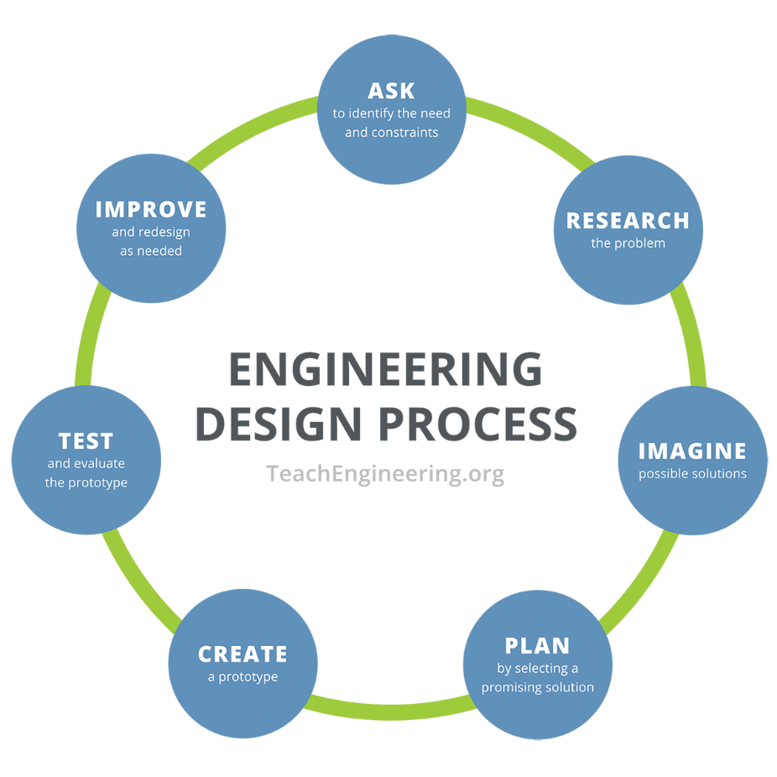
Objective: You will use the engineering design process to design and build a maglev train prototype.

Ask
Your challenge (what you are asked to do): Each group will make a “train” car levitate above a magnet strip “track” so that it can freely move back and forth above the track. You will try to hold the most weight on your train prototype.

What are the constraints of the challenge?
Potential answers: time, types of supplies provided, amounts of supplies available.

Research
Phenomenon: As you watch the video about the fastest train ever built, write down your observations. Include three questions you have from watching the video.
Answers will vary.
Imagine
What are some solutions to this challenge? Make sure to consider the following:
- Where will you put your magnets on the track?
- Where will you place your magnets on your prototype?
- How will you arrange the poles of your magnets?

Brainstorm ideas with your group and sketch those ideas below. Remember, all ideas are good at this stage!
Answers will vary.

Plan
As a group, pick one design you will create. Draw your maglev train prototype below, making sure to label the parts of your maglev system and indicate which materials will be used.
Answers will vary.
Create and Test
Follow your plan and build your maglev train protoype. Then answer the questions below:
- What worked well with your maglev train prototype?
Answers will vary.

- What did not work well with your maglev train prototype?
Answers will vary.

- How much weight did your maglev train prototype hold and successfully move?
Answers will vary.

- What would you like to improve on your maglev train prototype?
Answers will vary.
Improve
Improve: Make changes to your maglev train prototype based on what worked and what did not work. Retest your maglev train prototype and then answer the questions below:
- How did you improve your system?
Answers will vary.

- Were your improvements successful?
Answers will vary.

- Were you able to hold more weight? If so, how much more, and why do you think it held more this time?
Answers will vary.

- What would you like to improve on your updated maglev train prototype?
Answers will vary.

Summary
Answer the following questions:
- Which group in your class had the prototype that held the most weight?
Answers will vary.

- Why do you think that group’s prototype could hold the most weight?
Answers will vary.

- If you could make more improvements to your maglev train prototype, what would you do differently? If your maglev train prototype was the best in the class, then how could you make it even better (i.e., hold more weight)?
Answers will vary.

Conclusion
Answer the following question:
What factors affect the strength of the electric and magnetic forces?
Electric and magnetic forces are affected by a few key factors. For electric forces, the strength depends on how big the charges are and how far apart they are. The bigger the charges and the closer they are, the stronger the force. The material between the charges also matters—some materials weaken the force. Magnetic forces, which happen between magnets or electric currents, are stronger when the magnets are bigger or the current is stronger. Just like electric forces, magnetic forces get weaker as the objects move farther apart. The strength of the magnetic force also changes depending on the material around the magnets, like how iron makes magnets stronger.

