Post-Assessment Answer Key
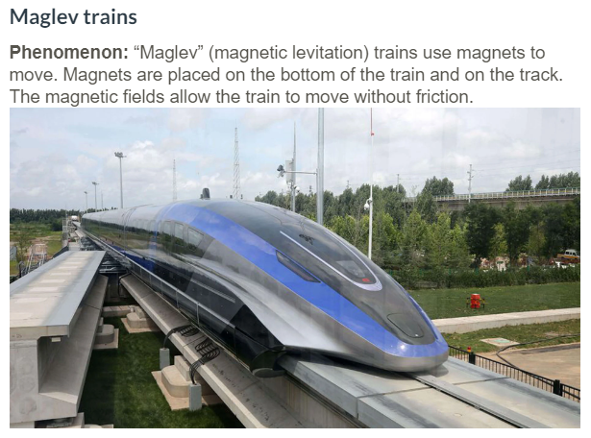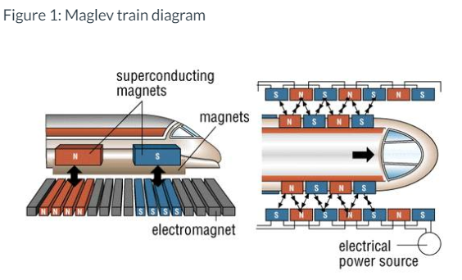
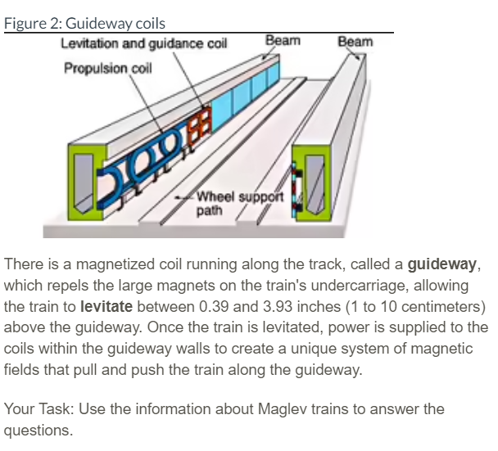

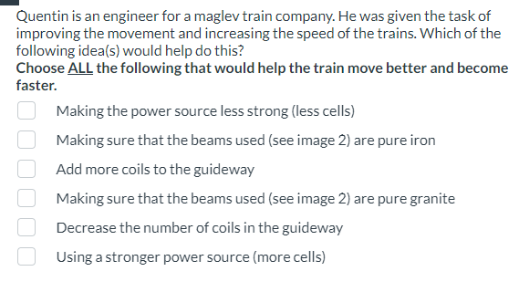
Answer: Add more coils to the guideway, Making sure that the beams used (see image 2) are pure iron, and Using a stronger power source (more cells).

