**Pre/Post-Quiz**

|  |  |
| --- | --- |
| **Damaged Item** | **Solution** |
| Stained |  |
| Ripped |  |

|  |  |  |  |
| --- | --- | --- | --- |
|  |  |  |  |
|  |  |  |  |

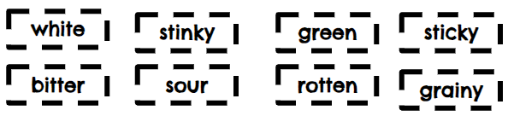

|  |  |  |  |
| --- | --- | --- | --- |
| white | stinky | green | sticky |
| bitter | sour | rotten | grainy |