**Properties of Matter**

**Observation Booklet**

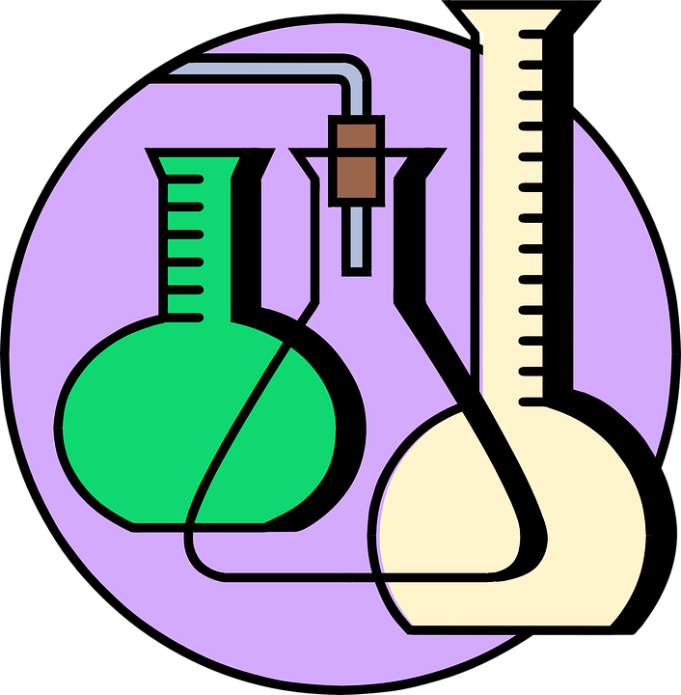

By: ___________________________

