**Pre-Reading: What Causes Tooth Damage?**

Have you ever stopped to wonder why you brush your teeth every day? The dentist tells us to brush our teeth to prevent cavities and other tooth damage, but what causes tooth damage in the first place?

**The Science of Your Mouth**

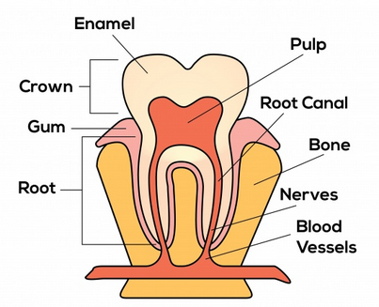You may be surprised to learn that chewing with your teeth is a complicated bit of biomedical engineering! The chewing machine that is your mouth includes three major components, or parts: teeth, saliva (spit), and other solid materials such as food or a toothbrush. These different components interact to help you eat, but sometimes their interactions can cause damage. Damage caused by acids or other chemicals in the mouth is called chemical wear, and damage caused by solid surfaces in contact is called mechanical wear. Let us look a little closer at the parts of the mouth and how tooth damage can occur.

*https://www.publicdomainpictures.net/pictures/250000/nahled/tooth-description-background.jpg*

**Teeth**

Did you know that your teeth are alive? Your teeth are covered by an extraordinarily strong solid material called enamel. The enamel protects the soft inner parts of the tooth, but because the enamel is on the outside, it can be damaged by chemicals, bacteria, or other objects. This damage to the enamel is what causes those cavities that your dentist looks for. Cavities allow bacteria to slip inside the tooth and infect the pulp, which is the living part inside the tooth. The pulp helps the tooth fight against bacteria that get past the hard enamel. Your teeth are held in your mouth by the root, which is the bottom part of the tooth that also contains blood vessels and nerves that keep the tooth alive.

**Saliva**

Saliva acts as a natural defense mechanism for our teeth. It contains minerals such as calcium and phosphate, which help to keep the outer part of teeth—the enamel—strong. Saliva also contains helpful chemicals that fight bacteria and protect against tooth decay.

You might have noticed that when you spit, the saliva sticks together in a big glob. This “stick together” ability is called cohesion. Cohesion is the ability of a liquid to stick to itself and form droplets. Drops of spit like to stick together because cohesion makes the outside of the drop have something called surface tension. You may have noticed the effects of surface tension in other liquids, such as when water forms droplets on the side of a cold glass or when water can hold up a very lightweight bug on the top.

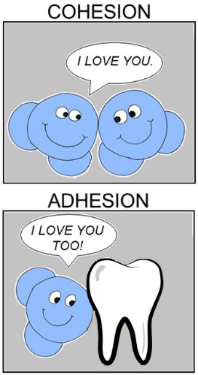Saliva has another important property called adhesion. Adhesion gives saliva the ability of two different materials to stick together. You might have heard this word before when buying “adhesive tape” as a school supply. Tape sticks to or adheres to paper. Similarly, saliva adheres to the surface of the tooth and protects the tooth.

https://o.quizlet.com/D3I80BvUnZ65-Ou7PQmt2g_b.png

**What Causes Tooth Damage?**

Saliva protects the teeth, but remember that there are more parts of the chewing machine than just saliva and teeth. Sometimes the interactions of these other parts with the teeth can cause damage. For example:

1. **Other teeth** – When different teeth grind against each other they can wear down their enamel (outer surfaces). Dentists call tooth grinding bruxism (brux – is – um). Scientists call the damage caused by grinding attrition.
2. **Liquids in the mout**h – When other liquids besides saliva adhere to the surfaces of the tooth, that causes problems. These liquids can contain acid that chemically removes the tooth enamel. Other times the liquids carry bacteria that form plaque on the teeth that can cause the tooth underneath to decay.
3. **Solids in the mouth** – Enamel, the outer surface of the tooth, is very hard, but even very hard things can be damaged if you rub them enough. Abrasion is the name for the process of other solid materials wearing away teeth. Hard particles in foods, mouth jewelry, and even toothbrushes can cause abrasion and damage teeth.

**What can you do to prevent tooth damage?**

You only get one set of adult teeth, so it is important to take good care of them! Reducing your intake of acid-containing beverages such as sodas can help reduce the chemical damage to the enamel that allows bacteria to adhere to the surface. Maintaining good general health ensures that your body produces saliva with the right chemical balance for proper cohesion. Finally, proper brushing technique, using a soft-bristled toothbrush, and selecting toothpaste with mild abrasives, can help minimize abrasion. Regular dental check-ups and cleanings are also important, to identify any early signs of tooth wear or damage and to receive guidance on proper oral hygiene practices.

**Your challenge:**

How many times each day do you brush your teeth? Brushing is good for you—right? You just read about how tooth brushing and other forms of mechanical wear can damage your teeth. Research shows that the friction from toothbrushing might help bacteria adhere to your teeth better to make cavities!

Colgate Corporation, the largest toothbrush manufacturer in America (annual sales of $46.6 million) is seeking innovative designs for an electric brush that makes teeth shiny clean without causing damage to the enamel surface. You and your team are challenged to design a motor-powered brush that meets these criteria and constraints. In other words, you want a brush that scrubs the scum (bacteria and other particles that adhere to the tooth), but saves the shine (smooth surface where cohesion of the liquids in contact is greater than the adhesion of the liquids to the surface).

You will create and test a prototype, then work with a team to iterate, or change, your design to combine the best features of each design into the ultimate brushing machine. Be sure to gather data to justify your design to the Colgate Corporation and, who knows, you could be the next toothbrush millionaire!