**Product Pitch Assignment**

Now that you have created the “best” motor-driven toothbrush ever, it is time to sell your product to Colgate Corporation, the largest toothbrush manufacturer in America (annual sales of $46.6 million). Your team will create a product “pitch” using the format of your choice, such as a presentation, video, audio, or a poster with narrative description. All pitches must meet the following requirements to ensure sufficient information is provided to Colgate to evaluate your product (and the designers).

* Must be less than 4 minutes or, if using a poster (physical or digital), less than 50 cm x 50 cm.
* Must include connections to at least two scientific concepts or vocabulary words related to the effects of brushing on teeth.
* Must describe at least three phases of the engineering design process used during design and testing (see diagram below for reminders of the steps).
* Must show individual contributions of each group member.
* Must have all team members participate in the delivery of the pitch (if using a poster, delivery includes verbal explanation).
* Must showcase the creativity and ingenuity of your team in an organized, well-sequenced, and appealing manner.

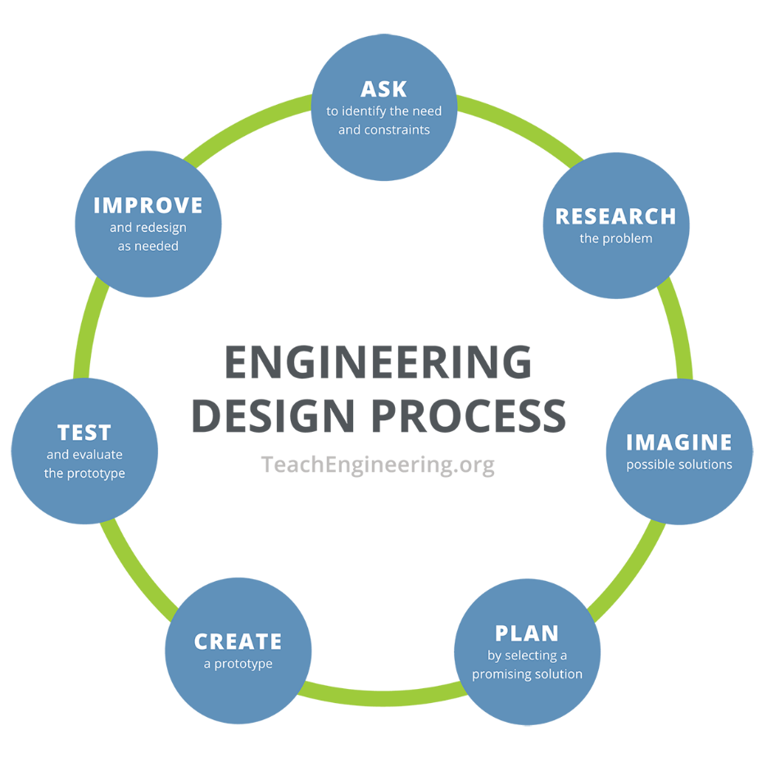

**Evaluation Rubric:**

|  |  |  |  |  |
| --- | --- | --- | --- | --- |
| Project Component | Advanced  (Proficient AND…) | Proficient  (Basic AND…) | Basic | Evaluation and Feedback |
| Use of Scientific Vocabulary and Reasoning | Justifies prototype design using at least three related scientific concepts with appropriate vocabulary **and data.** | Relates two or more scientific concepts to prototype design using appropriate vocabulary; makes some reference to data. | Includes at least two related scientific concepts and an attempt at connecting science to design features. |  |
| Demonstration of Engineering Design Process | Includes information about at least four steps of the engineering design process, including explanation of redesign decisions. | Describes at least three phases of the engineering design process with appropriate examples. | Names at least three phases of the engineering design process and demonstrates at a basic level. |  |
| Evidence of Teamwork/  Collaboration | Involvement of all team members in presentation, testing, and design is clearly evident in multiple components of the pitch. | All team members are able to explain their individual contributions; pitch includes evidence of how teamwork improved design. | Some level of collaboration is evident in the presentation and/or design process. |  |
| Delivery of Pitch | All team members participate in pitch presentation or recording; excellent use of narration and visuals to explain design and content. | Some evidence of involvement of multiple team members; includes appropriate narration and visual evidence. | Pitch includes visuals for both content and design process with appropriate narration at a basic level. |  |
| Overall Content Organization and Creativity | Clearly demonstrates full knowledge of the design process, includes pertinent, well-sequenced examples; includes avenues for future redesign and improvement. | Addresses all major components of science and engineering processes in a logical manner; purpose is clear and addressed to appropriate audience. | Addresses multiple components of science and engineering processes and includes justification of design for intended audience. |  |