Timeline of Climate Change Worksheet

Part 1: Notice and Wonder Chart
Write down what you notice and wonder in the chart below based on this graph.
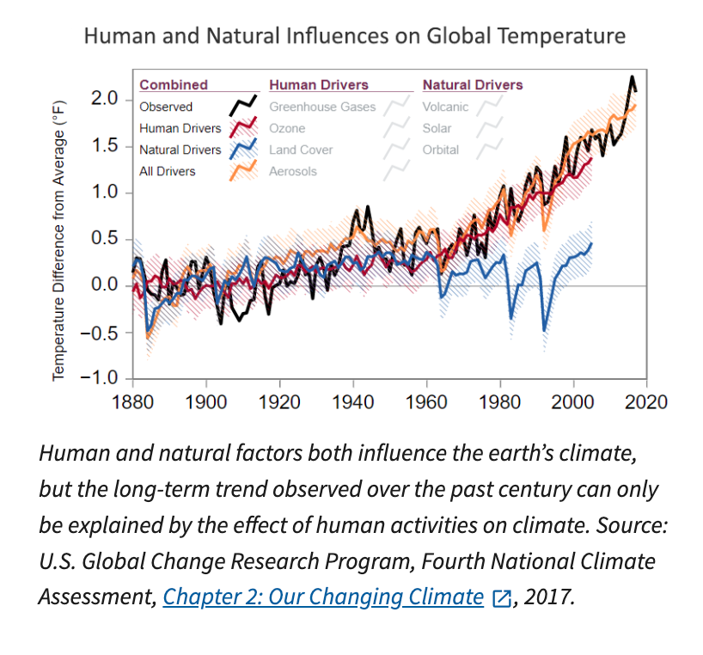

Notice | Wonder

Part 2: Climate Change Timeline
Use the following websites to write down 10 of the most important events that you will include on your climate change event timeline.
- https://www.history.com/topics/natural-disasters-and-environment/history-of-climate-change
- https://climate.nasa.gov/evidence
- https://www.epa.gov/climatechange-science/causes-climate-change
- https://www.britannica.com/story/timeline-of-climate-change
- https://climate-wise.com/news-and-articles/climate-change-a-timeline

Event 1

Event 2

Event 3

Event 4

Event 5
Event 6

Event 7

Event 8

Event 9

Event 10

