Materials Matter Activity 2 Worksheet Answer Key

Objectives: To study and learn how different materials are combined to change their properties.

Materials: paper, glue, hole puncher, packaging tapes, string, scissors, ring stand with clamp

Procedures:

- Take two to three sheets of paper and cut them into 4 cm by 8 cm strips.
- After cutting the paper into strips, take out one strip, then two separate strips, then three separate strips, then four separate strips, and then five separate strips.
- Take two strips of paper and glue them together using a glue stick or glue.
- Repeat Step 3 and glue three strips of paper together.
- Repeat Step 3 and glue four strips of paper together.
- Repeat Step 3 and glue five strips of paper together.
- Reinforce the top part of each of the combined paper strips with clear or packaging tape.
- Punch one hole on the top and bottom parts of combined strips (1 to 1.5 cm away from the top and bottom.
- Cut five pieces of yarn/string that are 30 cm long.
- Tie one end of the yarn/string to the top hole of the paper strip.
- Tie the other end of the yarn/string to the ring on the ring stand.
- Repeat Steps 10 and 11 for the other four paper strips. Make sure the strips are hanging at equal distances.
- Attach a hanging 100 g mass at the bottom hole. Wait for two minutes.
- Attach a second 100 g mass to the first one. Wait for two minutes.
- Keep adding 100 g until the paper breaks.
You could change from 100 g to 500 g masses as the paper strips increase.

Record your data:
Write your data as your record your masses:
# | Number of paper strips combined | Mass paper rips at (g)
1 | 1 | 500 g
2 | 2 | 1,000 g
3 | 3 | 1,300 g
4 | 4 | 1,900 g
5 | 5 | 2,500 g

Create a line graph of the number of strips versus the ripping mass:

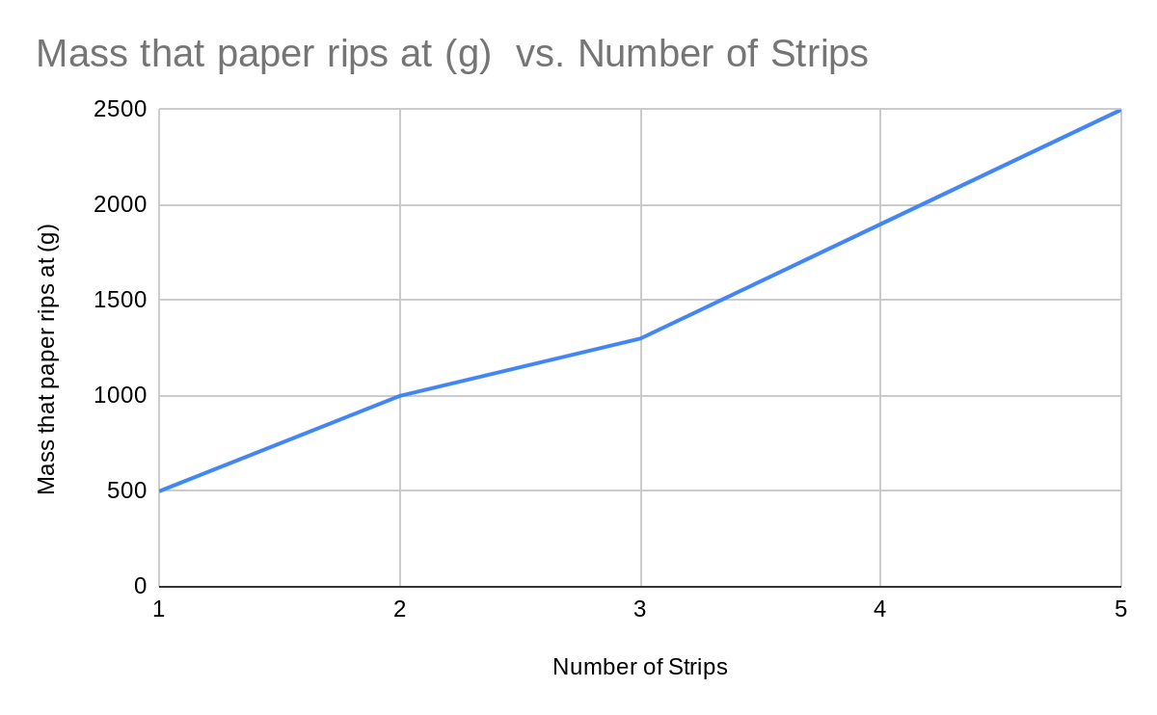

To convert grams to kg:

# | Mass paper rips at (g) | Mass paper rips at (kg)
1 | 500 g | 0.5 kg
2 | 1,000 g | 1.0 kg
3 | 1,300 g | 1.3 kg
4 | 1,900 g | 1.9 kg
5 | 2,500 g | 2.5 kg

Questions:

1. Using the graph, describe the relationship between the number of strips and the mass at which the paper strips rip.

As the number of strips increases, the mass at which the paper rips increases as well. The graph shows that as the paper strips were combined, the strength of the paper increased.

2. How is the strength of the paper affected by the number of strips?

The strength of the paper increased as the paper strips increased. So a combination of five paper strips took longer to tear, with a higher mass, than one paper strip. The mass needed to rip the paper quadrupled from the one paper strip to the combination of the five paper strips.

3. How can the strips of paper be classified as a composite?

The paper strips can be classified as a composite because the paper strips are combined together through glue. So the chemical properties have not changed. Also, the combinations of paper strips caused the product to become stronger and more durable.

Conclusion:

Write a conclusion for this activity based on your observations.

I learned that composites are used in daily life. The paper strips combined had more strength than one piece of paper. This has shown me that a composite is more durable and stronger than the original product.

