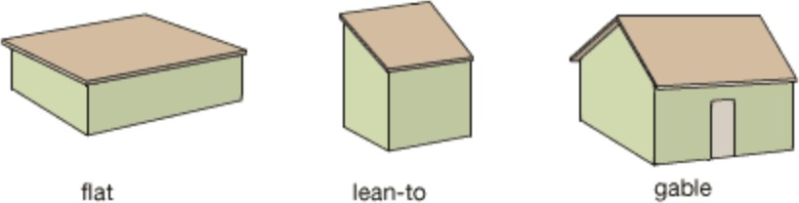
Raise the Roof! Engineering Challenge

What:
- In an eﬀort to help solve the country of Ghana’s recycling challenge and better utilize resources, you are going to create a simulation of a basic housing structure in order to design and build a more sustainable and leakproof roof.
- Once the housing structure and roof are built, water will be poured on it and left for ﬁve minutes.

Rules:
- The housing structure must be a 6 in. by 6 in. box with no windows, doors, ceiling, or ﬂoors.
- The roof:
  - Must cover the entire housing structure, but not hide the housing structure.
  - Must not hold water.
  - Must not have any leaks.
  - Must be made out of resources available to the country of Ghana and recycled materials.
- The shape of the roof will determine the housing structure shape.
- The more recycled materials added, the better the grade.

Checklist:
- Ask questions.
- Conduct research.
- Imagine three prototypes.
- Choose one prototype design.
- Build the design.
- Test the prototype.
- Improve the prototype.

Grading:
You will be graded on the following criteria:
- How well the water runs oﬀ the roof.
- How the resources were utilized.
- How much of the structure is made of recycled materials.
- How well the roof holds its shape after ﬁve minutes.

