Loops and Switches Pre/Post-Quiz Answer Key
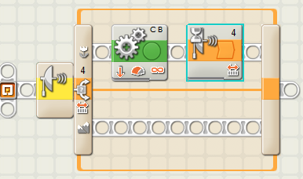
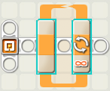
- What kind of blocks are these?

loop

switch
- Name two kinds of controls can be specified to determine how long a loop repeats.
Any two of the following: “Forever” (a never-ending loop), any sensor, “count” (tell the loop to repeat, for example, 5 times), “time” (tell the loop to repeat, for example for 1 minute), logic

- Give an example of a program you could write that would use a switch.
Example answer: While the touch sensor is pressed, go forwards, otherwise move backwards.

