Day 5: Programming Robot Movements Sheet Answer Key
Group Members: ___________________________________________
Translating EMG Data to Robot Movements
You will program both micro:bits in the Micro:bit MakeCode editor online. Use the following tips to write your code:
- The micro:bit attached to your muscle sensor should be programmed to send EMG data to your robot using radio signals. Review the micro:bit page on radios and pins for more information.
  - Use an if-else statement to set a threshold for which numbers in the EMG data should trigger movement in your robot. If your data is over that threshold, it should send a specific radio signal, and if it’s below, it should send a different signal.

- The micro:bit attached to your robot should be programmed to move the robot forward based on the radio signals it receives. Review the Cutebot wiki for more information on programming the robot to move.
Paste screenshots of the code for each micro:bit below.
Code may vary. As long as the code accomplishes the task of moving the robot in response to EMG signals, it is acceptable. A sample program is shown below.

Muscle Sensor Micro:bit Code:
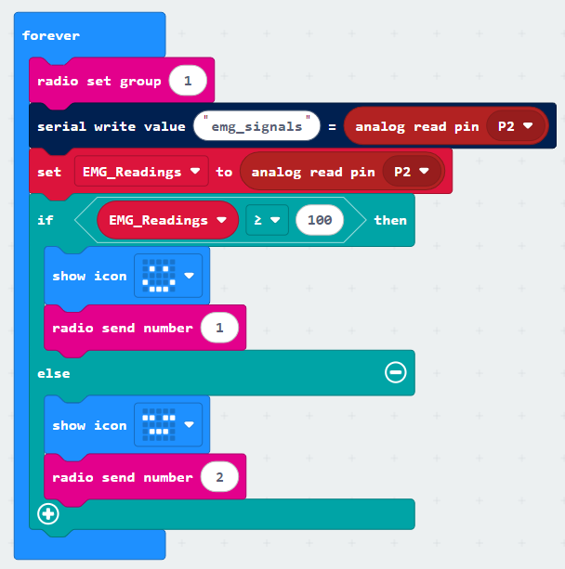
Robot Micro:bit Code:
