Day 4: Initial Data Collection Sheet Answer Key
Group Members: ___________________________________________
Programming the EMG Micro:bit
You will be programming the micro:bit connected to your muscle sensor to be able to record EMG signals. The output graph should look something like this:
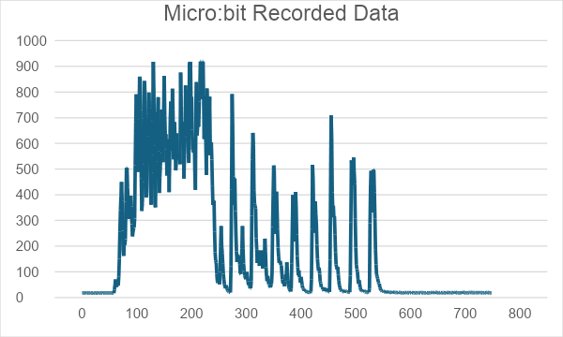
Figure 1. EMG recording of the forearm using 3M integrated gel electrodes, the MyoWare 2.0 muscle sensor, micro:bit v2, and connecting wires with alligator clips. The recording shows three states: rapid finger movement (plateau), periodic finger-to-palm movement (peaks), and rest (flat-line).

- Select one member of your group to be the test subject. Attach three electrodes to your MyoWare muscle sensor, and then place it on the test subject’s forearm. Pick the location based on your experiment design. The muscle sensor should be placed similarly to what is shown in Figure 2. The reference electrode (labeled “REF” on the Myoware muscle sensor) is placed towards the outside of the chosen muscle, while the two other electrodes are placed across the muscle.
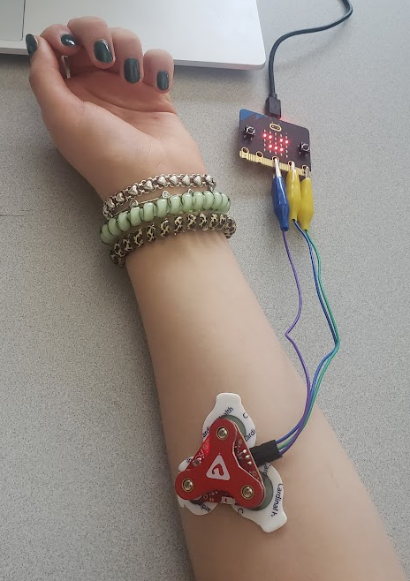
Figure 2. Example placement of MyoWare muscle sensor with electrodes on forearm.

If your teacher provided you with a 3 mm electrode cable or alligator clips, use those to attach the electrodes to the MyoWare muscle sensor. The electrode placed on the elbow or other arm should be connected to the reference snap connection on the muscle sensor (labeled “REF”). The other two should be connected to the remaining snap connections on the muscle sensor.
- The muscle sensor should already be connected to your micro:bit, based on your build yesterday. If not, connect it now. The wires on the muscle sensor should be connected to pins on the micro:bit as follows:
Muscle Sensor | Micro:bit
VIN wire | 3V power pin
GND wire | GND
ENV wire | Pin 2 (P2)

- Connect the micro:bit to your laptop. Open the Micro:bit MakeCode editor online. Follow the steps to connect your micro:bit, and then add the following code to your program.
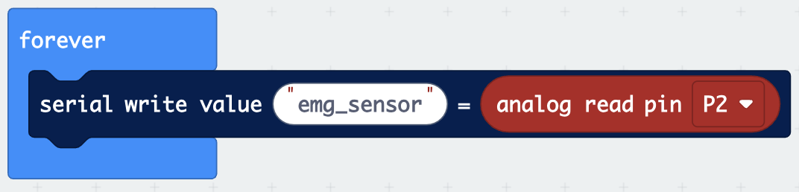
Figure 3. MakeCode program to record EMG data.

- Click “Show data” on the left side of the code editor to view EMG data for the student who is connected to the muscle sensor. As they make movements in their hand, observe how the graphs and numerical data change.

Initial Data Collection
Collect EMG data for a few different hand movements, based on your experiment design. This initial data will be vital for your next phase, where you will write code to translate the EMG data to robot movements in real time.
For each muscle movement, provide a description and a screenshot of the EMG signal data, along with observations about the numerical data (for example, what was the minimum and maximum you observed during the movement? When did the numbers peak?). The description should be a detailed account of what the test subject did to create this data. You may add more movements as desired. Make sure the movements are spaced out appropriately, so that you are able to differentiate which movements correspond to which spikes in the EMG data.

Muscle Movement #1
Description:
Submissions will vary. An example would be:
The test subject clenched their left fist as hard as possible for 5 seconds. They then released their fist. Their other arm and the rest of their body were still.

Screenshot of EMG Data:
Students should insert the graph of the EMG data that was created by micro:bit.

Observations About the Numerical Data:
Students should write observations about the numerical data they record. For example, they may write “as the test subject clenches their fist, the EMG signals remain around 400, with a peak at 452. As they unclench their fist, the numbers go back to a baseline of around 50-60.” They should write in as much detail as possible, so that they have as much information as possible when translating the data into robot movements.

Muscle Movement #2
Description:

Screenshot of EMG Data:

Observations About the Numerical Data:

Muscle Movement #3
Description:

Screenshot of EMG Data:

Observations About the Numerical Data:

