**Engineering Design Process Worksheet**

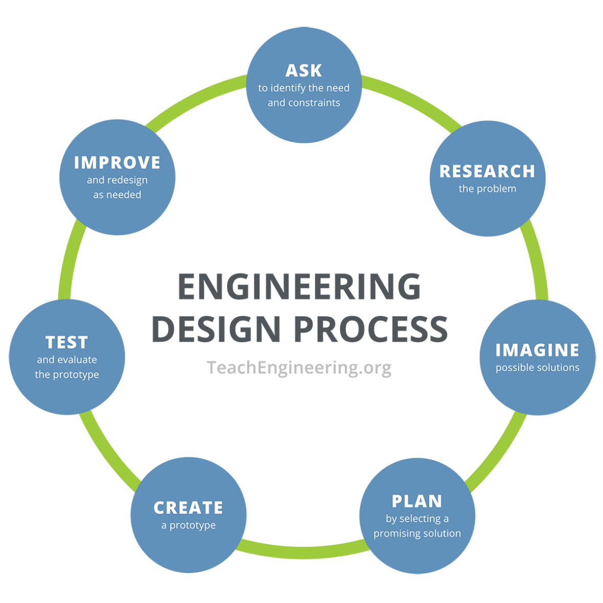**Instructions:** Using the engineering design process, you and your team will solve a problem that deals with sunlight/light and/or vision.

1. **Ask** **–** Identify the need and constraints of your problem.

____________________________________________________________________________

____________________________________________________________________________

____________________________________________________________________________

____________________________________________________________________________

____________________________________________________________________________

1. **Research –** Research and learn about your problem.

____________________________________________________________________________

____________________________________________________________________________

____________________________________________________________________________

____________________________________________________________________________  
  
____________________________________________________________________________

____________________________________________________________________________

____________________________________________________________________________

____________________________________________________________________________

1. **Imagine** – Individually sketch out four possible solutions.

|  |  |
| --- | --- |
| a | b |

|  |  |
| --- | --- |
| c | d |

1. **Plan** – Have each team member share their sketches. As a team, select ONE solution. This can be one specific solution or a mixture of ideas. Draw your team’s solution in the box below. Make sure to identify which materials you will be using.

|  |
| --- |
|  |

1. **Create** – Build your project exactly as shown in your group’s drawings.
2. **Test** – Test your design and then answer the following questions.

What worked in your design, and why?

____________________________________________________________________________

____________________________________________________________________________

____________________________________________________________________________

____________________________________________________________________________

____________________________________________________________________________

What did not work in your design, and why?

____________________________________________________________________________

____________________________________________________________________________

____________________________________________________________________________

____________________________________________________________________________

____________________________________________________________________________

How would you improve your design?

____________________________________________________________________________

____________________________________________________________________________

____________________________________________________________________________

____________________________________________________________________________

____________________________________________________________________________

____________________________________________________________________________

____________________________________________________________________________

1. **Improve** – Make changes and retest your updated prototype.

Did your changes improve your prototype? How?

____________________________________________________________________________

____________________________________________________________________________

____________________________________________________________________________

____________________________________________________________________________

____________________________________________________________________________

What worked in your updated design, and why?

____________________________________________________________________________

____________________________________________________________________________

____________________________________________________________________________

____________________________________________________________________________

____________________________________________________________________________

What did not work in your updated design, and why?

____________________________________________________________________________

____________________________________________________________________________

____________________________________________________________________________

____________________________________________________________________________

**Reflection –** Answer the following questions.

1. What worked during this activity?

____________________________________________________________________________

____________________________________________________________________________

____________________________________________________________________________

1. What did not work during this activity?

____________________________________________________________________________

____________________________________________________________________________

____________________________________________________________________________

1. What would you change if you could do this activity over again?

____________________________________________________________________________

____________________________________________________________________________

____________________________________________________________________________

____________________________________________________________________________