Assessment #4: Applied Knowledge

Consider the following diagram.
Hypothalamus
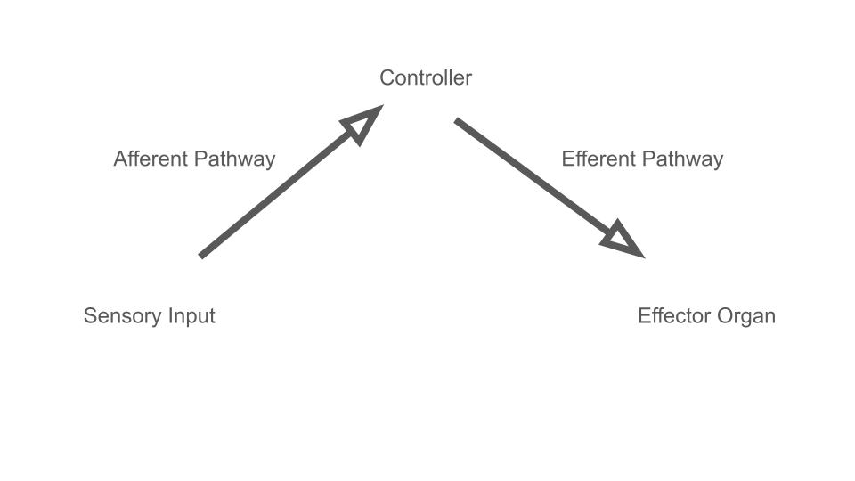

Stomach
Activate Peristalsis
Release Digestive Enzymes

Stretch Receptors
Activated
(food in stomach)

This simple diagram illustrates the flow of communication processed by our brain following a stimulus. First there is a sensory input. Perhaps the stretch receptors in your stomach have been activated because you ate a full meal. This will send a message down a sensory nerve. This first neural message is called an afferent signal. The destination for that message is a control center, and when dealing with autonomics, the master controller of the body is the hypothalamus. The hypothalamus will receive the afferent information and will initiate a response, which is usually activation of a motor neuron (efferent signal) that is innervated to a muscle or a gland. The effector organ will act based on the information coming from the hypothalamus down the efferent pathway; in this case, the muscles in the stomach will need to be activated for digestion to take place. Activation of these muscles is known as peristalsis. This would be parasympathetic stimulation. Notice that the organ under parasympathetic activation (in this case, from the vagus nerve) activates more than just one function; in this case, the stomach will also release digestive enzymes.

Now you try.
Instructions: Please complete the diagram for two different scenarios involving different stimuli. Make sure to indicate whether the outcome would be activation of the sympathetic or parasympathetic nervous system. You do not have to use the hypothalamus as your controller.

Hypothalamus

Explanation:

One more.
Hypothalamus

Explanation:

