Assessment #4: Applied Knowledge – Answer Key

Consider the following diagram.
Hypothalamus
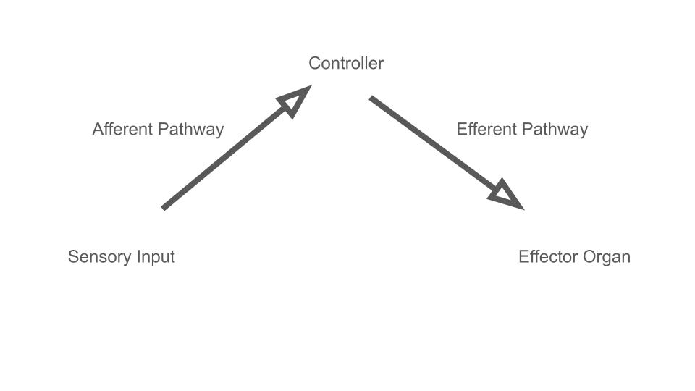

Stomach
Activate Peristalsis
Release Digestive Enzymes

Stretch Receptors
Activated
(food in stomach)

This simple diagram illustrates the flow of communication processed by our brain following a stimulus. First there is a sensory input. Perhaps the stretch receptors in your stomach have been activated because you ate a full meal. This will send a message down a sensory nerve. This first neural message is called an afferent signal. The destination for that message is a control center, and when dealing with autonomics, the master controller of the body is the hypothalamus. The hypothalamus will receive the afferent information and will initiate a response, which is usually activation of a motor neuron (efferent signal) that is innervated to a muscle or a gland. The effector organ will act based on the information coming from the hypothalamus down the efferent pathway; in this case, the muscles in the stomach will need to be activated for digestion to take place. Activation of these muscles is known as peristalsis. This would be parasympathetic stimulation. Notice that the organ under parasympathetic activation (in this case, from the vagus nerve) activates more than just one function; in this case, the stomach will also release digestive enzymes.

Now you try.
Instructions: Please complete the diagram for two different scenarios involving different stimuli. Make sure to indicate whether the outcome would be activation of the sympathetic or parasympathetic nervous system. You do not have to use the hypothalamus as your controller.

Hypothalamus

Sweat glands

Secrete sweat
Thermoreceptors

Increased body temperature

Explanation: Here the stimulus will be an increase in temperature (maybe working outside on a hot day). The thermoreceptors on your skin, as well as inside your body, will provide information to be processed by the hypothalamus. This information is sent down the afferent pathway. The hypothalamus will then initiate a reaction to the stimulus, which is to activate sweat glands to secrete sweat, creating evaporative cooling on the surface of the skin, lowering the temperature back to normal. Normal temperature will stop the hypothalamus from activating the sweat glands, and sweating will stop.

One more.
Pancreas
Hypothalamus

(self) Pancreas
Secrete insulin

Sequester glucose into cells, lower blood sugar
Eating candy

Increase in blood sugar levels

Explanation: Here is a feedback loop involving the pancreas as a controller. The pancreas has receptors that can sense increases in blood sugar levels. This will stimulate the pancreas to release the hormone insulin. Insulin will travel through the blood, activating all tissues to increase their permeability to glucose. This allows tissues to take in the sugar from the blood for metabolism and to carry out cellular processes. Once blood sugar is lowered to the set point, the pancreas will stop secreting insulin.

