Assessment #2 Pre-Lab: Interpreting Diagrams – Answer Key

Figure 1. Autonomic projections from the brain and spinal cord to various organs.
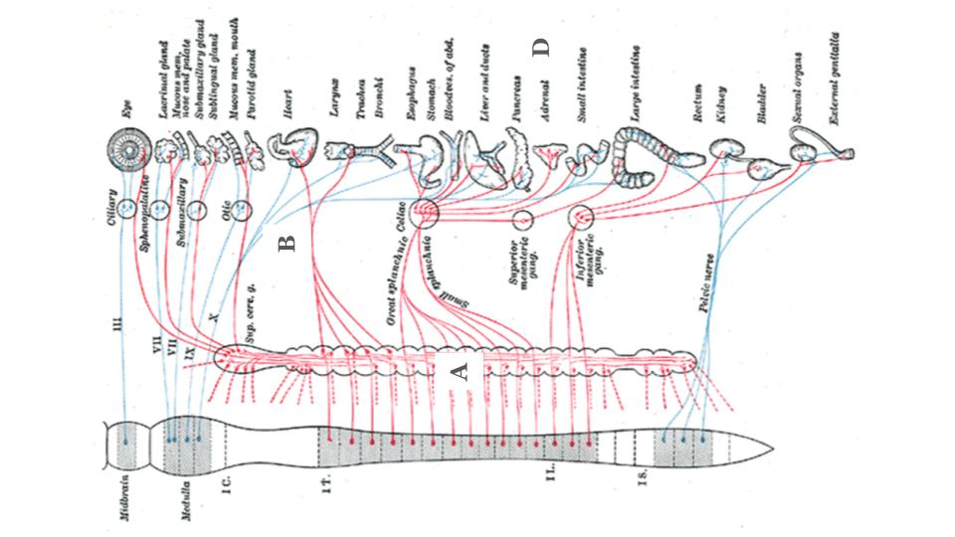
This diagram shows the brainstem and spinal cord with various nerve projections that eventually terminate at specific organs. The left-most image is the spinal cord and the brainstem (medulla, midbrain); the blue projections represent parasympathetic nerves, and the red projections represent sympathetic nerves. Points of interest: (a) Note that sympathetic nerves (red) take a “pit-stop” at nerve ganglia immediately after exiting the spinal cord; (b) the parasympathetic (blue) nerve labeled X is the vagus nerve, which innervates all visceral organs; (c) consider a skin cell, not pictured, which will receive both sympathetic and parasympathetic innervation; (d) note that the adrenal medulla, responsible for releasing the hormone adrenaline, is under sympathetic innervation only.

Figure 2. Organ functions based on autonomic stimulation.
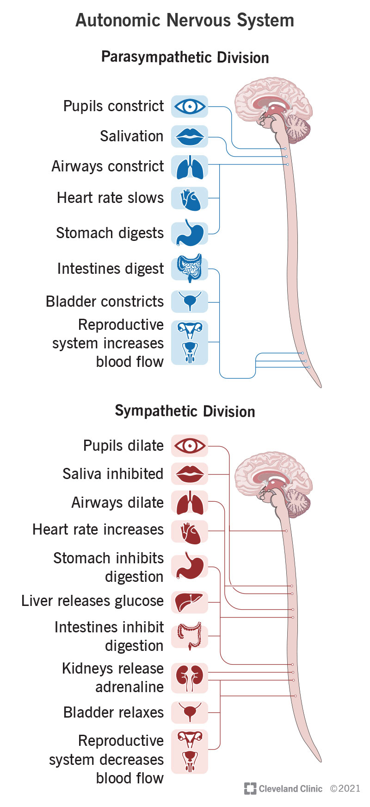
Here is a functional representation of each autonomic nervous system and the organ’s effect under either parasympathetic or sympathetic response: (a) parasympathetic response, known as “rest and digest,” and (b) sympathetic response, known as “fight or flight.” Notice that stimulation of one division directly imposes the alternate division.
A

NOTES:_________________________________________________________________________________________________________________________________________________________________________________________________________________________________________________________________________________________________________________________________________________________________________________________________________________________________________________________________________________________________________________________________________________________________________________________________________________________________________________________________________________________________________________________________________________________________________________________________________________________
B
- What would you expect to happen to heart rate during stimulation of the vagus (X) nerve? Why?
Stimulation of the vagus nerve should lower heart rate due to parasympathetic activation on the cardiac pacemaker.

- What type of activity would you expect to activate the vagus nerve?
The vagus nerve is activated by consumption of food, meditation, rest, sleep, etc.

- Notice in Figure 2 that the liver will release glucose during the sympathetic response. What is the purpose of this?
Releasing glucose from the liver will increase the blood glucose levels, providing fast, readily available energy to the working muscles. This is important for the fight-or-flight response, because skeletal muscles will be working harder than normal.

- Medical Connection. An albuterol inhaler activates receptors in the lungs to relax the muscles around the airways, making it easier to breathe, especially if you have asthma. Before taking this medication, it is advised to consider the effects it may have on your heart. What effect on the heart would you expect this medication to have? How do you know?
Because the albuterol medication dilates airways, it is a sympathetic activator. Therefore, we should expect the heart rate to increase.

