**Sample Graph**

1. Complete the following table with the data gathered from the test strips.

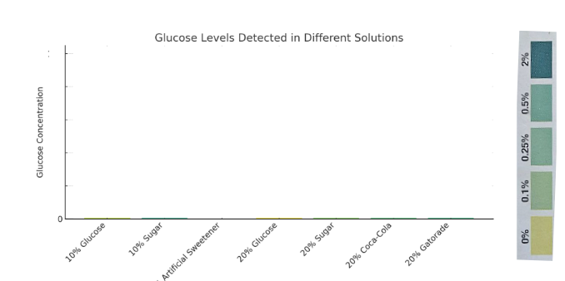

2. What patterns do you see in the graph? What conclusions can you draw?

|  |
| --- |
|  |