**Sample Graph Answer Key**

1. Complete the following table with the data gathered from the test strips.

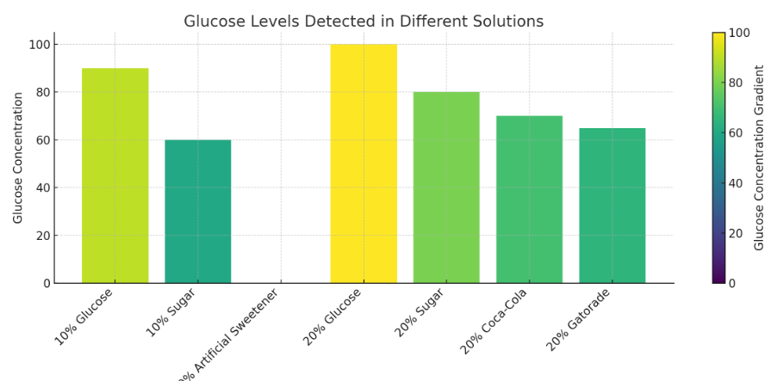

2. What patterns do you see in the graph? What conclusions can you draw?

A) Higher concentrations contain more glucose: The 20% glucose solution has a higher glucose level than the 10% glucose solution, showing that more concentrated solutions contain more glucose.

B) The artificial sweetener solution has 0 glucose units, meaning that not everything that tastes sweet raises glucose levels.

C) Soda and sports drinks, despite tasting different, have the same glucose level.

D) Even though both sugar and glucose solutions are sweet, sugar solutions show lower glucose levels than glucose solutions at the same concentration.