**Pre-Assessment**

Instructions: Answer the following questions.

1. After spending 20 minutes playing outside, you feel thirsty. Which one of the following would you drink? Why? (water, sports drink, soda, juice)

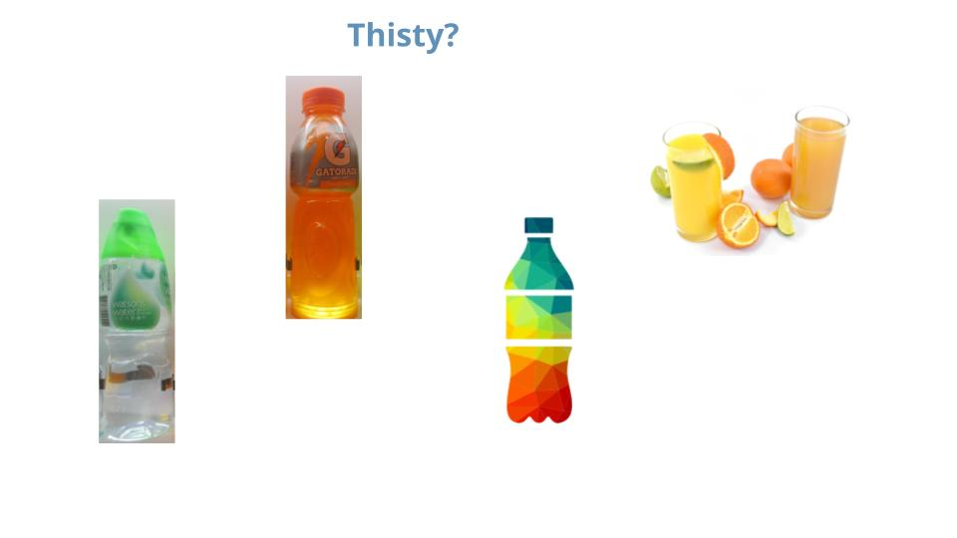

1. What happens to your body when you eat or drink sugar?
2. Have you ever heard of diabetes? What do you think it means?