Pre-Assessment Answer Key

Instructions: Answer the following questions.

- After spending 20 minutes playing outside, you feel thirsty. Which one of the following would you drink? Why? (water, sports drink, soda, juice)

Answers will vary.

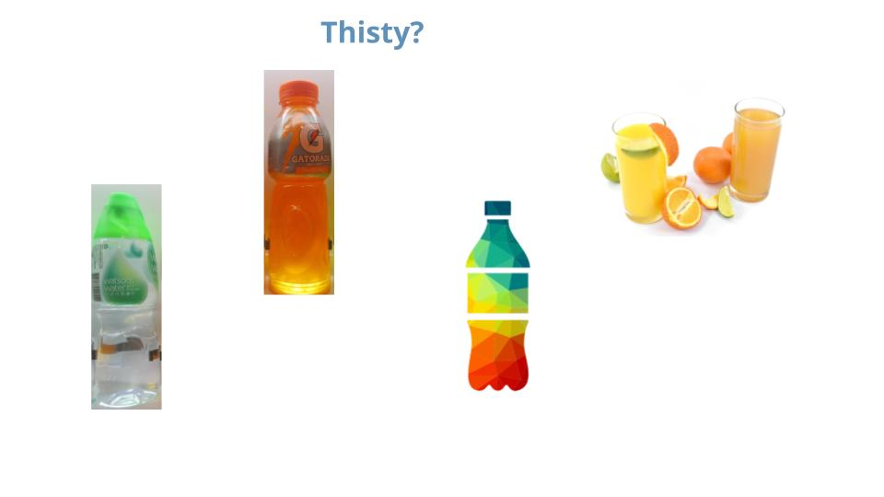

- What happens to your body when you eat or drink sugar?

Answers will vary.

- Have you ever heard of diabetes? What do you think it means?

Answers will vary.

