**ML4K Tutorial**

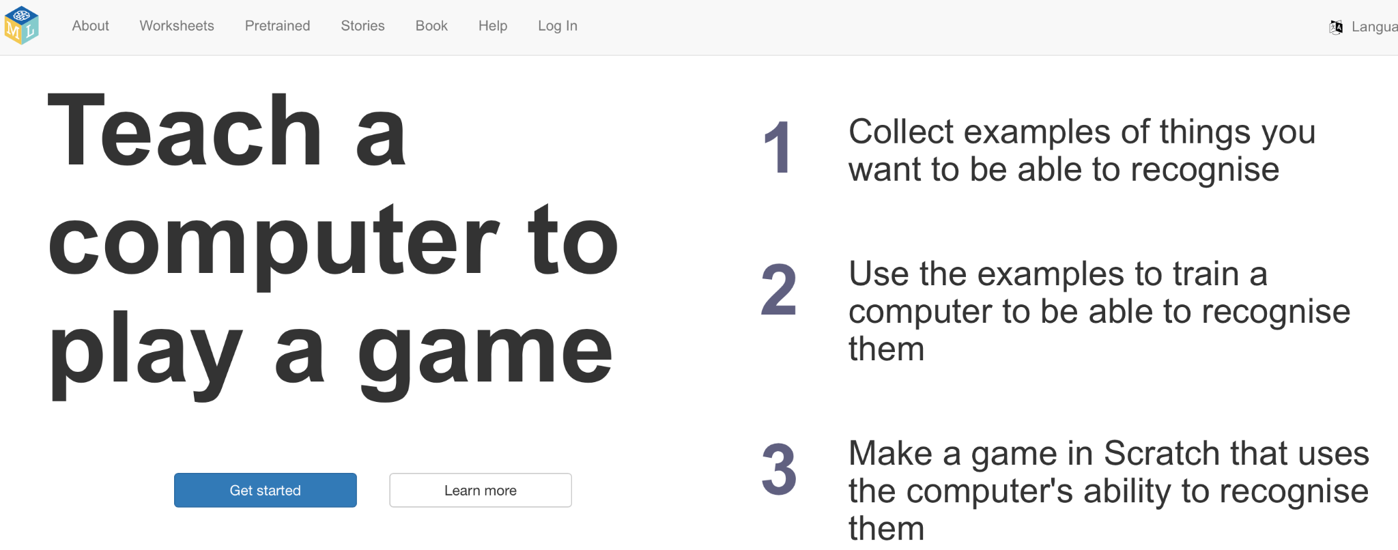

1. Go to [machinelearningforkids](https://machinelearningforkids.co.uk)

2. Click on "Get started."

3. Click on "Log in."



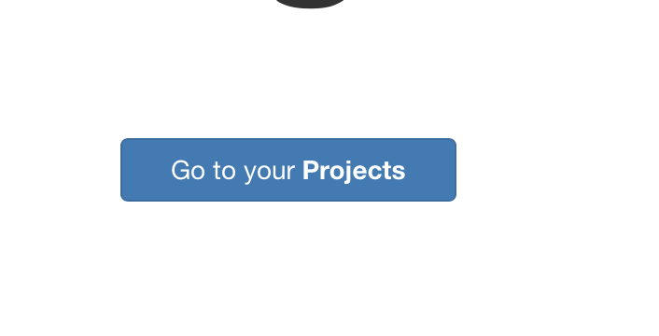

4. Use the login provided

(if your teacher created an account).

5. Click on "Go to your projects."

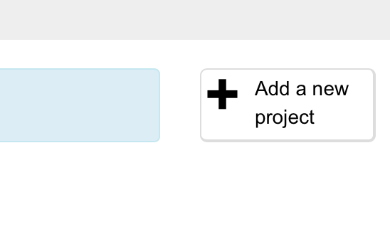

6. Click on "Add a new project."

7. Add the following:

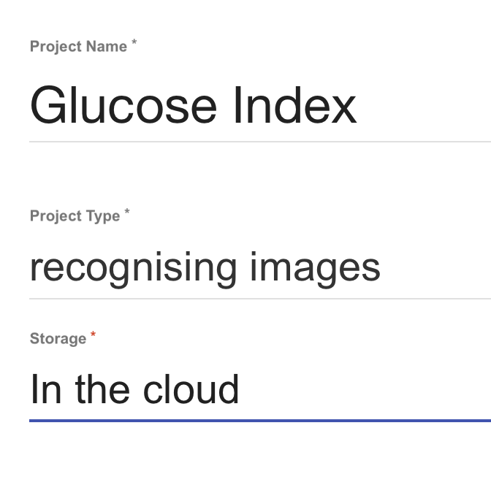

8. Click on "Create" at the right bottom of the page.

9. Click inside your project to open it.

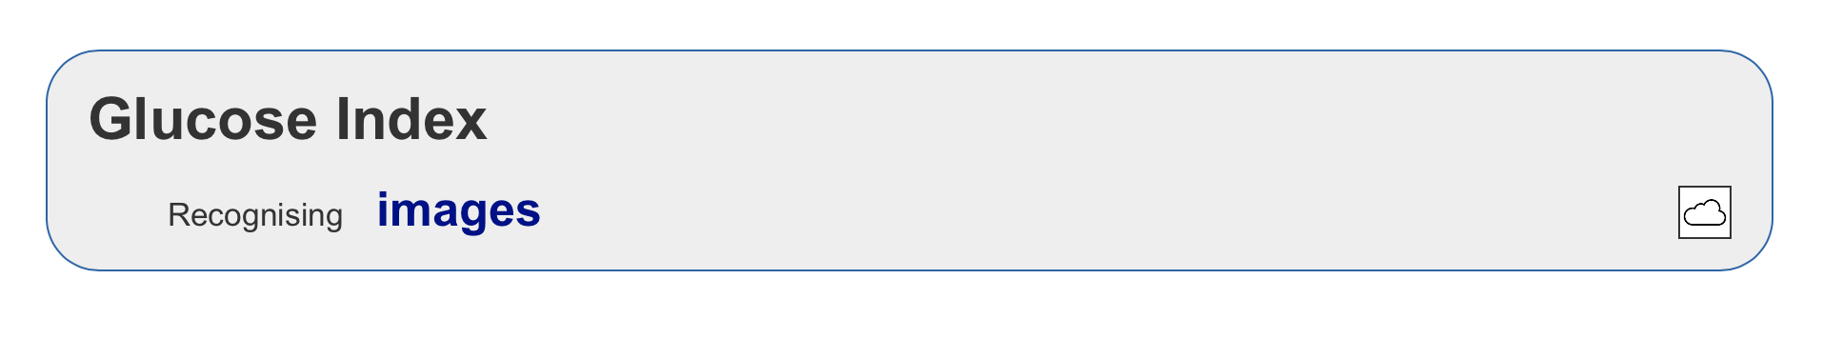

10. Click on "Train."

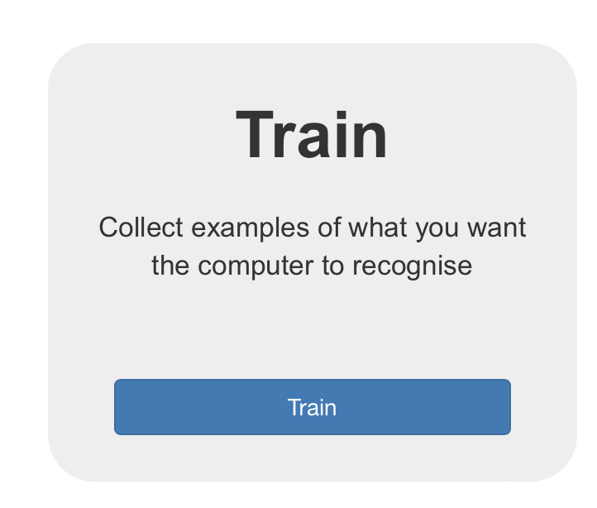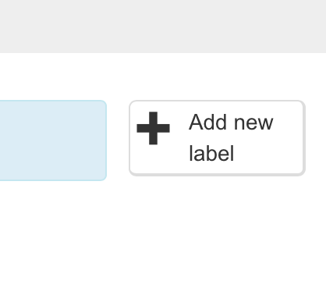

11. Add a new label.

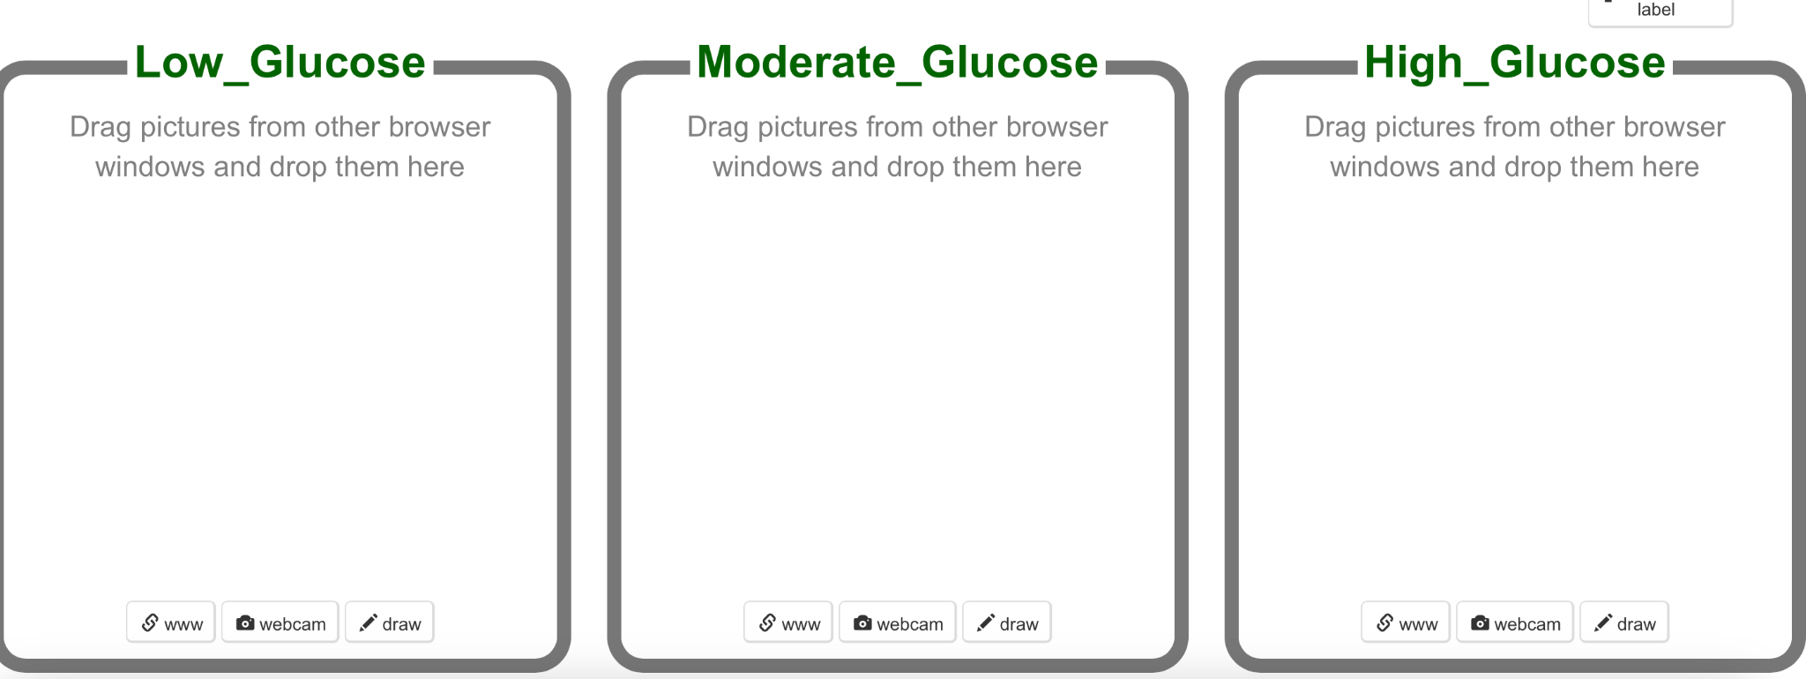

12. Create these categories:

13. Click on the webcam and then on "Allow" to start adding pictures in the correct categories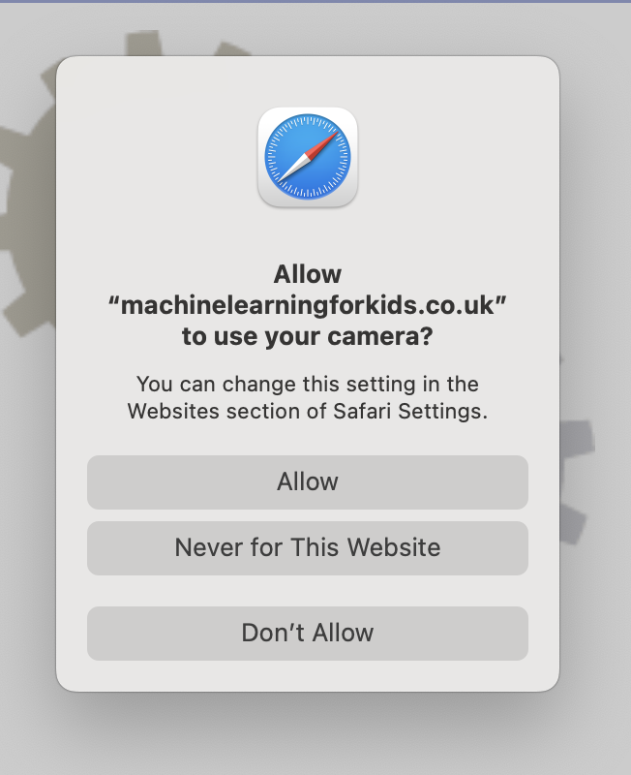.

14. It will look like this:

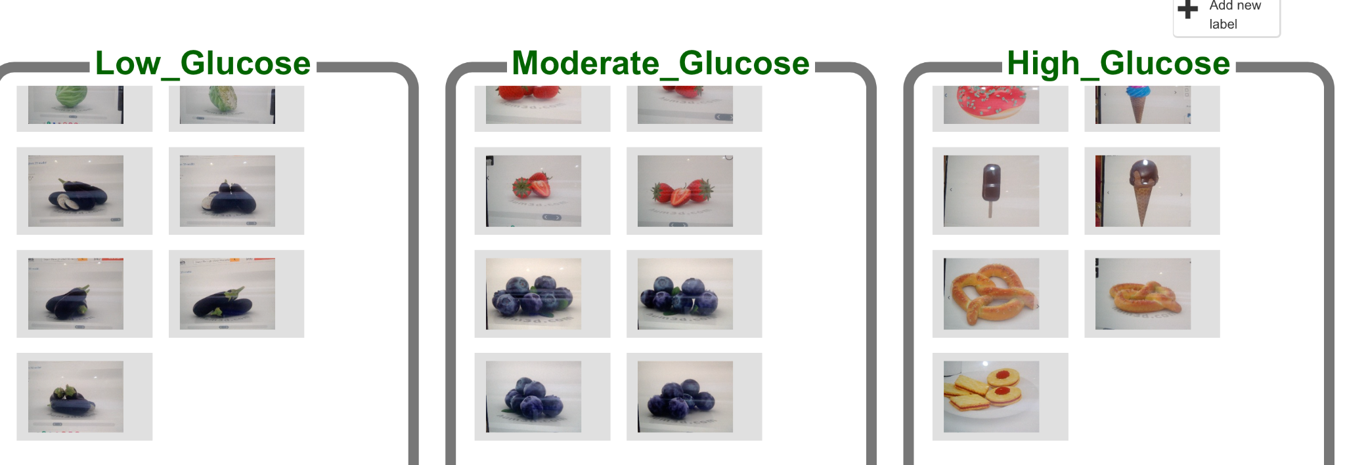

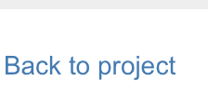

15. Click on "Back to project."

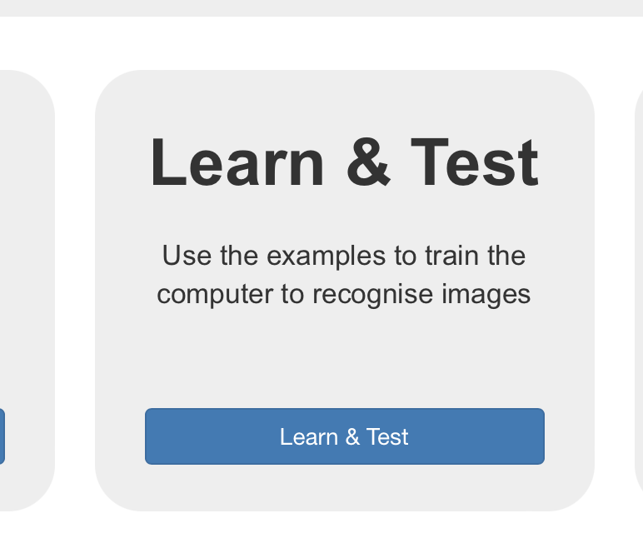16. Click on "Learn & test."

Once finished, click on "Go back to project."

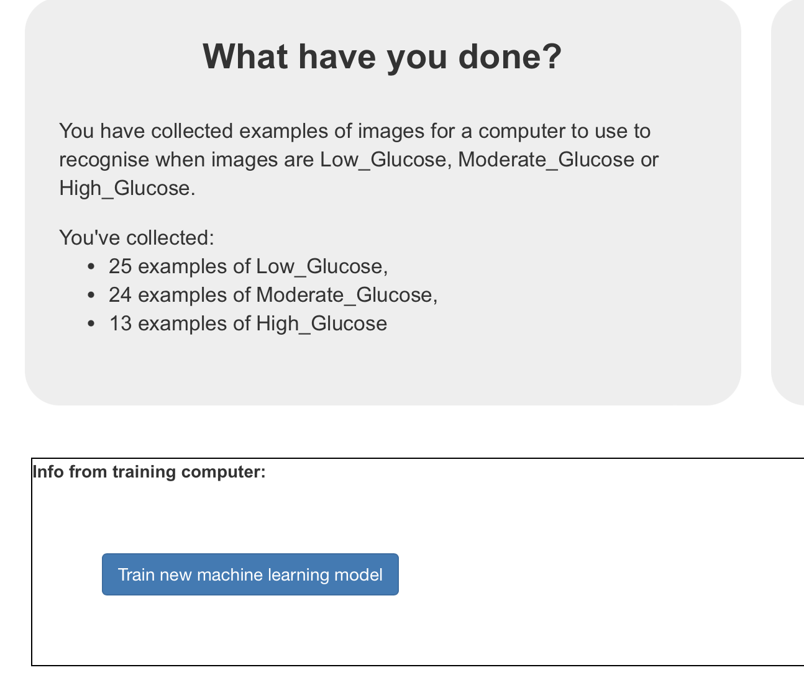17. Click on "Train new machine

learning model."

18. Click on "Test with webcam"

and hold a picture.

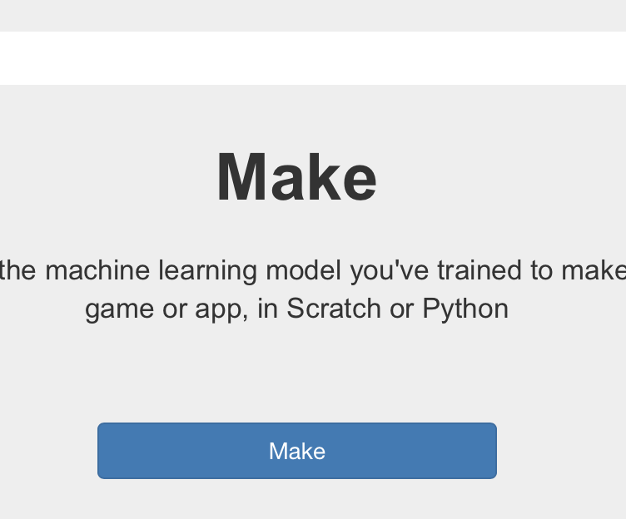

19. Click on "Go back to project."

20. Click on "Make."

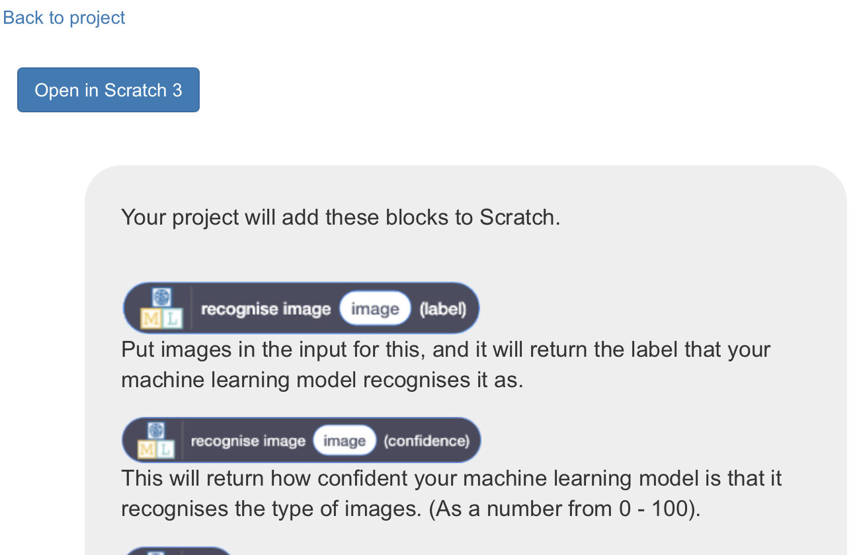

21. Click on "Scratch 3."

22. Click "Open in Scratch 3."

23. In Scratch, click on "Project templates."

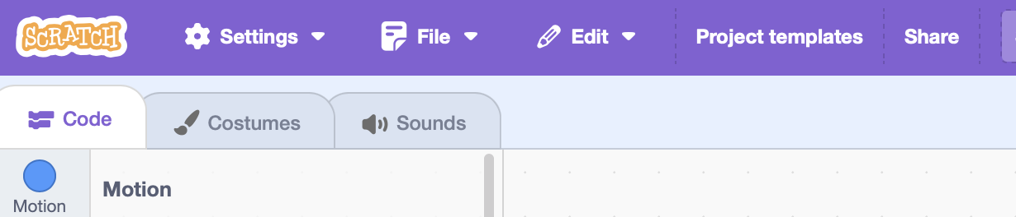

24. Scroll down and find "Judge a book" tutorial.

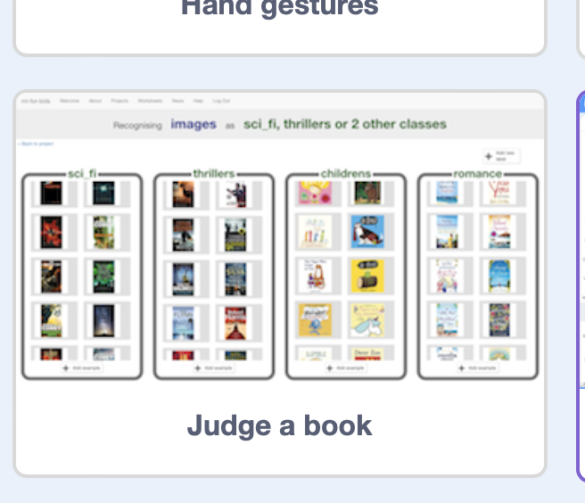

25. Click on "Sci-fi" and then click on "Costume" on the top left to change the name to our category.

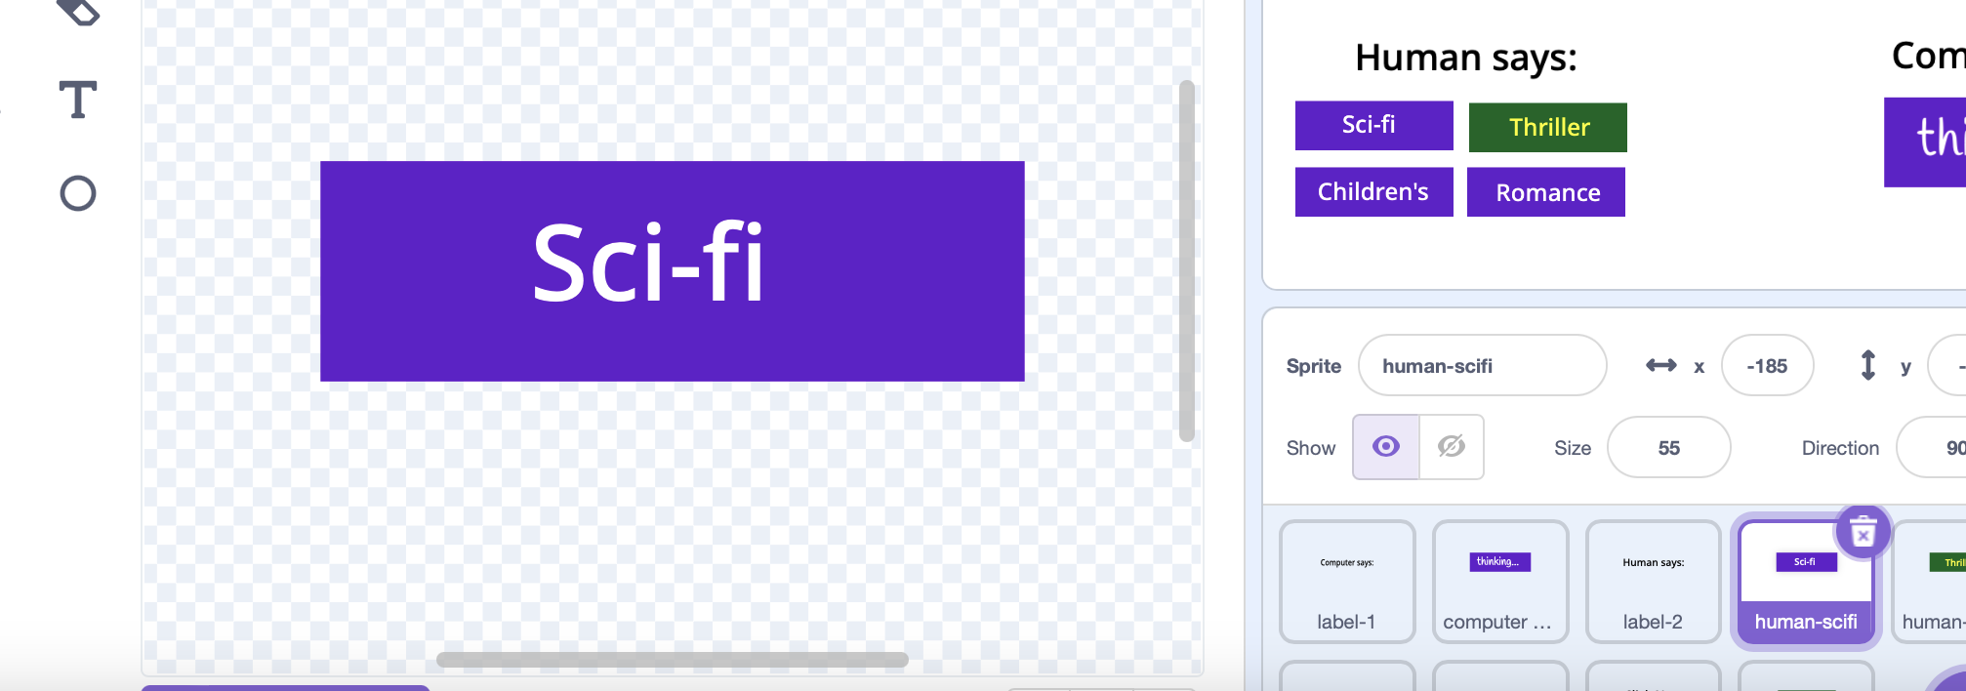

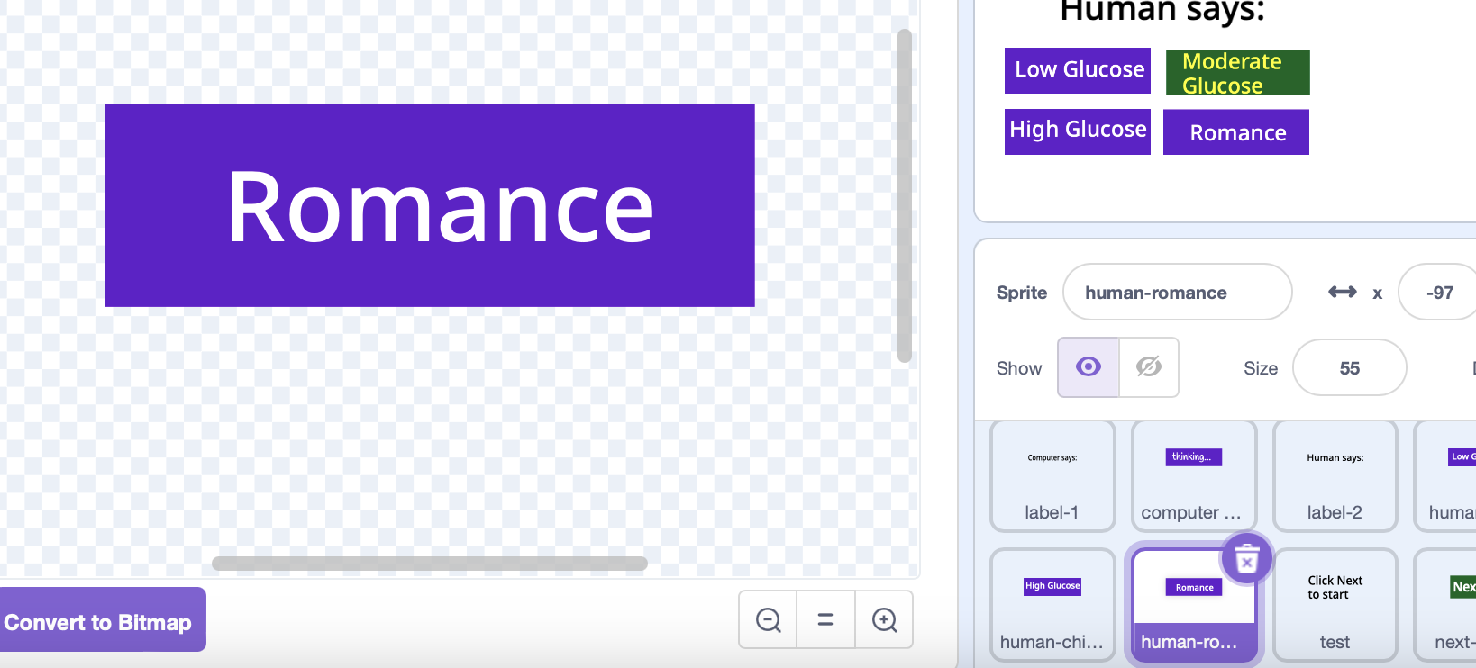

26. Rename all three and delete

one.

Rename sprite too.

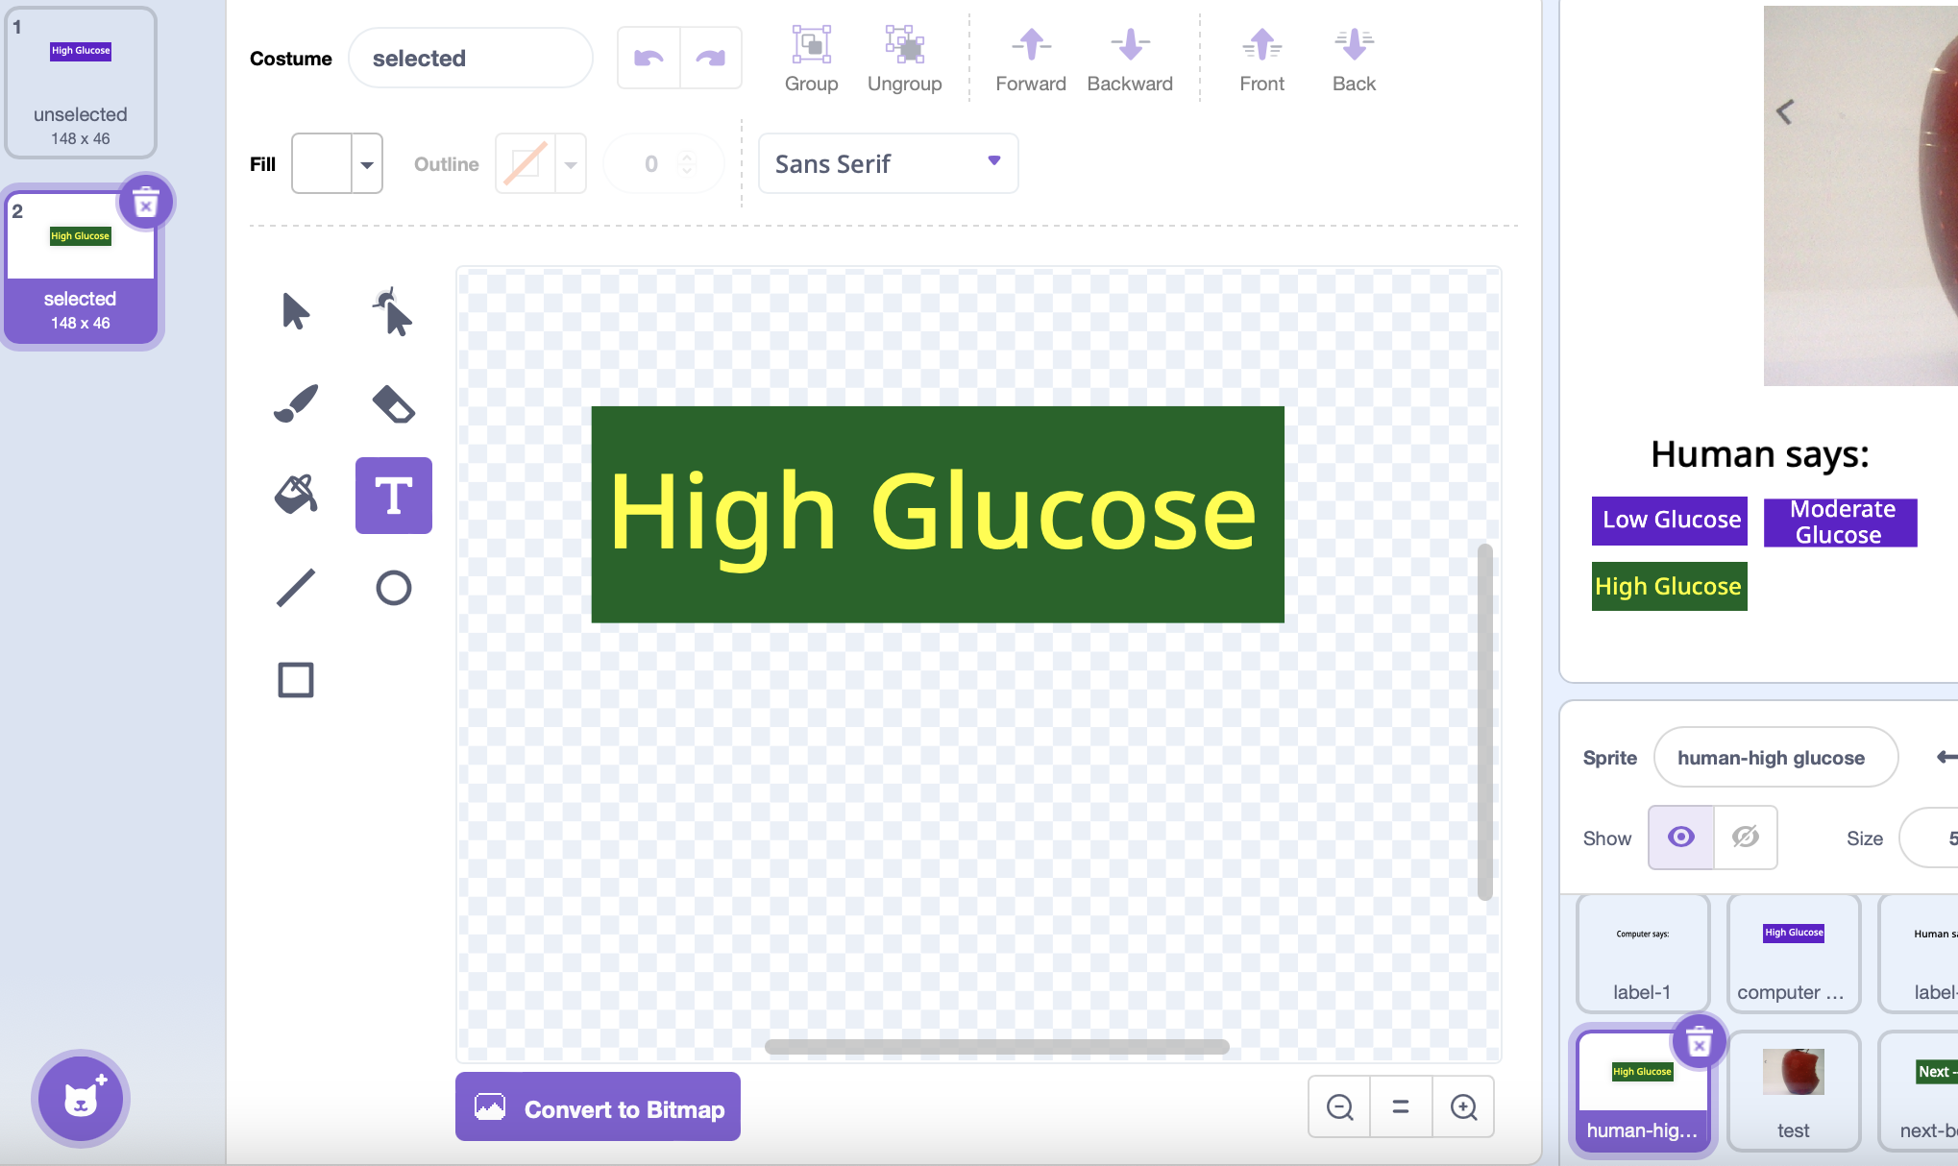

27. Click on the "test" sprite and "code."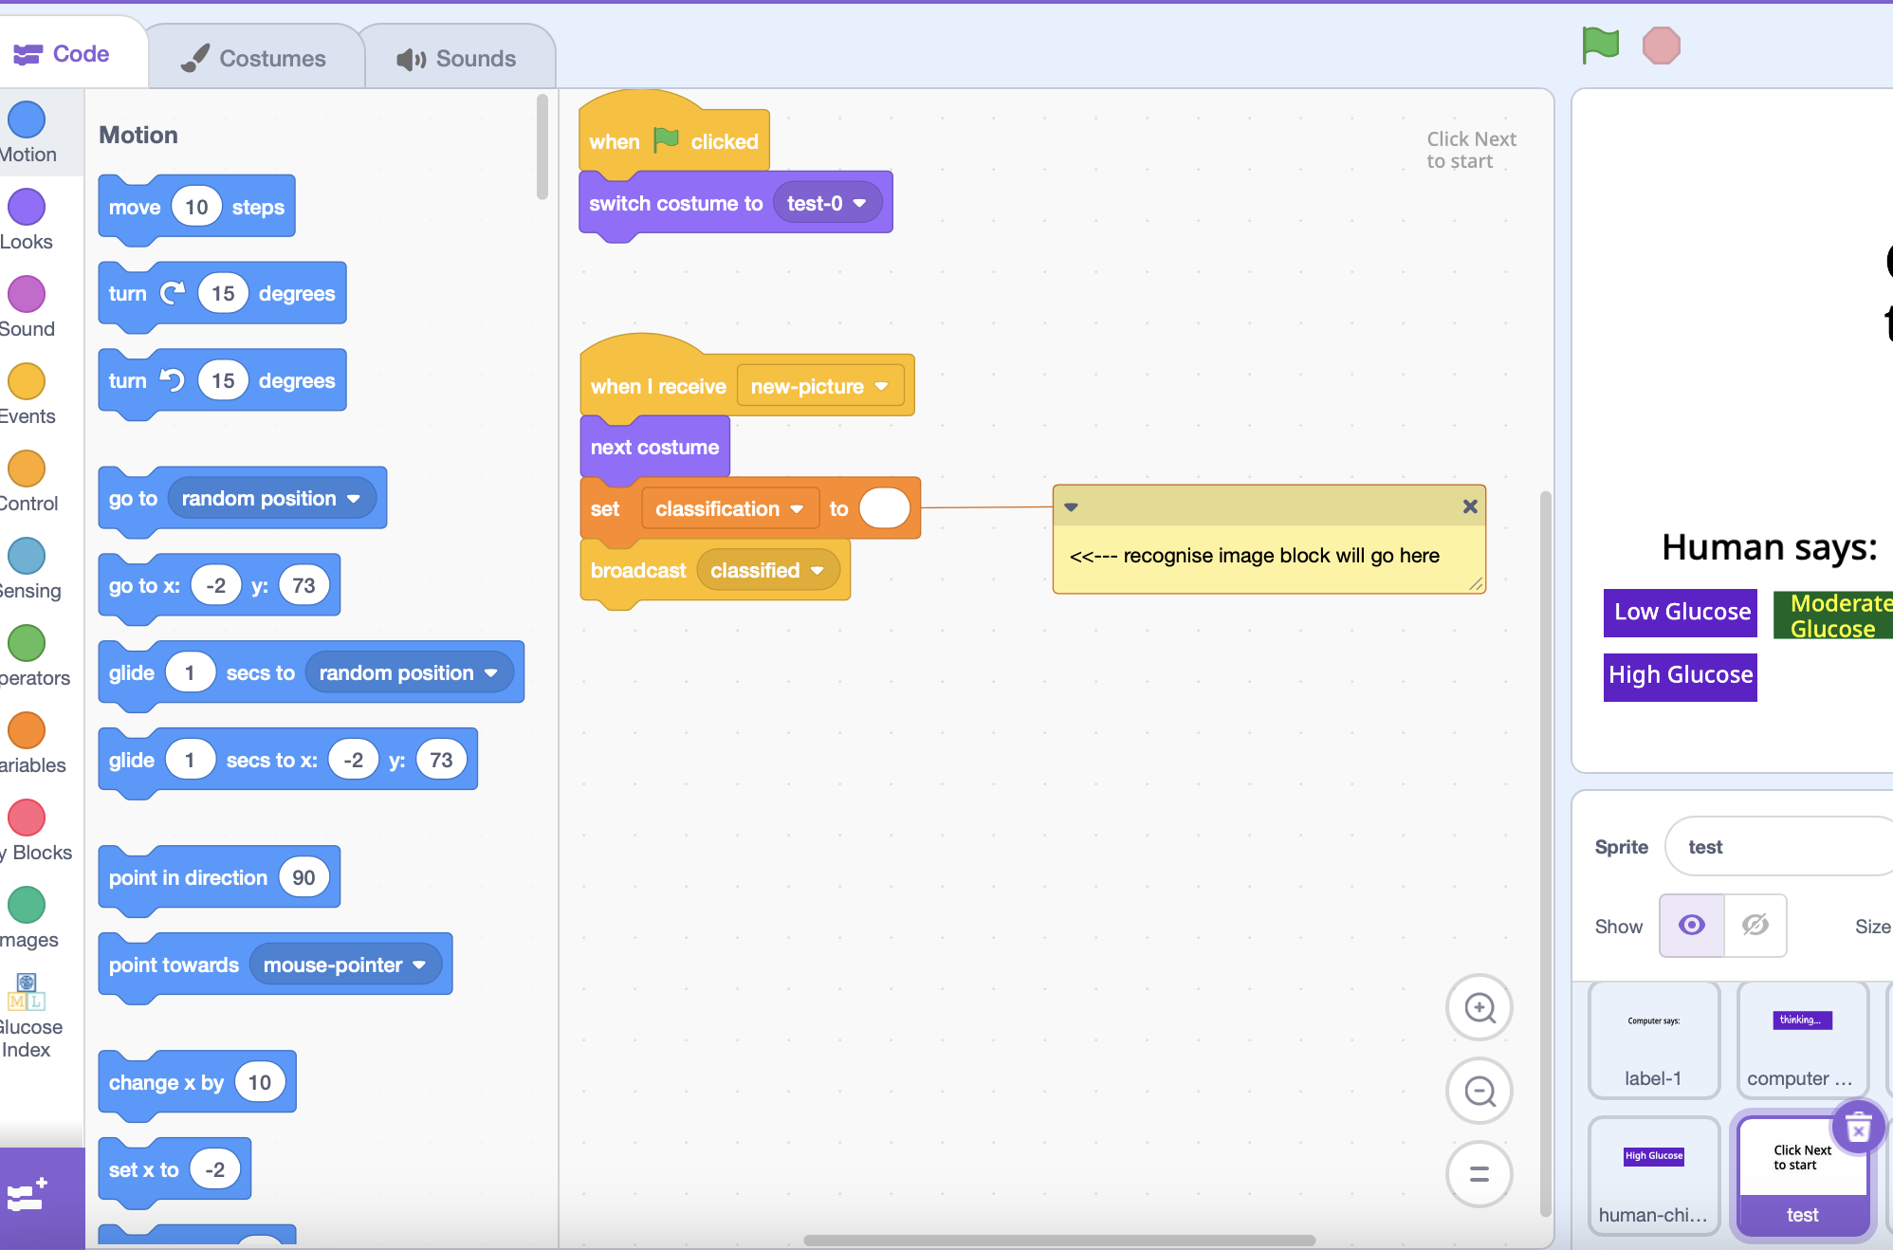

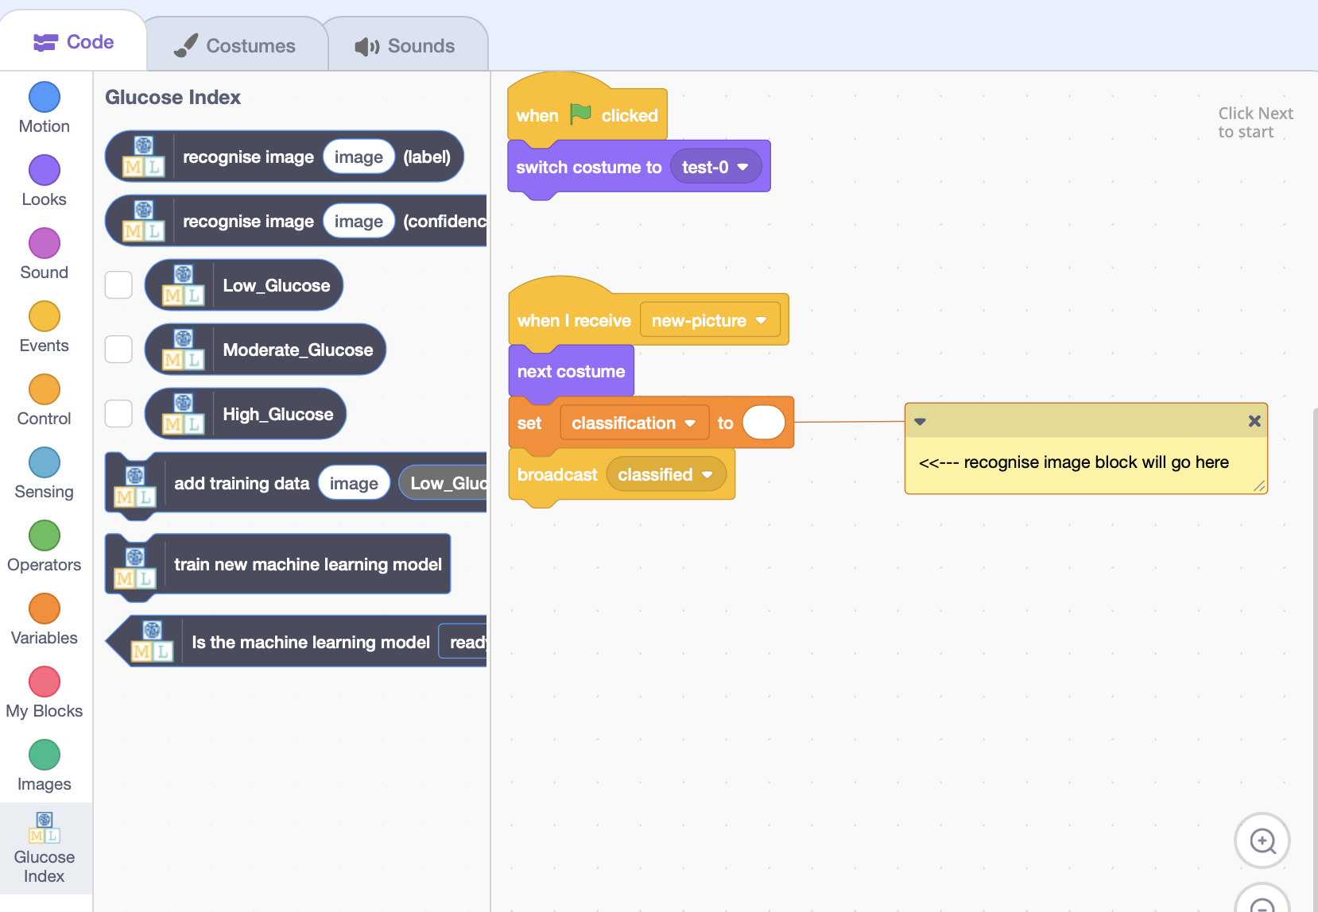

28. Click on the last button to add

the "recognize image (label)" and

"costume image" blocks.



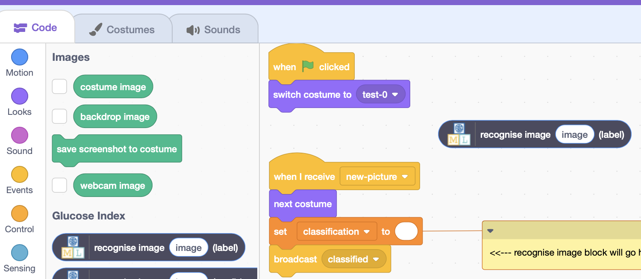



29. It will look like this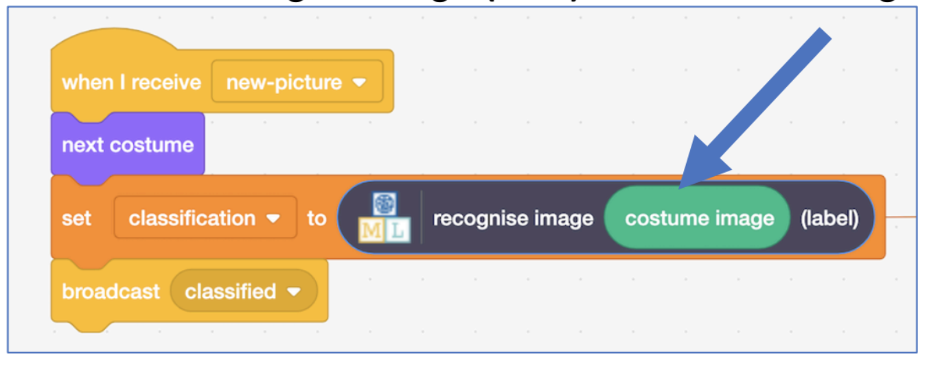:

30. Click the "Costume" tab and then click "Upload" costume.

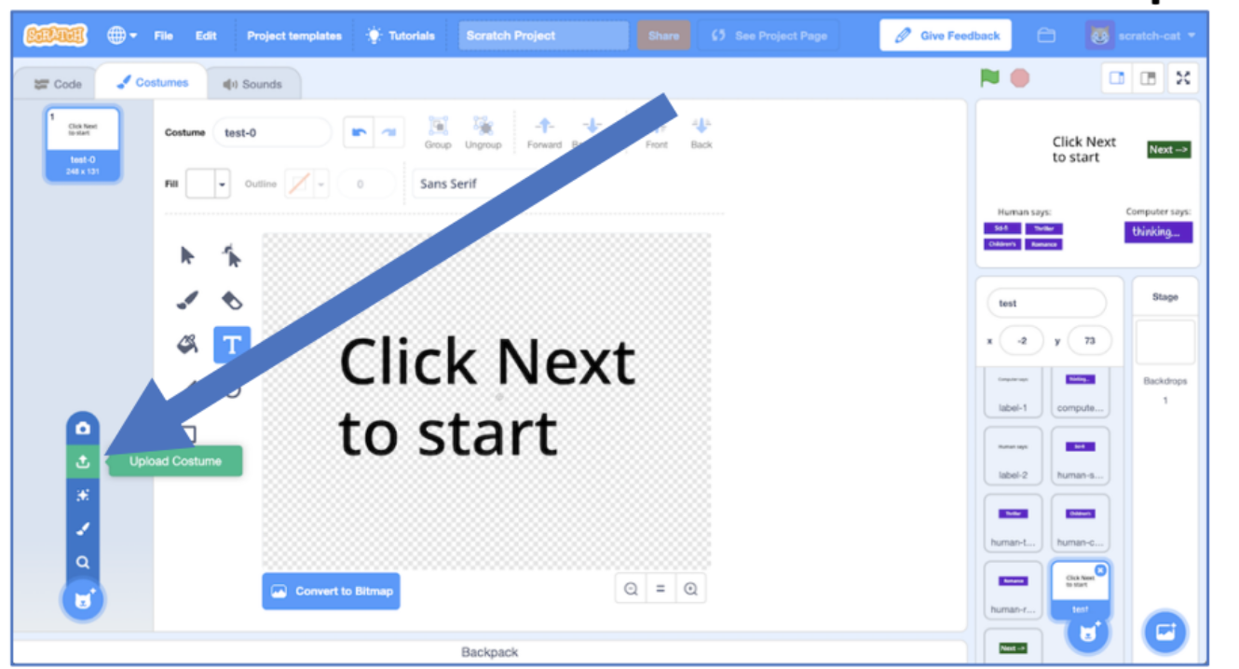

31. Click on the "camera" and take pictures of foods you will find inside the envelope provided. 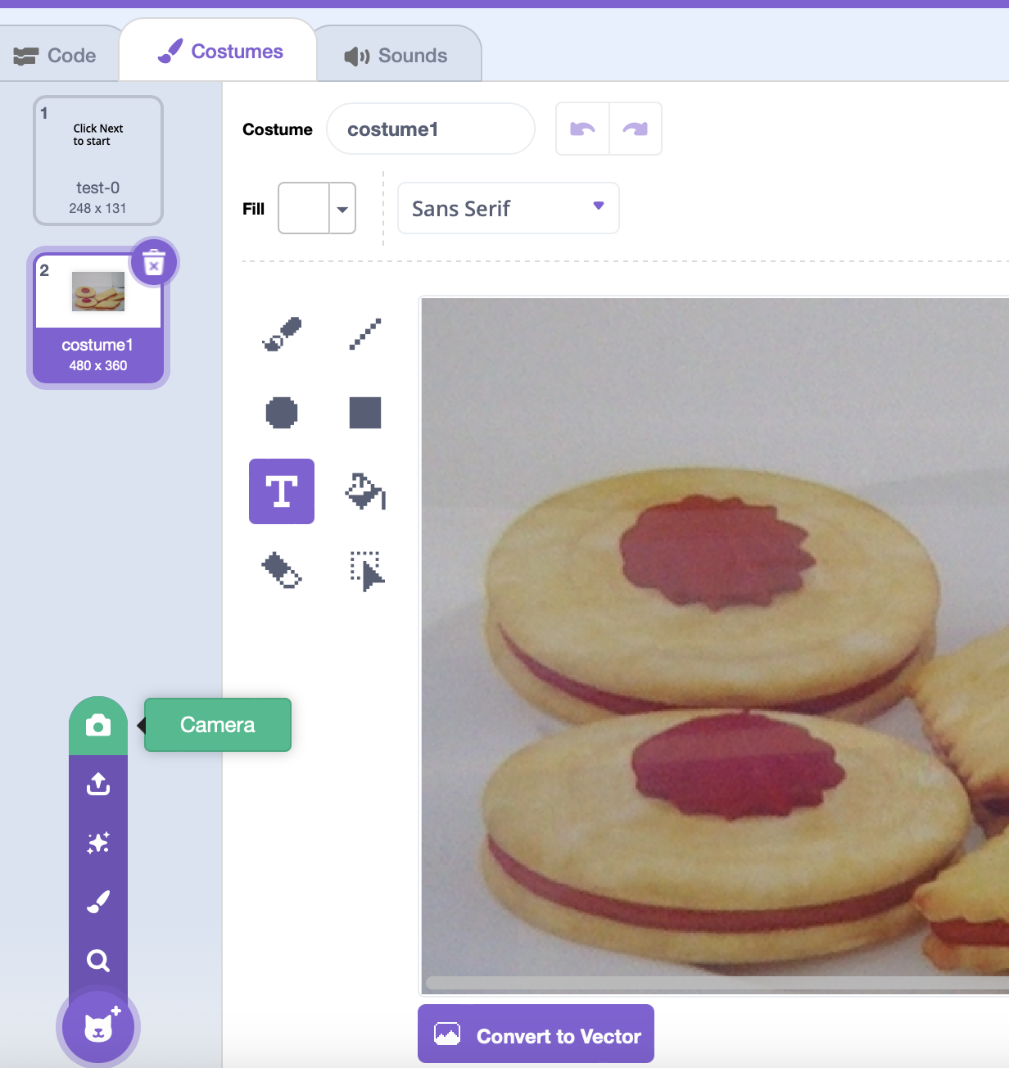

32. Click on "computer guess" sprite and click on Costume.

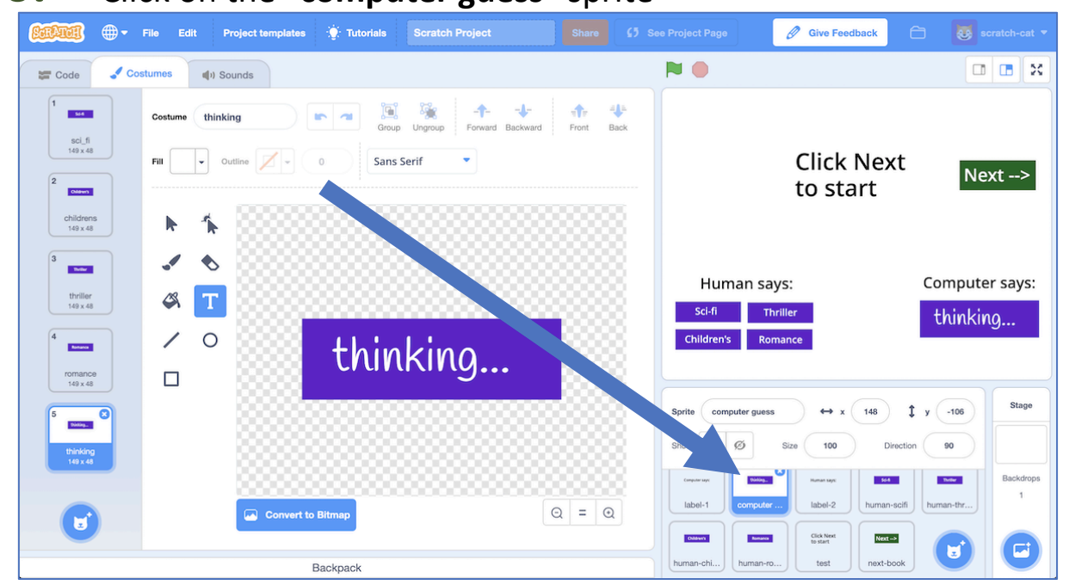

33. Change the categories and delete the extra.

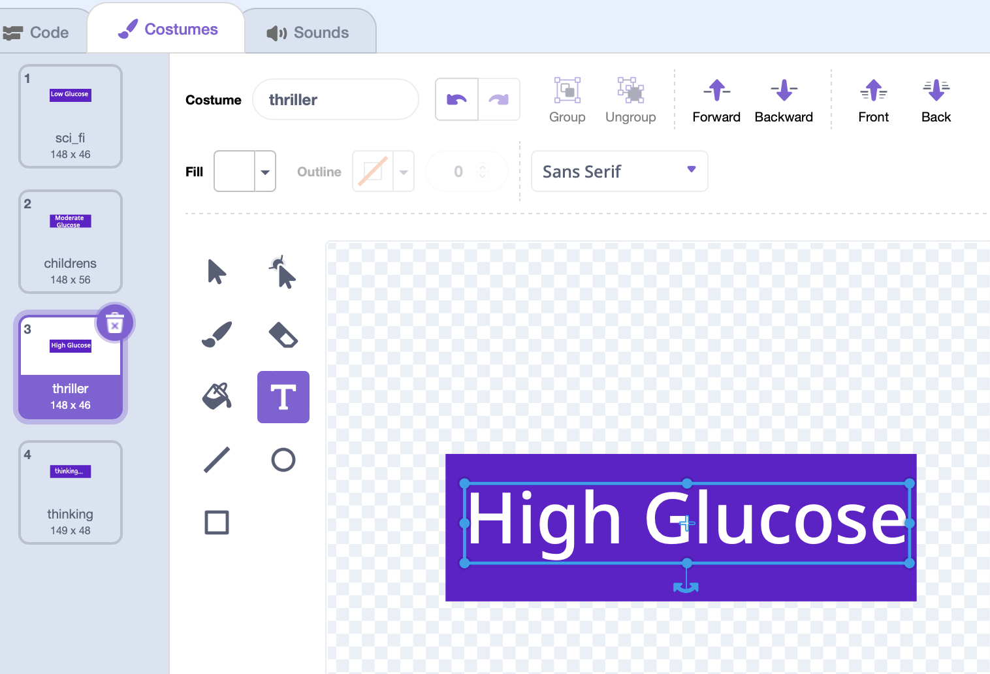

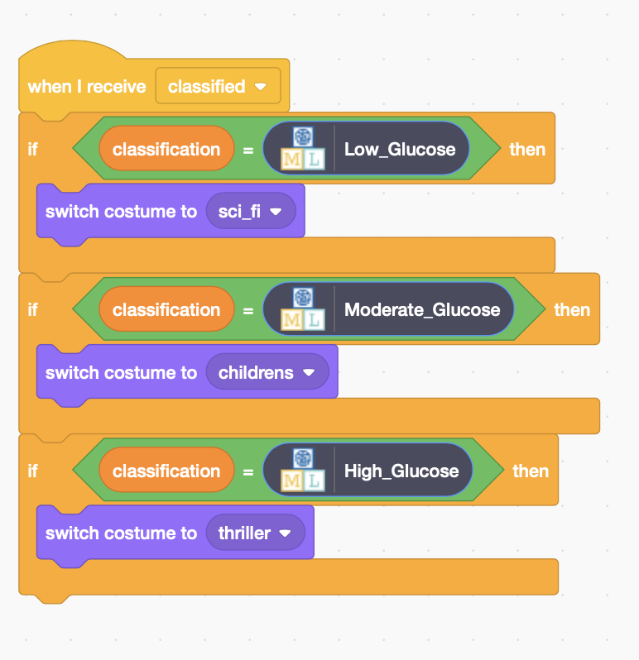

34. Then, click on

Code and copy this code:

Run the code!