**Saving Coral Reefs: Define the Problem and Brainstorm Solutions**

1. Define the problem: What is the issue you are going to be solving with your prototype? Be specific about your issue, and why you chose it. Note: This will be more specific than the category you were given as an issue.

Example answer: My group will be creating a prototype to protect coral reefs from negative effects of tourism. Specifically, we will be looking at helping coral reefs not be damaged by boat anchors.

1. Brainstorm ideas for your prototype below. Use one of the brainstorming formats discussed in class in the PowerPoint presentation.
   1. Which brainstorming method are you using? Example answer: Fish Skeleton Method

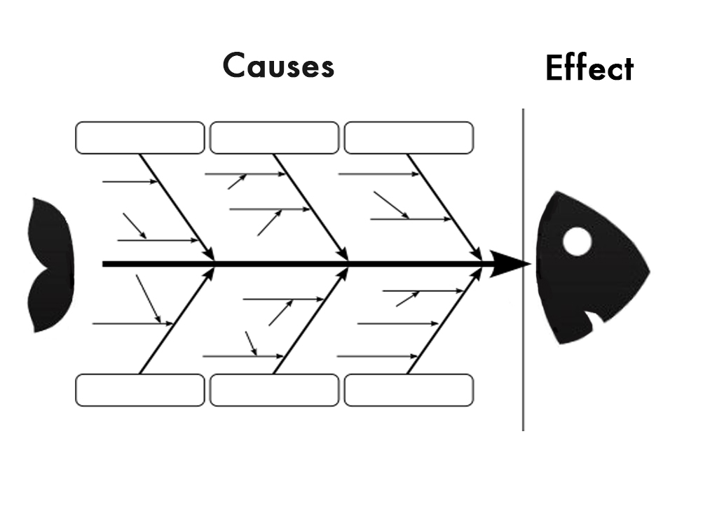This would be filled out.