Infographic Trends Worksheet

Directions: After viewing infographics on different mosquito-borne illnesses, identify trends or commonalities you notice across various types of illness in terms of symptoms, area of the world where people are affected, prevention methods, and treatments.

Symptoms:

Areas of the world where people are affected:

Prevention methods:

Treatments:

Post-Activity Questions: Use the map below to answer Question 1.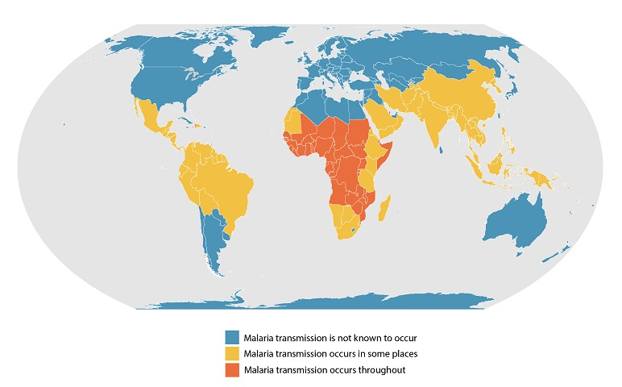
- You’ll notice Africa is affected by malaria transmission throughout most of the continent, although malaria transmission is not known to occur in the northern parts of Africa. Why is this the case?

- When looking at trends of where most mosquito-borne illnesses are, what similarities do you notice about the environments where these illnesses are most common?

- Some of these mosquito-borne illnesses, such as West Nile virus, occur in small rates within the United States. Does this information surprise you? Why or why not?

