Infographic Trends Worksheet Answer Key

Directions: After viewing infographics on different mosquito-borne illnesses, identify trends or commonalities you notice across various types of illness in terms of symptoms, area of the world where people are affected, prevention methods, and treatments.

Symptoms:
Answers will vary depending on the assigned mosquito-borne illness.

Areas of the world where people are affected:
Answers will vary depending on the assigned mosquito-borne illness.

Prevention methods:
Wear bug repellent, wear protective clothing, remove items that contain standing water from your property, etc.

Treatments:
Answers will vary depending on the assigned mosquito-borne illness.

Post-Activity Questions: Use the map below to answer Question 1.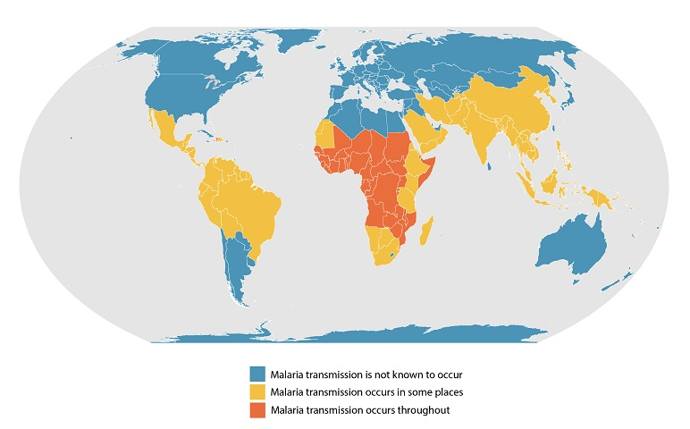
- You’ll notice Africa is affected by malaria transmission throughout most of the continent, although malaria transmission is not known to occur in the northern parts of Africa. Why is this the case?
The Sahara Desert is located in northern Africa. Because there is a lack of adequate water, it does not contain ideal conditions for mosquito breeding.

- When looking at trends of where most mosquito-borne illnesses are, what similarities do you notice about the environments where these illnesses are most common?
Environments are located in areas where water is available (non-desert areas). These areas also include warmer areas, not near Earth’s poles.

- Some of these mosquito-borne illnesses, such as West Nile virus, occur in small rates within the United States. Does this information surprise you? Why or why not?
Answers will vary.

