**CO2 Emissions Poster Presentation and Rubric**

Environmental engineers aim to protect our environment by analyzing data related to a healthy environment. The world is currently dealing with the effects of climate change. The circle graph below shows the total amount of greenhouse gas (GHG) emissions as reported in 2021. CO2 is a leading factor for climate change. If we are going to reduce the amount of CO2 in the atmosphere, we need to decide where the United States should direct resources to reduce CO2 in the atmosphere. Improve fuel efficiency? Reduce forest fires? Working with a partner, using **both** the Excel graphing activity and the Knoll Fire scenario, decide how the U.S. should spend its money. Each group needs to use two of the resources listed below to back up their ideas. A bibliography of the websites must be added to your poster. These posters will be presented to the class.

*Grades will be determined using the rubric below.*

*Sketch out some ideas for how you would like to set up your poster.*

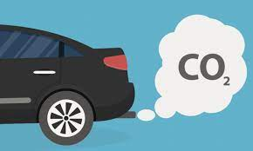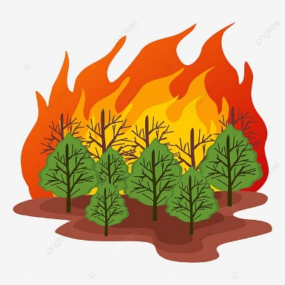



**List of References (You must use two of the references on your poster)**

Buis, A. (2021, February 22). *The climate connections of a record fire year in the U.S. west*. NASA. <https://climate.nasa.gov/explore/ask-nasa-climate/3066/the-climate-connections-of-a-record-fire-year-in-the-us-west>

California Air Resources Board. (n.d.). *Frequently asked questions: Wildfire emissions*. <https://ww2.arb.ca.gov/resources/documents/frequently-asked-questions-wildfire-emissions>

Department of Infrastructure (Ed.). (2023). *Green vehicle guide: Vehicle emissions*. Green Vehicle Guide. Retrieved September 20, 2023, from <https://www.greenvehicleguide.gov.au/pages/UnderstandingEmissions/VehicleEmissions>

Environmental Protection Agency. (2022, December 12). *Highlights of the automotive trends report*. Retrieved September 20, 2023, from <https://www.epa.gov/automotive-trends/highlights-automotive-trends-report>

Environmental Protection Agency. (2023, August 28). *Greenhouse gas emissions from a typical passenger vehicle*. Retrieved September 20, 2023, from <https://www.epa.gov/greenvehicles/greenhouse-gas-emissions-typical-passenger-vehicle#:~:text=typical%20passenger%20vehicle%3F-,A%20typical%20passenger%20vehicle%20emits%20about%204.6%20metric%20tons%20of,8%2C887%20grams%20of%20CO2>.

Flint, A. (2023, August 3). *Land matters podcast: Summer of smoke and swelter*. Lincoln Institute of Land Policy. <https://www.lincolninst.edu/publications/articles/2023-08-land-matters-podcast-the-science-behind-climate-induced-wildfires?utm_medium=cpc&utm_source=google&utm_campaign=lilp23&gclid=CjwKCAjwsKqoBhBPEiwALrrqiIMmA90AQEN_jihyPxlGGGTwF5rbVmf-rxoNeiTZbTiH0-X6LuXltxoCaBcQAvD_BwE>

Mulkern, A. C. (2022, October 18). *California's 2020 wildfires negated years of emission cuts*. Scientific American. <https://www.scientificamerican.com/article/californias-2020-wildfires-negated-years-of-emission-cuts>

National Institute of Environmental Health Sciences (Ed.). (2023, September 8). *Air pollution and your health*. <https://www.niehs.nih.gov/health/topics/agents/air-pollution/index.cfm#:~:text=Vehicle%20emissions%2C%20fuel%20oils%20and,of%20human%2Dmade%20air%20pollution>

Shirley, C. (2022, December). *Emissions of carbon dioxide in the transportation sector*. Congressional Budget Office. Retrieved September 20, 2023, from <https://www.cbo.gov/publication/58861>

United States Environmental Protection Agency. (2023, August 25). *Sources of greenhouse gas emissions*. <https://www.epa.gov/ghgemissions/sources-greenhouse-gas-emissions#land-use-and-forestry>

**CO2 Emissions Poster Presentation Rubric**

**OBJECTIVE:** Create a presentation to describe how U.S. funds should be spent to reduce CO2 emissions. This rubric will be used by your peers to grade your presentation. The class will be split into two groups. Half the class will present, and the other half will listen and grade. Remember, groups need an accurate grade from you, so if you don’t hear something on the rubric, ask questions. Each group will present three times, so take time to look at the rubric to reflect on how you can make your presentation better.

| **Criteria** | **Proficient** | **Developing** | **Beginning** | **Incomplete** |
| --- | --- | --- | --- | --- |
| **Part 1: Creating a Poster** | | | | |
| **Decision:**  A decision is made and justified to show where the U.S. should spend its money to reduce CO2 emissions. | 3 | 2 | 1 | 0 |
| **Wildfires and Cars:**  Poster describes how wildfires and cars increase the amount of CO2, explaining how CO2 gets back into the atmosphere. Diagrams, research, and/or graphs are used in your explanation. | 3 | 2 | 1 | 0 |
| **Poster:**  Poster is neat and organized. Data is easy to understand. It is clear you spent time and are proud of your work. Make sure everyone can work on the poster at the same time. | 3 | 2 | 1 | 0 |
| **Part 2: Presentation to Peers** | | | | |
| **Wildfires and Cars and CO2:**  Presenters discuss how wildfires increase the amount of CO2. Background should include information from the Excel graphing activity. | 3 | 2 | 1 | 0 |
| **The Knoll Fire:**  Presenters discuss their findings with the Knoll Fire, explaining the amount of CO2 given off by the wildfire compared to the cars. | 3 | 2 | 1 | 0 |
| **Decision:**  Decision is justified, with two resources found with an explanation. | 3 | 2 | 1 | 0 |
| **Presentation:**  The presentation is organized, and all voices are heard. Presenters answer questions with confidence. It is clear you practiced and prepared. | 3 | 2 | 1 | 0 |

**Total score: ________ /21 points**