**Knolls Fire and Evacuation Worksheet Answer Key**

***Scenario*:** Saratoga Springs, Utah, is a city with a population of 58,500, located just south of Salt Lake City. Saratoga Springs is blocked on both sides by topographical features. Utah Lake borders the east side of the city, and the Lake Mountains border the west, as shown in Figure 1. On June 28, 2020, a fire broke out south of the city that was named the Knolls Fire. This was a human-caused fire that quickly spread and threatened the southern area of the city. An evacuation was declared, forcing 13,000 residents from their homes, as shown in Figure 2. The only route moving out of town was northbound on Redwood Road. This caused congested or stop-and-go traffic as residents slowly moved north 5 miles to safety.

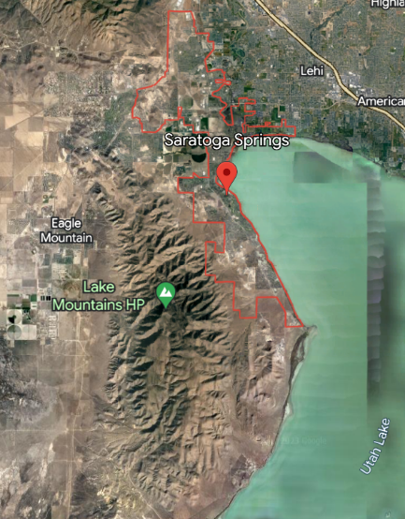After this evacuation occurred, news organizations began to run stories wondering which causes more CO2 to be released into the atmosphere: cars or wildfires. As an environmental engineer, you are going to analyze the Knolls Fire to determine whether more CO2 was released from the fire or from the evacuating cars. This is only one case of a small fire, so you also need to go back to your wildfires vs. cars graphing exploration in Excel to also consider a broader picture of all the cars and wildfires in the U.S.

Figure 1: Map of Saratoga Springs, *Google Earth*

Figure 2: Evacuation Area, *Graphic by Christopher Cherrington, The Salt Lake Tribune*

***Directions*:** Your first job as an environmental engineer is to analyze the Knolls Fire. Did the evacuating cars or the wildfire emit more CO2? Remember, the numbers have labels, so use your unit analysis skills to determine the labels.

1. Estimate the amount of CO2 emitted from cars evacuating the Knolls Fire and compare it with an estimate of the amount of CO2 emitted from the Knolls Fire.
2. **Wildfire Emissions:** *The Knolls Fire burned approximately 15.6 mi2*.

Recall from your Excel graphs that an estimate of the CO2 released by a forest fire is between 3,125 kg/mi2 (low boundary) and 12,500 kg/mi2 (higher boundary) burned. Show your work below.

(15.6 sq. miles)(3125 kg/sq. mile) (15.6 sq. miles)(12,500 kg/sq. mile)

Lower estimate ____48,750_____ kg CO2 Upper estimate _____195,000_____ kg CO2

1. **Vehicle Emissions**. Decide how many people would be in each car to determine the total number of cars evacuating.
   1. 13,000 residents evacuated at ___4___persons /car. __3,250_____ cars

(students could pick any number; we are showing 4 in this key)

b. Evacuation route 5 is miles. Multiply by your number of cars to find miles driven. _16,250__miles driven

c. Average miles per gallon (mpg) for a car is 24. Congested traffic can reduce mpg

up to 40%. (24 * 0.6) ____14.4_____ mpg

d. Estimate the number of gallons of fuel burned. (miles driven/mpg) __1,128.47___ gallons

e. Estimate the kg of CO2 emitted. (gallons)*(*8.887 kg of CO2/gal*). __10,028__ kg of CO2

<https://www.epa.gov/greenvehicles/tailpipe-greenhouse-gas-emissions-typical-passenger-vehicle>

**Conclusions:**

Answer each of the following questions.

* 1. For this fire, what were your results for wildfire emissions of CO2 and cars evacuating?

The emissions from the Knolls Fire, if it burned out right away, would be on the low boundary and emit 48,750 kg of CO2. If the fire burned longer and hotter, thus getting closer to the upper boundary, it could emit 195,000 kg of CO2. This fire caused an evacuation, so I think it would be closer to the upper boundary, or 195,000 kg of CO2.

I chose to show 4 people per car would evacuate, so the amount of CO2 emitted would be 10,028 kg of CO2. This is much lower than the CO2 emitted from the Knolls Fire.

* 1. Compare the Knolls Fire data to the Excel graphing activity for all the cars and wildfires in the United States. Do you think the Knolls Fire is an accurate representation of CO2 emissions? Why or why not?

The Knolls Fire data shows that the wildfire is emitting much more CO2 than the vehicles.

The Excel data shows that, on average, wildfires in the U.S. emit up to 200,000,000 kg of CO2 at their upper boundary. On the other hand, the vehicle data shows that it is emitting 29,000,000,000,000 kg of CO2. Vehicles are much higher in CO2 emissions than wildfires.

Students should note that after a wildfire, the forest will begin to grow again and become a carbon sink and absorb CO2. Vehicles never stop running unless they note the dates in 2020 (during Covid) when people were home.