Flood Risk Management Worksheet Answer Key
Part 1: Flood Control Structures
- Watch the video “How do Flood Control Structures Work?” on YouTube.
- Fill out the following table on the benefits and drawbacks of the different flood control methods.
Flood Control Structure | Description | Benefits | Drawbacks
Levees | Earthen embankments or concrete walls that make the banks of the river higher. | Protect developed areas.  Areas outside levees flood less frequently.  Simple. | Always possible to have extreme event that erodes or breaches levee.
Diversions | Human-made channels used to divert flood waters to undeveloped flood areas. | Can use in highly developed areas. | Can affect other areas.
Dams / Reservoirs | Impound and store large volumes of water. | Can store extreme flood event water and release slowly over time. | If reservoir is full, flood waters must be released.  Frustrating for residents who thought they were protected.
Strategic Development | Reserving or converting the floodplain for natural wetlands, parks, trails, etc. | Property buyouts are cost effective. | Not politically popular.

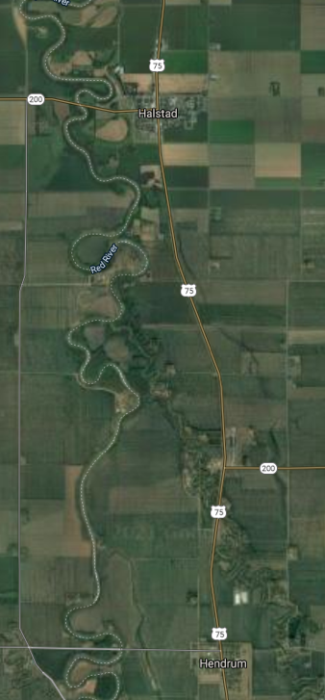
Part 2: River Management Stakeholders
- Watch the video “How “levee wars” are making floods worse” on YouTube.
- Read the following hypothetical scenario:

The City of Hendrum, MN, (300 residents) received a proposal from a wealthy residential developer who wants to pay for the installation of levees along the Red River and Wild Rice River north of Hendrum to build a country club community between the two rivers. This community will include large riverside homes for commuters to Fargo or Grand Forks, and a country club with a pool and beautiful destination golf course. Six miles downstream of Hendrum is Halstad, MN (600 residents). The residents of Halstad fear that this development will cause increased flood damage to their community because the inundation of flood waters will increase due to the presence of levees upstream. However, both cities would benefit greatly from an increase in money being spent in their communities.

Discussion:
What are the pros and cons of installing the levees and creating this country club community?
Pros | Cons
Answers will vary, but the following should be included:  - Hendrum will be protected from higher flood levels.  - Brings money into the communities. | Answers will vary, but the following should be included:  - Increased flooding in Halstad.

Do you think the levees should be installed? Provide reasoning that supports your decision.
Answers will vary.

Describe an alternative flood control method that either community could use to improve the flood risk management for both communities. (Hint: Look at Part 1 for ideas!)
Answers will vary. Should talk about diversions, dams/reservoirs, or strategic development.

