Flood Management Scenario Worksheet
Flood Management Scenario - 15 years later…
You are a team of engineers working for the City of Fargo. The past 15 years have been very dry, with the Red River flowing at a minimum level. Now, construction contractors want to build houses along the Red River, for a new development they want to call Forest River Park Development, in an area that is south of town near 88th Ave South. The contractors believe this is valuable, wasted land. They also feel that homeowners will want to buy the lots that have a view of the river and will pay a premium price for them. They have come to the City with a proposal to build houses along the north side of the river. The City planning board is on board with this proposal. The map is shown below, with the Forest River Park area labeled.
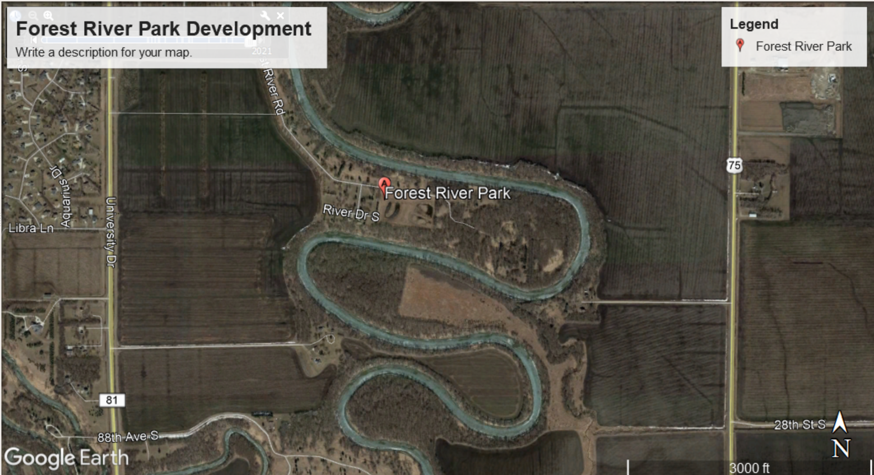
You need to go to the City planning board meeting with a presentation explaining what the best course of action should be for the City of Fargo.

Directions: Your group will put together a presentation with the following information, and you will record your presentation.
Your presentation must include the following:
- The above map of the Red River showing the direction the river is flowing, as well as where the fastest flowing part of the river is located.
- An explanation of why this land should or should not be developed. Your reasoning should include terms such as meander, cutbank, point bar, erosion, and deposition.
- Flood mitigation strategies that would be necessary to prevent flooding in the building area.

Each team member is expected to work on this project, and each person should be heard during the presentation. The presentation should be easy to follow and make sense—in other words, practice your presentation a couple of times before you record it!
Rubric:
Criteria | 4 | 3 | 2 | 1
River Description | The map is in the PowerPoint with labels on the river, as well as the direction the river is flowing. | Map is missing one component. | Map is missing two components. | Map is not labeled.
Building Decision | Group has decided whether building should or should not happen in this area, with sound reasoning. | Group has decided, but reasons are not stated clearly. | Group has decided, but no reasons are given. | Group does not make a definitive answer.
Flood Causes | Group comprehensively discusses the causes of flooding. | Group is missing one or two of the factors that cause a flood. | Group is missing most factors of what causes a flood. | Flood causes are unclear.
Flood Mitigation | Group discusses plans to prevent flooding in this development. | Mitigation plan is missing one component. | Mitigation plan is missing two components. | Mitigation plan is unclear.
Teamwork | Each person contributed to the research, planning, and creation of the presentation. You divided up the work AND came together to talk about how each person contributed to the presentation. | Team members divided up the work, and worked on their part, but did NOT come back together to talk about how each part contributed to the whole project. | Team members expressed frustration AND team did not come together to talk about how each part worked to answer the question. | Team members did not work together. Collaboration was not witnessed.
Presentation | Each person's voice is heard in the recording. The presentation makes sense and flows well without pauses. | One voice is missing OR the presentation is choppy. | One voice is missing AND the presentation is choppy. | More than one voice is missing.
TOTAL |  |  |  | /24

