Day 3 Worksheet

Python Analysis of Recordings
Follow your teacher’s directions on loading the Jupyter notebook/Python program to analyze your sound recordings. As you run the parts of the Python program (code cells in the interactive notebook), answer these questions.

Frequency Generation Code Cell
Draw some of the plots you created for 1, 2, and 3 frequencies.
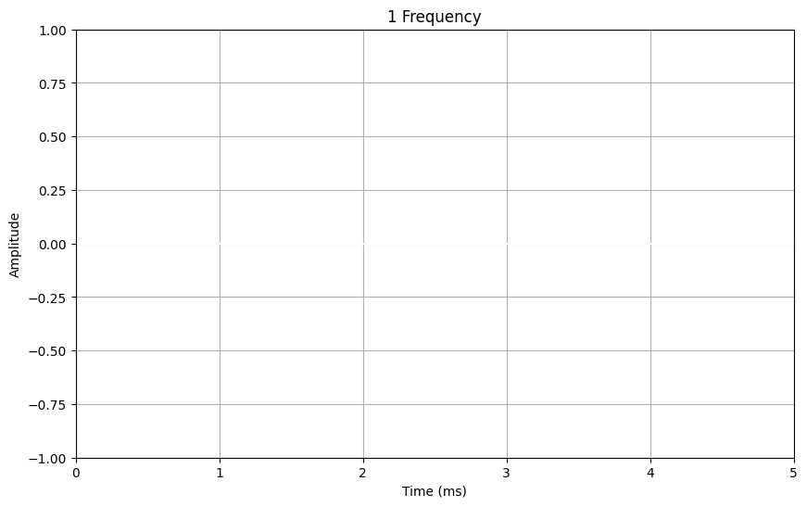 | Frequency: ________ Amplitude: _______
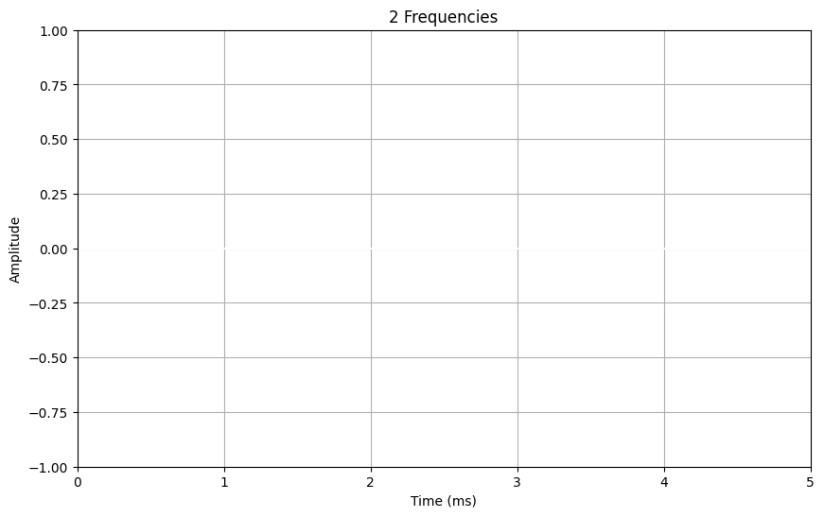 | Frequency: ________ Amplitude: _______  Frequency: ________ Amplitude: _______
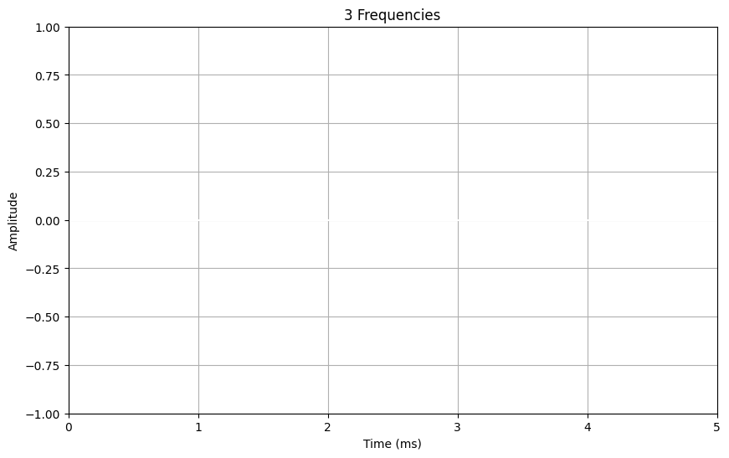 | Frequency: ________ Amplitude: _______  Frequency: ________ Amplitude: _______  Frequency: ________ Amplitude: _______

Experimental Block Testing
Using the Python program, compare the results from your different audio recordings to guess what the underside of the experimental set of blocks looks like.

Your guesses
Fill in the following table by drawing a block shape next to each sample you are to evaluate, which has an unknown number and location of holes on the bottom side. Label the sample identifier next to each sample.
Sample Identifier (e.g., “A01”) | What you think the bottom looks like

Reflection Questions about the Python program
- How did the digital tools help you analyze the tap sounds?

- What did you learn from the visualizations produced by the Python program?

- How did the frequency analysis help you identify flaws in the blocks?

- Compare the results from your human analysis on Day 1 with the digital analysis today. What differences did you notice?

- What challenges did you face when using the Python program, and how did you overcome them?

