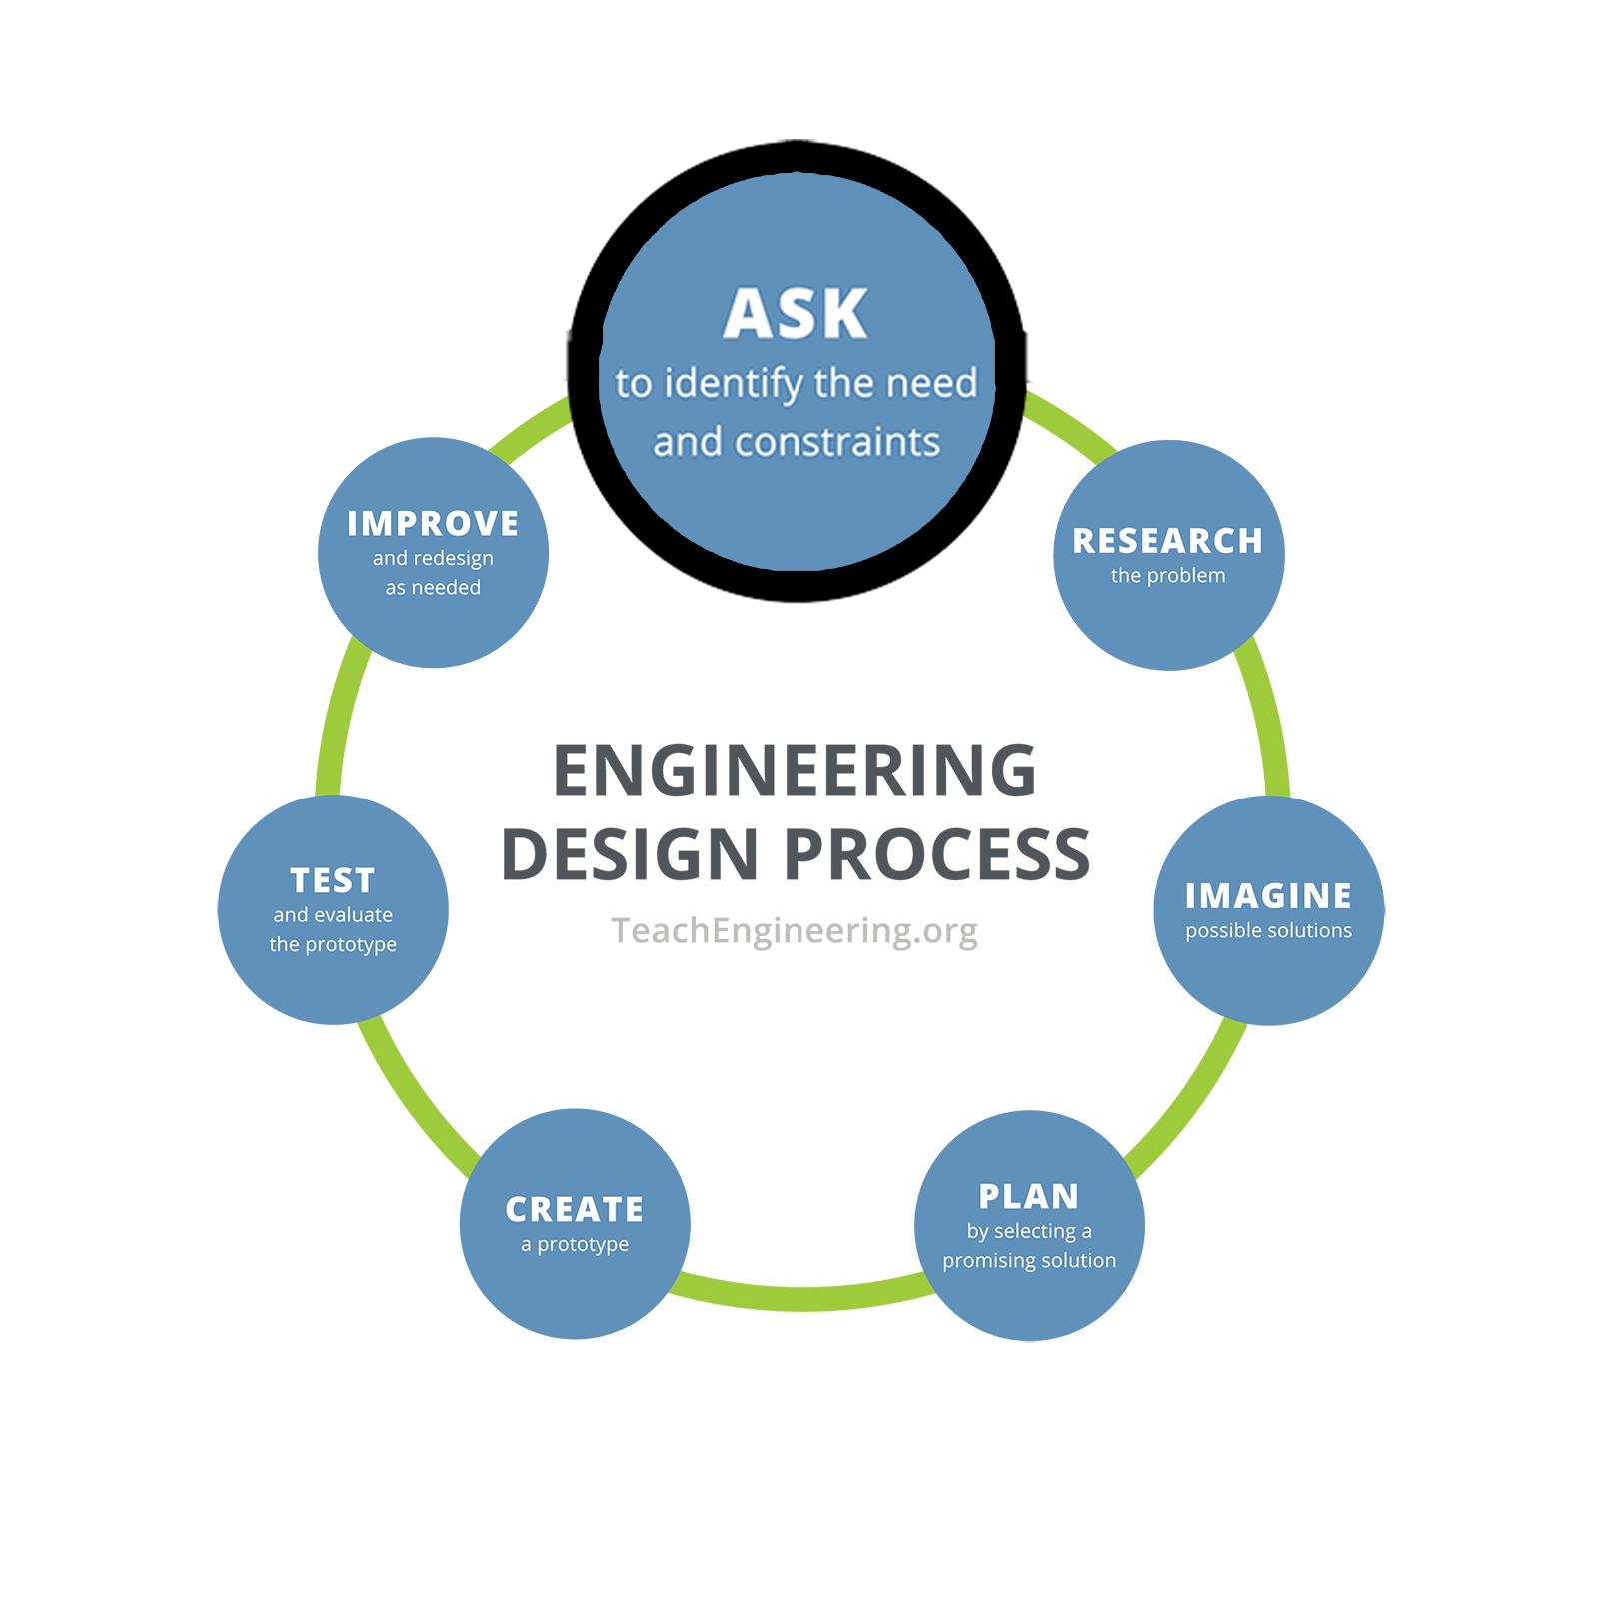
Day 2 Worksheet

Engineering Design Process, Step 1: Ask
What is the problem to solve? What do we want to design? Who is it for? What do we want to accomplish? What are the project requirements? What are the limitations? What is our goal?

On your own, jot down a quick answer to the following question.

Why is it important to limit background noise in our recordings?

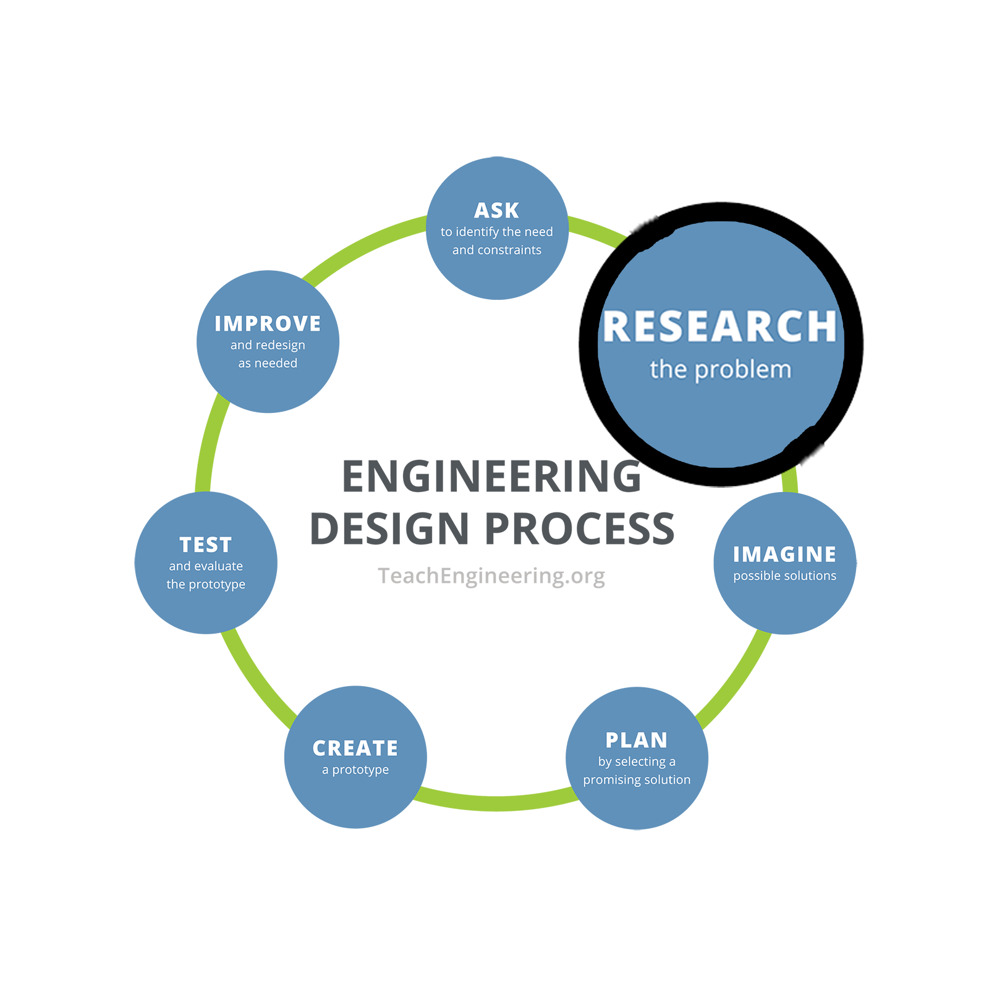
Share your answer with people around you and the group or class.

Engineering Design Process, Step 2: Research
What products or solutions already exist? What technologies might be adaptable to your needs?

Brainstorm a few answers to the following question, on your own or with a small group.

What materials and structures can be used to reduce background noise (beyond those available in the classroom today)?

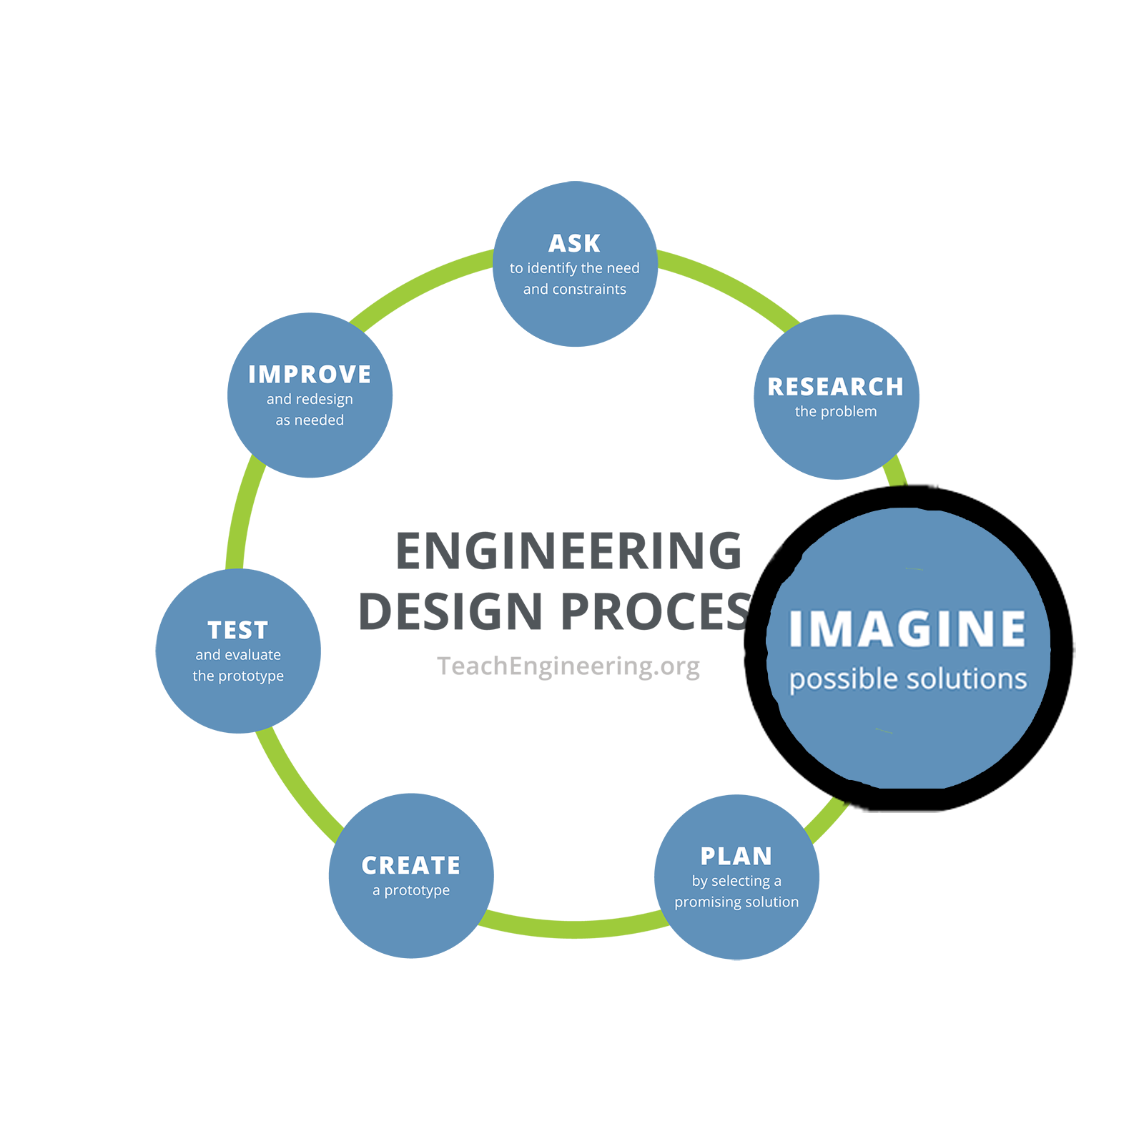
Engineering Design Process, Step 3: Imagine
This is the time to encourage wild ideas and defer judgment! Build on the ideas of others! Stay focused on topic, and have one conversation at a time! Remember: Good design is all about teamwork.

Your group will design a noise-isolating environment for recording tap sounds. Brainstorm what materials you could use and how you could build this environment. Write ideas below.

Materials to Use | Design Ideas

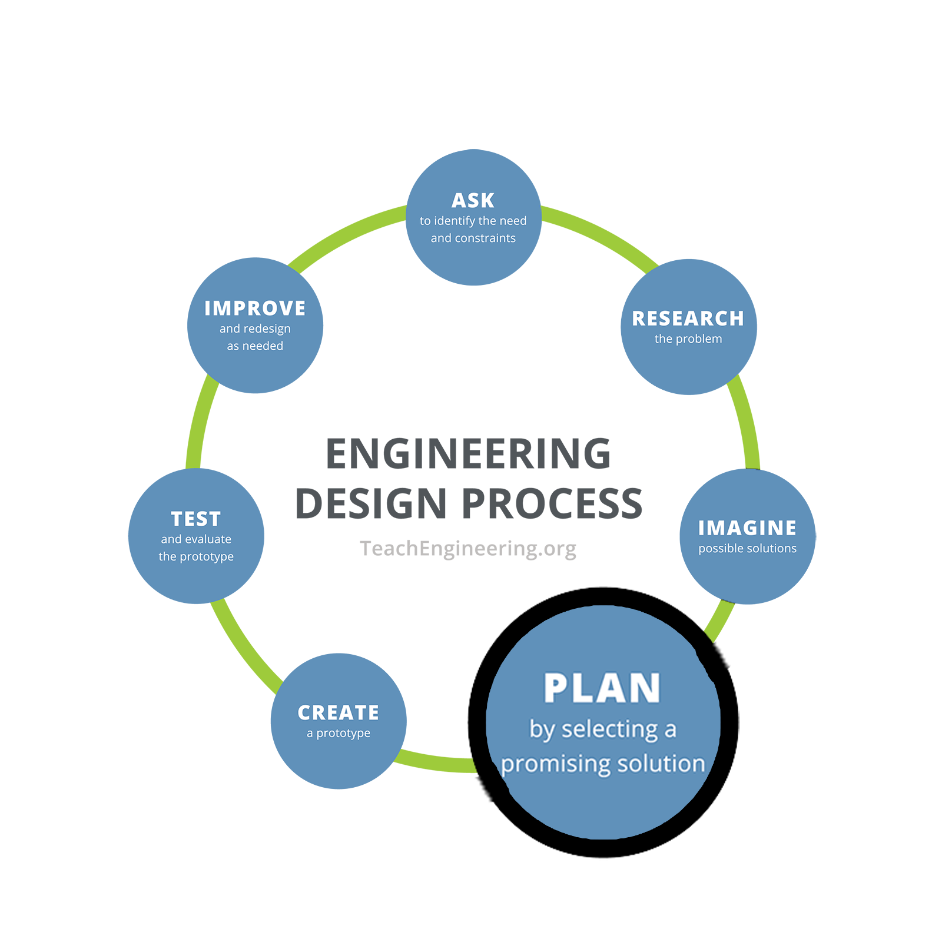
Engineering Design Process, Step 4: Plan
Revisit the needs, constraints, and research from the earlier steps, compare your best ideas, select one solution, and make a plan to move forward with it.

Decide on a plan for your noise-isolating environment. Sketch your design and list the steps needed to build it.

Sketch | Steps to Build

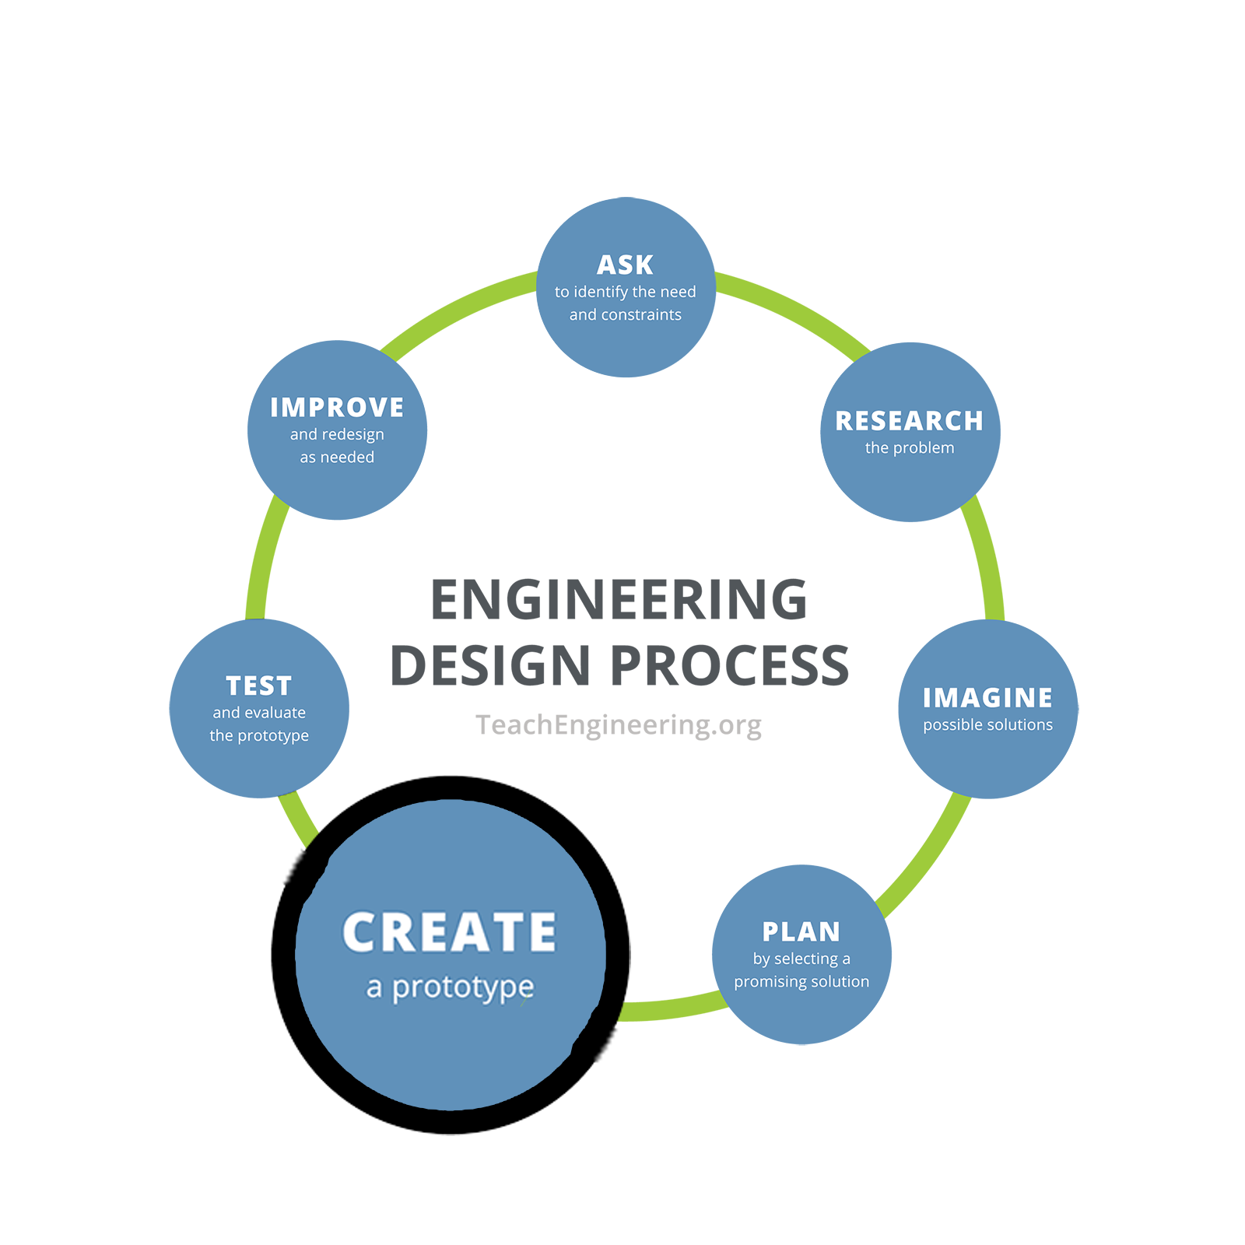
Engineering Design Process, Step 5: Create
Building a prototype makes your ideas real! These early versions of the design solution help your team verify whether the design meets the original challenge objectives. Push yourself for creativity, imagination, and excellence in design.

Work with your group to build your noise-isolating environment using the materials provided. Write notes about the construction process in the space below.

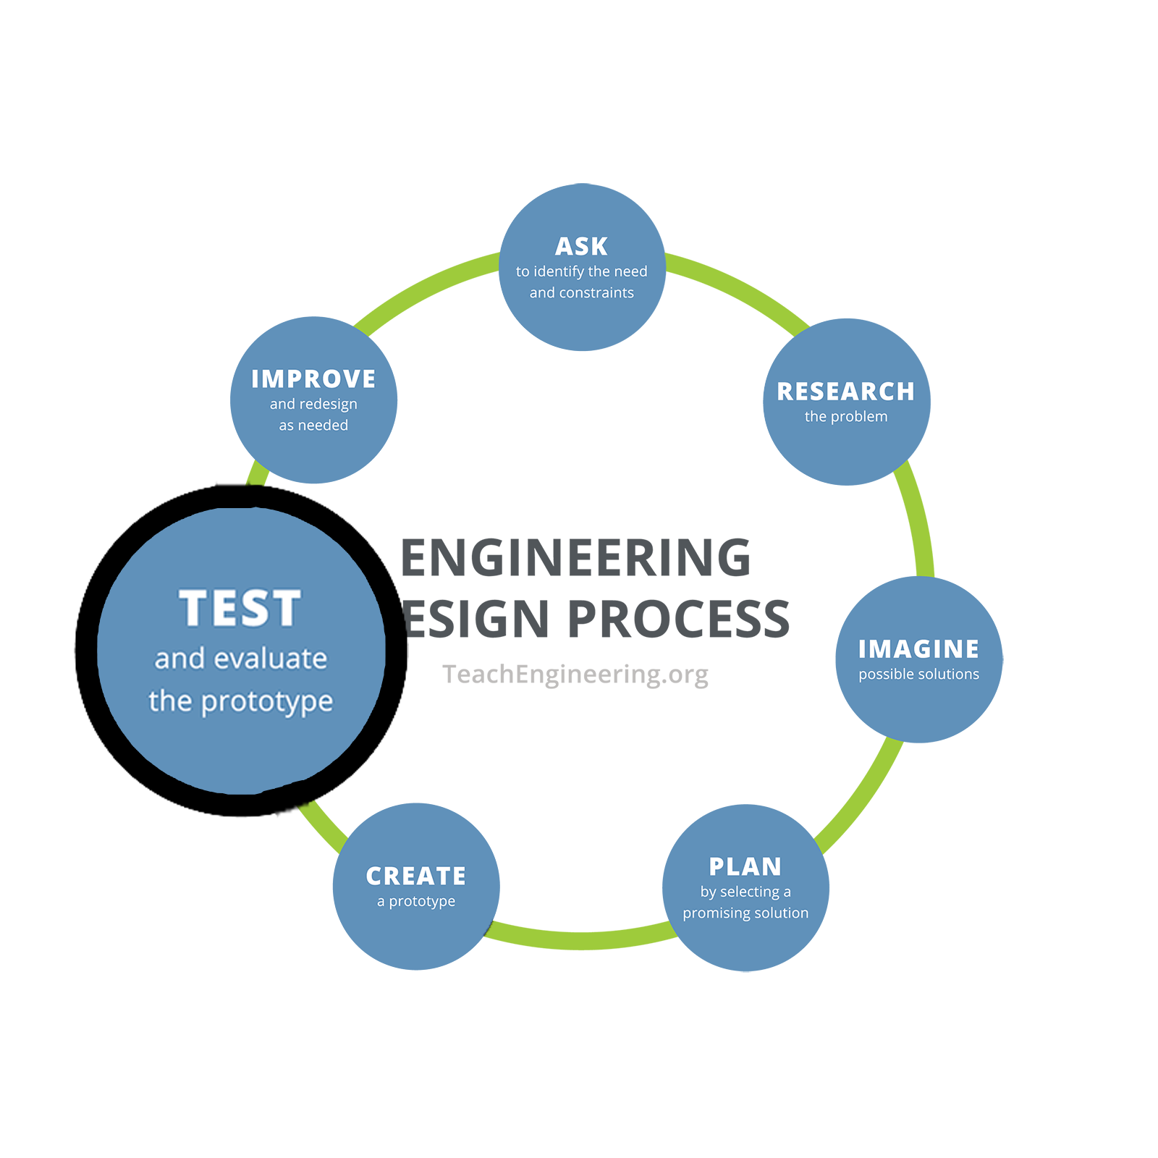
Engineering Design Process, Step 6: Test and Evaluate
Does it work? Does it solve the need? Communicate the results and get feedback. Analyze and talk about what works, what doesn't, and what could be improved.

Use your noise-isolating environment to record tap sounds. Listen to the recordings and answer these questions.
Did your device help you reduce background noise? What worked well? What could be improved?

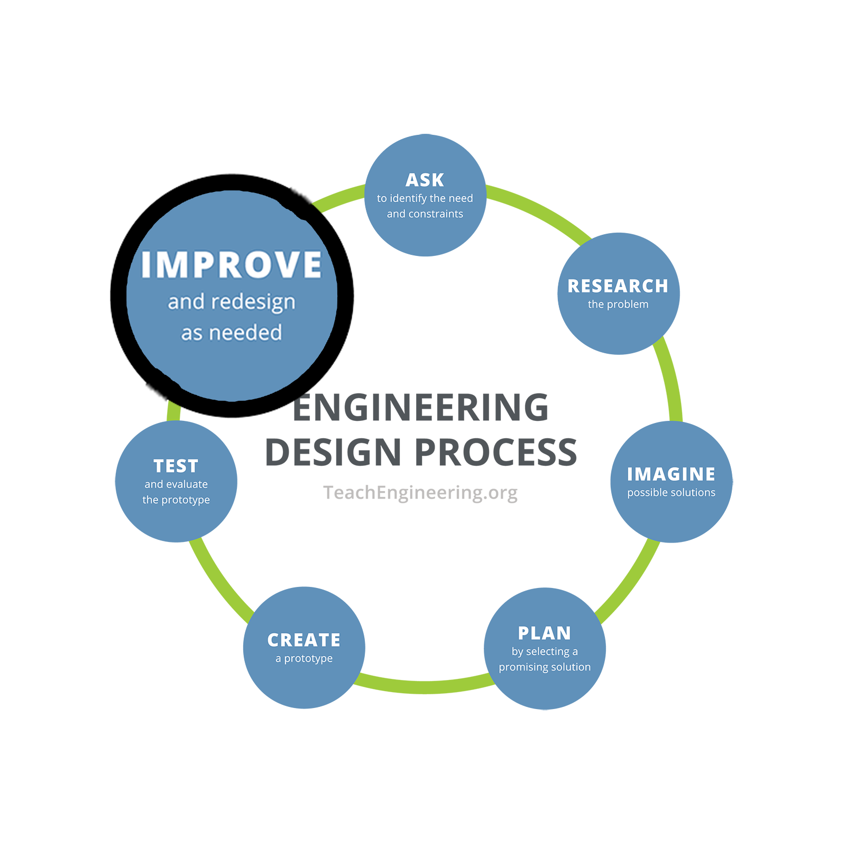
Engineering Design Process, Step 7: Improve
Discuss how you could improve your solution. Make revisions. Draw new designs. Iterate your design to make your product the best it can be.

Discuss how you could improve your noise-isolating environment. Make revisions and test again.
Observations and Improvements

