Day 1 Worksheet

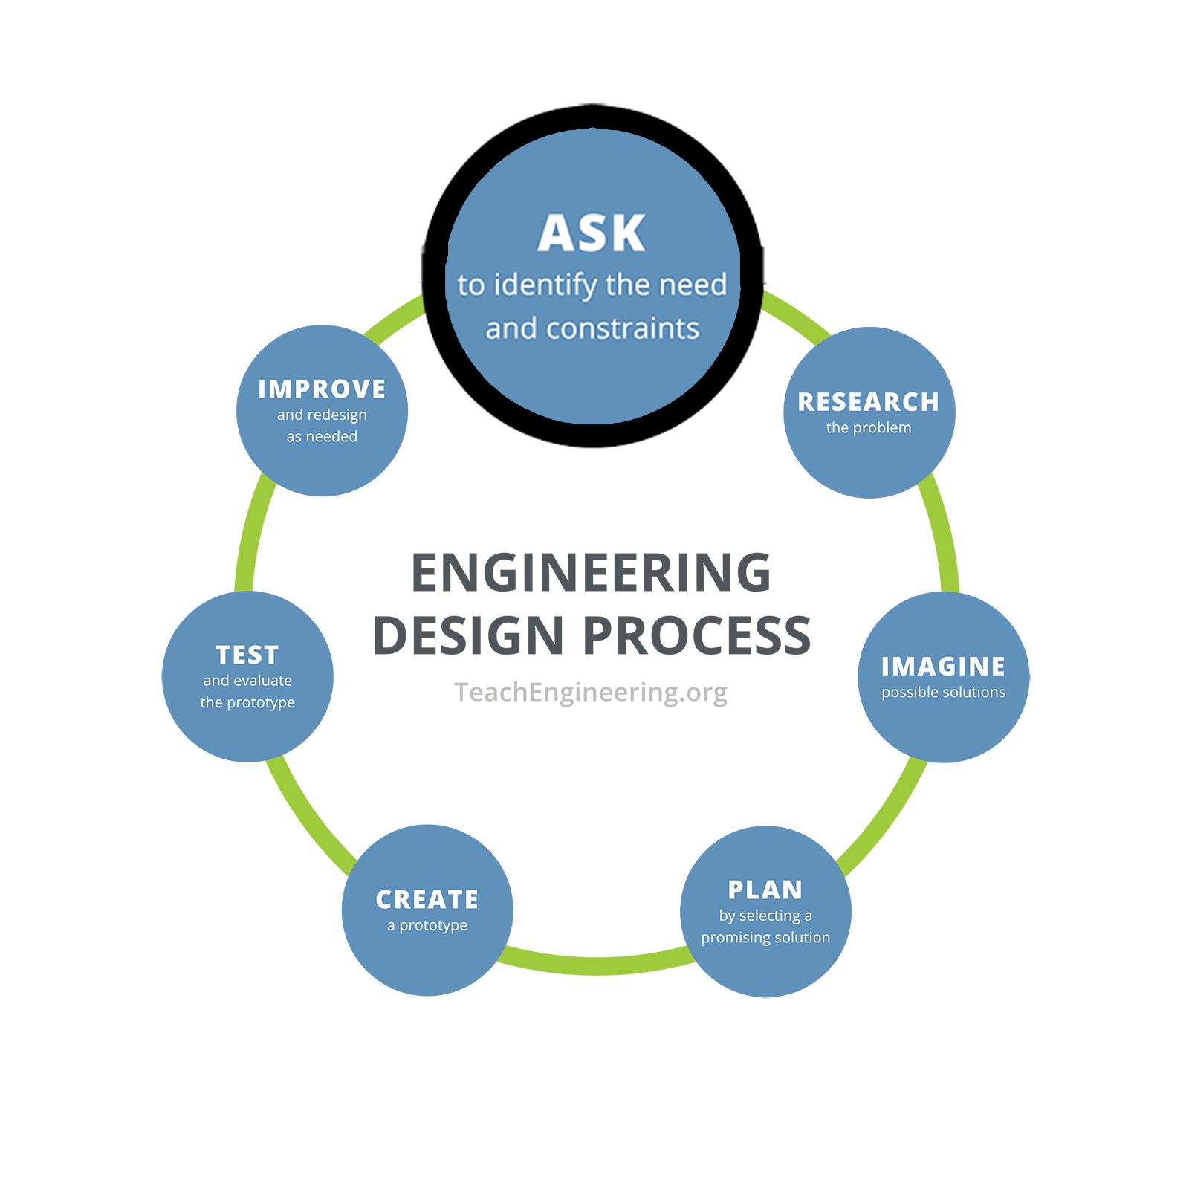
Engineering Design Process, Step 1: Ask
What is the problem to solve? What do we want to design? Who is it for? What do we want to accomplish? What are the project requirements? What are the limitations? What is our goal?

On your own, jot down a quick answer to the following question.

Why is it important to detect hidden flaws in materials?

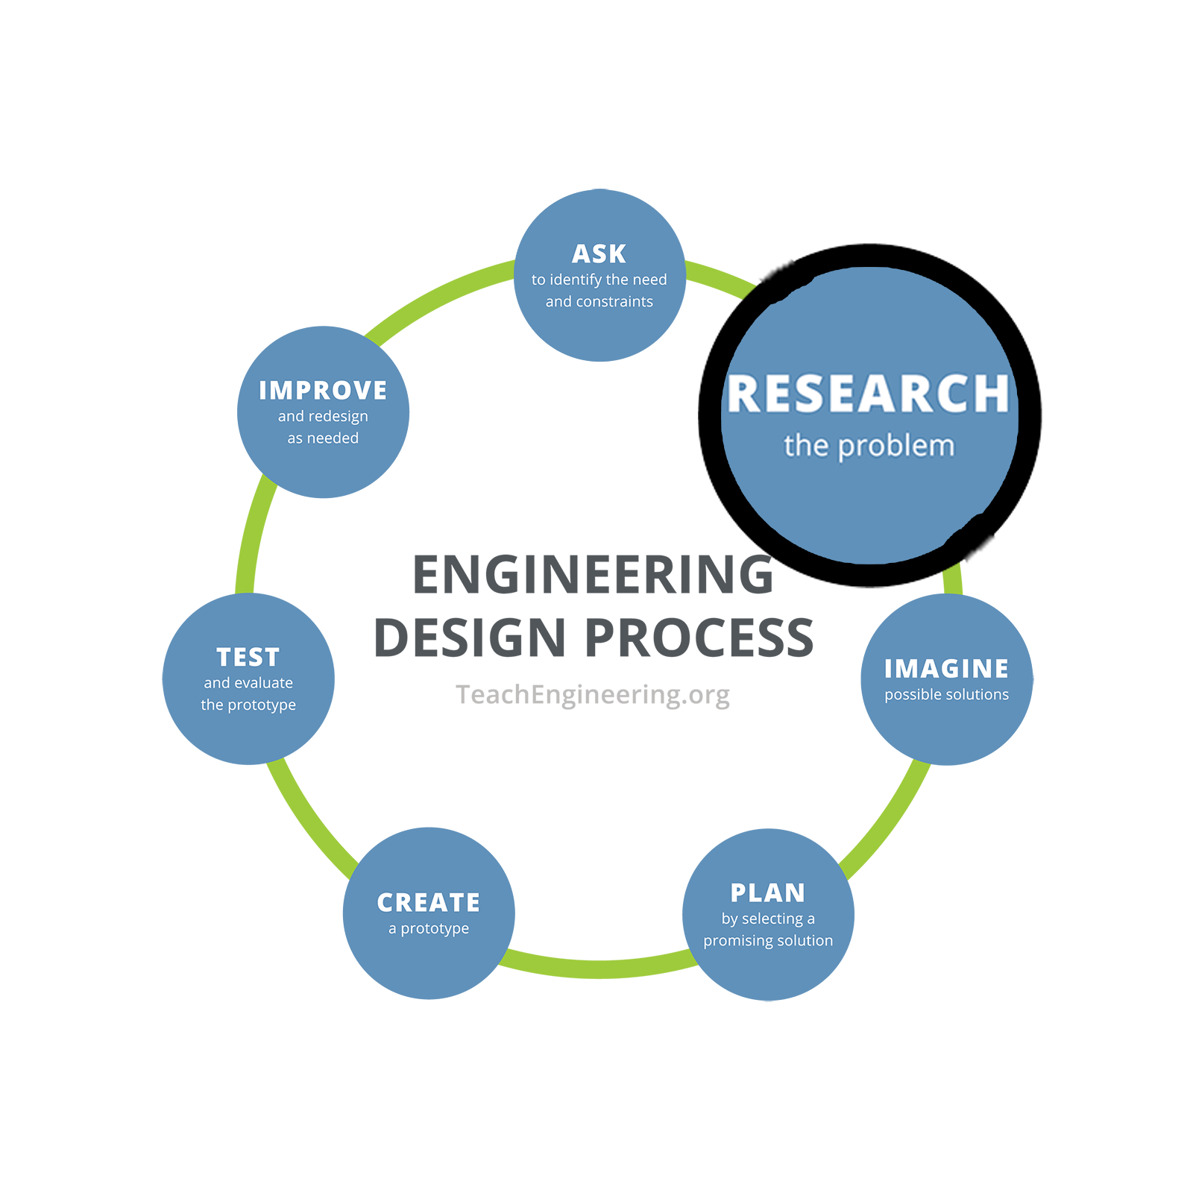
Share your answer with people around you and the group or class.

Engineering Design Process, Step 2: Research
What products or solutions already exist? What technologies might be adaptable to your needs?

Brainstorm a few answers to the following question, on your own or with a small group.

How do engineers use sound waves to detect flaws in materials?

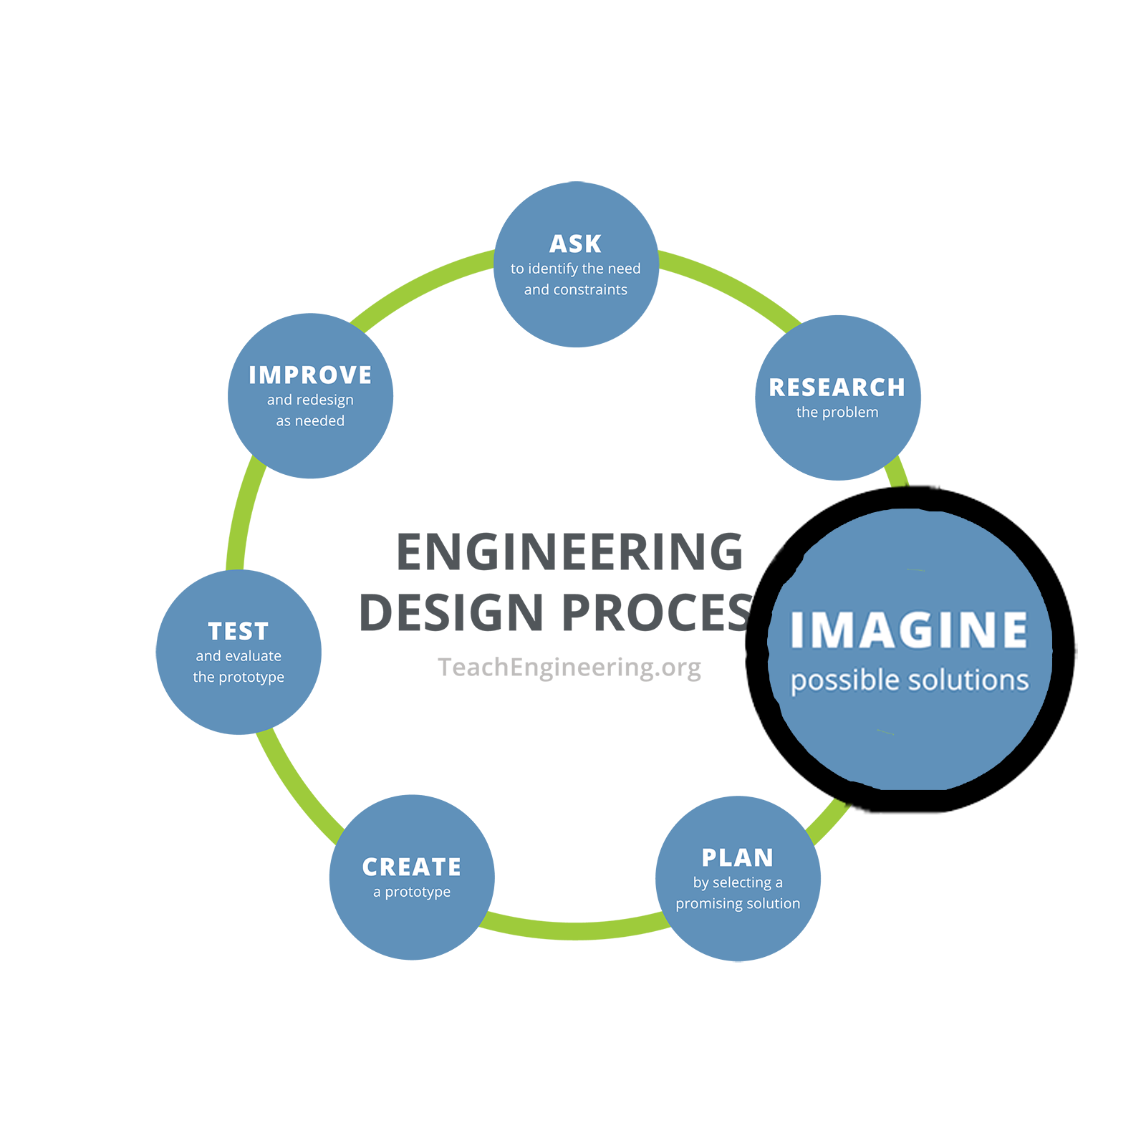
Engineering Design Process, Step 3: Imagine
This is the time to encourage wild ideas and defer judgment! Build on the ideas of others! Stay focused on topic, and have one conversation at a time! Remember: Good design is all about teamwork.

Your group is going to work together to design a vibration-isolating device to help detect hidden flaws in wooden blocks by tapping them and analyzing the sounds. With your group, brainstorm what materials you could use and how you could build this device. Write lots of ideas in the boxes below.

Materials to Use | Design Ideas
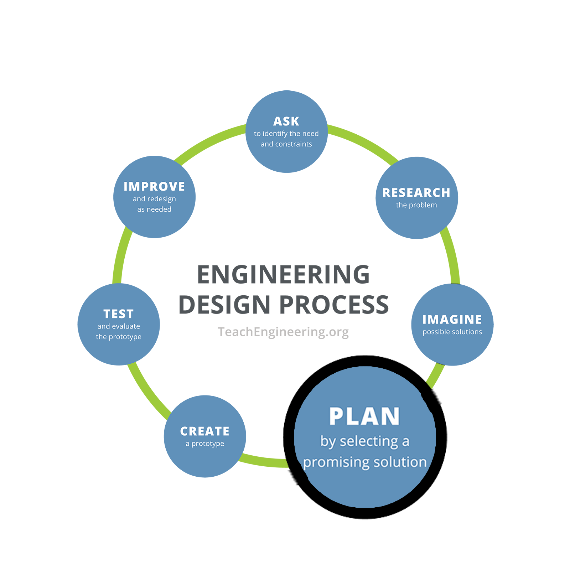
Engineering Design Process, Step 4: Plan
Revisit the needs, constraints, and research from the earlier steps, compare your best ideas, select one solution, and make a plan to move forward with it.

Decide on a plan for your vibration-isolating device. Sketch your design and list the steps needed to build it.
Sketch | Steps to Build

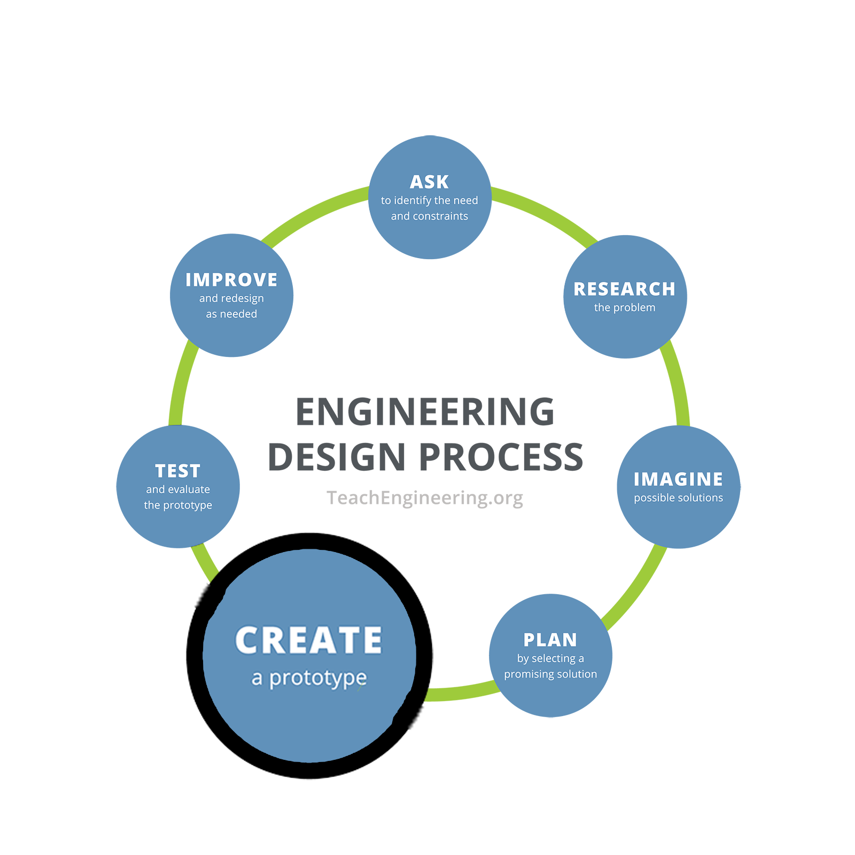
Engineering Design Process, Step 5: Create
Building a prototype makes your ideas real! These early versions of the design solution help your team verify whether the design meets the original challenge objectives. Push yourself for creativity, imagination, and excellence in design.

Work with your group to build your vibration-isolating device using the materials provided. Write notes about the construction process in the space below.

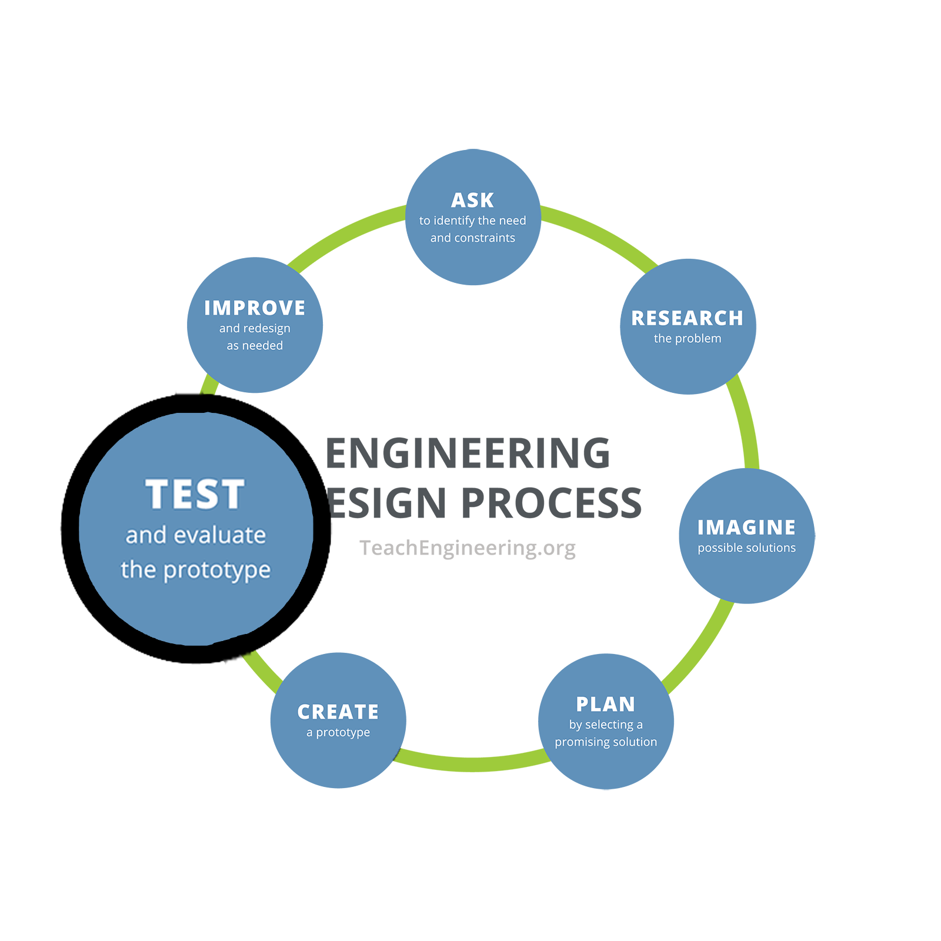
Engineering Design Process, Step 6: Test and Evaluate
Does it work? Does it solve the need? Communicate the results and get feedback. Analyze and talk about what works, what doesn't, and what could be improved.

Use your vibration-isolating device to tap the known blocks (no holes, center hole, and corner holes) and listen to the sounds produced. Record your observations.
Block Type | Sound Description
No Holes
Center Hole
4 Corner Holes
Did your device help you hear differences in the sounds? What worked well? What could be improved?

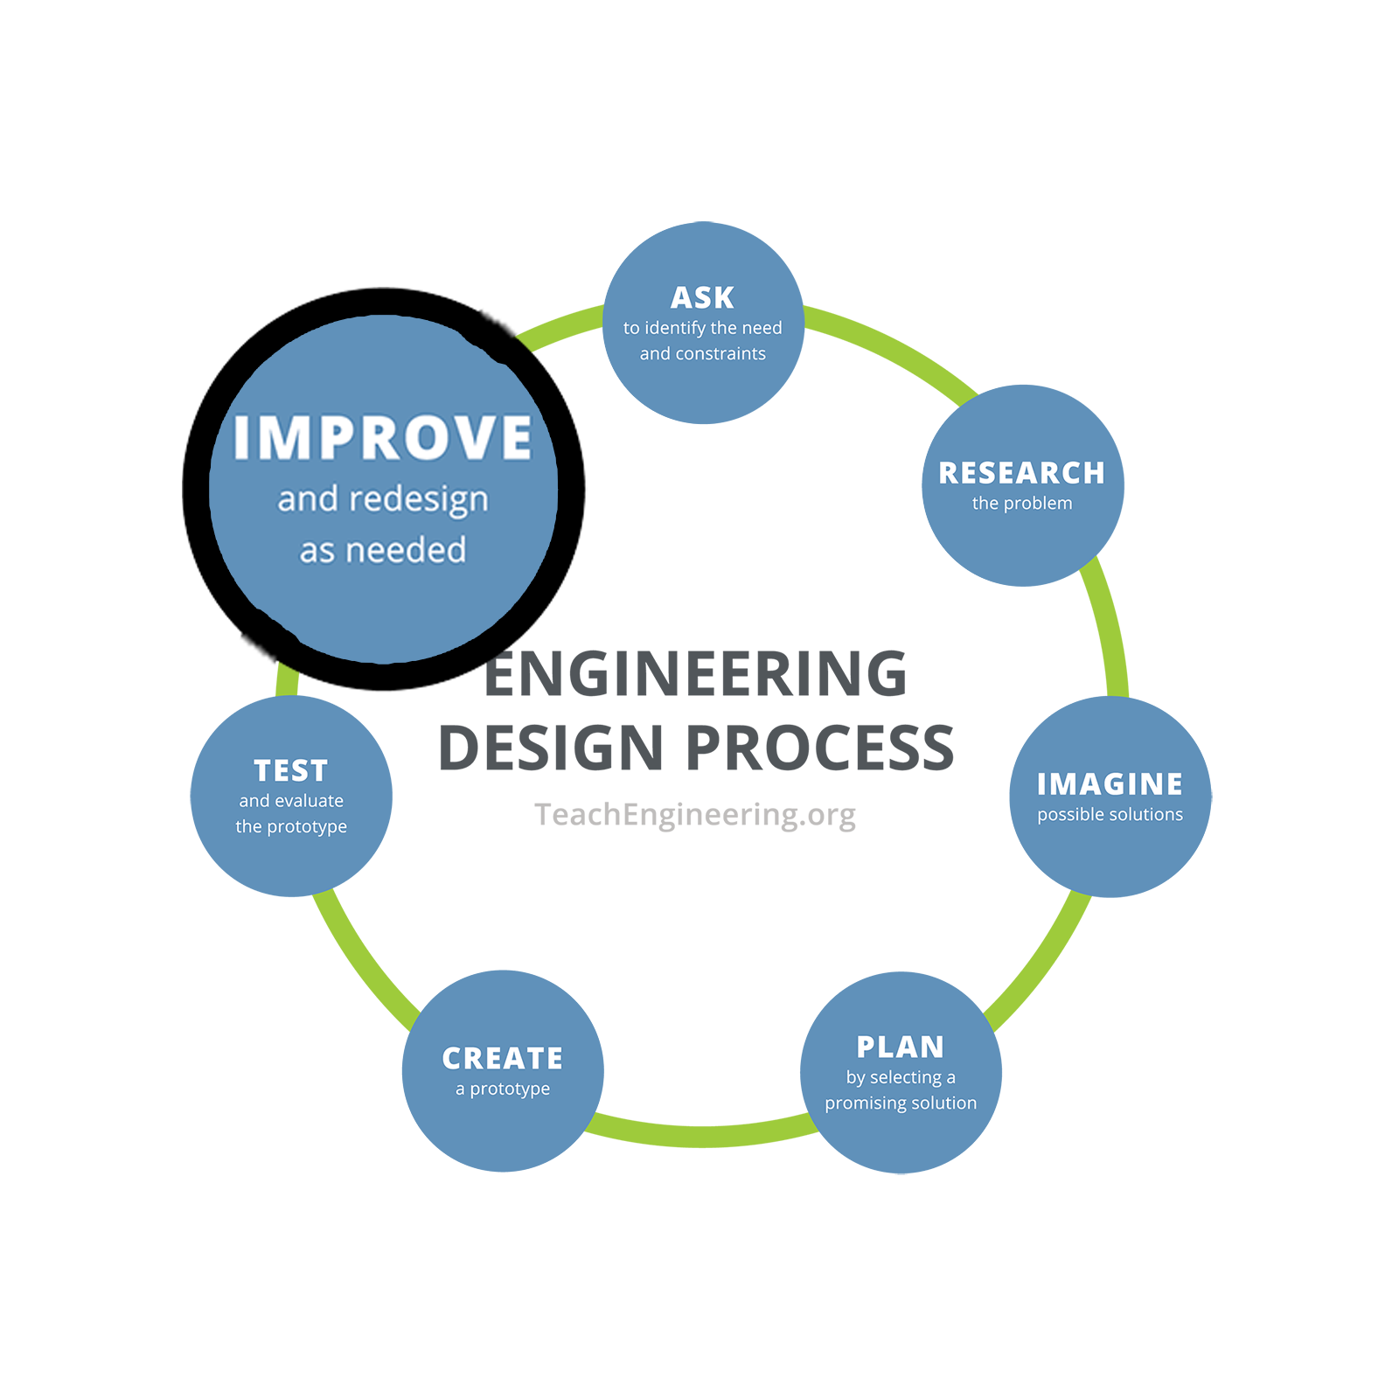
Engineering Design Process, Step 7: Improve
Discuss how you could improve your solution. Make revisions. Draw new designs. Iterate your design to make your product the best it can be.

Discuss how you could improve your vibration-isolating device. Make revisions and test again.
Improvements
Retest your device with the known blocks.
Block Type | Sound Description
No Holes
Center Hole
4 Corner Holes

Experimental Block Testing
Insert the experimental blocks into your vibration-isolating device and compare the sounds to the reference blocks. Use the sounds to fill out the table of guessed labels for the experimental blocks (next page). Use the following guide to help you draw pictures of what you think the block’s underside looks like.
No Hole | Center Hole | 1-4 Corner Holes in different locations
 | 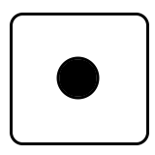 | 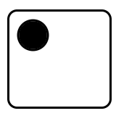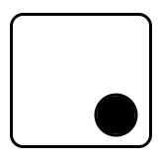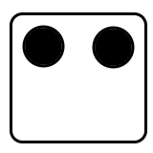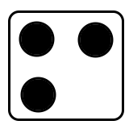

Your guesses
Fill in the following table by drawing a block shape next to each sample you are to evaluate, which has an unknown number and location of holes on the bottom side. Label the sample identifier next to each sample.

Sample Identifier (e.g., “A01”) | What you think the bottom looks like

