Creating Functions in Python With Copilot Worksheet

Introduction
Instructions
Before beginning this worksheet, ensure that you have downloaded all necessary materials and have read the Getting Started with Visual Studio Code and Copilot document.

Introduction
Human programmers often struggle with complexity. To manage this, we break down large problems into smaller, more solvable parts using functions. Functions are essential in software design, performing single tasks and making code easier to read, test, and debug.

In this worksheet, you will learn how to create functions in Python using Copilot and understand what makes a reasonable task for Copilot to handle.

Components of a Function
Every function in Python has:
- Function Header (Signature): This includes the def keyword, the function name, and its inputs.
- Function Body: The code that defines what the function does.
- Return Statement: The value that the function gives back.

Example
Here’s a basic function that finds the smaller of two numbers:
# This function takes two numbers and returns the smaller one
def smaller(a, b):

if a < b:
return a
else:
return b

Exercise 1: Understanding Function Headers
Instructions: Read the following function headers and answer the following questions:

def add(a, b):
return a + b

- What is the name of the function?

- What are the inputs to the function?

- What does the function return?

def greet(name):
return "Hello, " + name

- What is the name of the function?

- What is the input to the function?

- What does the function return?

Exercise 2: Writing Function Headers
Instructions: Write the function headers for the following tasks:

- A function named multiply that takes two inputs, x and y.

- A function named is_even that takes one input, num.

- A function named max_of_three that takes three inputs, a, b, and c.

Using Copilot To Write Functions
Copilot can help you write functions. Use comments (#’s) to guide Copilot on what you want the function to do. Follow the example below.

Example function: Write a function named multiply that takes two inputs, x and y, and returns their product.

Example answer using Copilot:
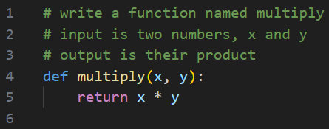

Lines 1-3 are comments you write. Lines 4 and 5 are the code generated by Copilot.
Using Copilot To Call Functions
Once we have a function, how do we use it? To use a function, we need to call it. Calling a function means invoking it with specific parameter values, known as arguments. Each value in Python has a type, and we must ensure that we provide values of the correct type. For instance, our function expects two numbers; if we provide non-numeric values, it may not work as expected. When we call a function, it executes its code and returns a result. To use this result later, we need to capture it in a variable, which is simply a name that refers to a value.

Calling the multiply function using Copilot:
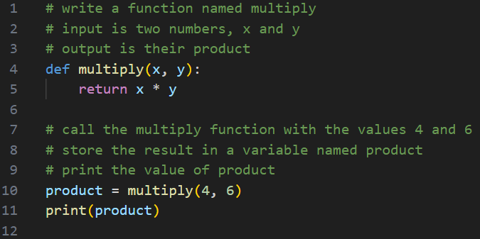

Lines 7-9 are comments you write. Line 10 is the call to the multiply function. Line 11 prints the result of the call to multiply. If you run the program, you will see 24 as the output.

Exercise 3: Using Copilot to Create Functions
Instructions: Write comments to guide Copilot in creating the following functions:
- A function named is_even that takes one input, num, and returns True if the number is even and False if it is not. Paste a screenshot of your code below.

- A function named max_of_three that takes three inputs, a, b, and c, and returns the largest of the three. Paste a screenshot of your code below.

Exercise 4: Using Copilot to Call Functions
Instructions: Answer the following:

- Call the is_even function with the following arguments:

Call to the is_even function | What is the output?
is_even(3)
is_even(6)
is_even(0)
is_even(“hi”)

- Call the max_of_three function with the following arguments:

Call to the is_even function | What is the output?
max_of_three(3, 5, 7)
max_of_three(7, 8, 5)
max_of_three(110, 205, 156)
max_of_three(3,6)

Exercise 5: Reasonable Tasks for Copilot
Instructions: Discuss with your classmates and answer the following questions:
- Why is it important to break down large problems into smaller tasks?

- What might happen if you give Copilot a task that is too complex?

- How can you decide what is a reasonable task for Copilot to handle?

Reflection
Think about a time when you had a big project or problem to solve. How did you break it down into smaller tasks? How did that help you? Write a short paragraph explaining your experience and how it relates to what you learned today.

