What’s In Our Stars? Lab Handout Answer Key
Before the lab:
WARM-UP QUESTIONS:
- How do you know what something is made of? (What would you DO to figure out what an object is made of?)

Answers will vary.
Examples could include:
Chemical properties tests: flammability, pH, etc.
Physical properties tests: melting point, freezing point, solubility, density, malleability,
electrical conductivity.

- How would your answer change if it’s something you can’t see or touch directly? (e.g., air, an atom, or the sun)
Answers will vary – any realistic options of how to gather direct or more likely indirect evidence are acceptable.

- What tools or equipment would you need to determine the makeup of an object that is too small or too far away to observe directly?
Answers will vary – any realistic options of how to gather direct or more likely indirect evidence are acceptable.

- Why do we care about the composition of something? Why does it matter?
Answers will vary.
Examples may fall within the following categories, though these are not all inclusive:
Health and safety, medicine, industry research and development, forensics, environmental conservation, restoration/preservation of art, homes, cultural artifacts, fossils etc., quality control, scientific discovery and exploration, invention, engineering, etc.

BACKGROUND INFORMATION
As we hunt for Earth 2.0, a key aspect that needs to be considered is what star our new planet is going to be orbiting. There are trillions (or more!) of stars just in our Milky Way Galaxy. So, how do we as scientists begin to determine what makes a star ideal for sustaining life? The first step is to discover how stars differ from one another. As you look into the night sky, you can see that they differ in size and brightness. But stars also differ in elemental composition (i.e., what elements are in them). The way scientists determine what elements are in materials that are too far (or deadly) to bring into an actual lab is through spectroscopy. Spectroscopy studies the pattern of wavelengths of light that an atom absorbs or emits when energized. Each element has a unique “fingerprint” of wavelengths that they will absorb/emit. This information is incredibly valuable, because different materials interact with light in different ways. By analyzing the patterns of wavelengths that interact with an object, scientists can identify the material, study its properties, and even detect substances that are otherwise invisible to the naked eye.
However, to determine those wavelengths, we need specific tools—this is where engineers come in. Scientists can’t detect those patterns of wavelengths just by looking at an object with the naked eye; they need a tool that can recognize each wavelength and determine the intensity (i.e., the amount of energy) of each wavelength. Engineers make this possible by designing and building devices called spectrometers. There are many different types of spectrometers, varying in price, sensitivity, and method of detection, but the end goal is the same: to empower scientists to make new discoveries and form a deeper understanding of the world (and universe) around us.
In this lab, you will take on the role of an engineer and build a spectrometer! As a scientist, you will use the spectrometer to determine a unique spectral diagram for various lab materials, and then use those diagrams to identify an unknown substance. Last, you’ll apply the same concept and process to determine the composition of various stars in our galaxy!
COMPLETE THE TASKS/ANSWER THE QUESTION LISTED BELOW.
- Highlight or underline the definition of spectroscopy.

- Highlight or underline what a spectrometer does.
- What is one primary goal of engineering?
Create and design tools for scientific discovery.

During the lab:
PROCEDURE OUTLINE: Follow the steps outlined below. Use the video and slides provided/shown by your teacher to guide you through the specific step-by-step process. If you have any questions, ask your classmates and teacher for help.
PART 1:
- Download and install the Arduino software using the link in Google Classroom.
- Once installed, open Arduino IDE and add the SparkFun Library.
- Download the code for the activity (“Whats_In_Our_Stars_Arduino_Code”) from Google Classroom and open in Arduino IDE.
- Open the file “Whats_In_Our_Stars_Data_Dashboard” in Microsoft Excel found in Google Classroom.
  - Install Microsoft Excel prior to this step if needed.
- Download and install the Microsoft Data Streamer add-in using the link found in Google classroom.
PART 2:
- Connect the Qwiic cable to the spectrometer sensor.
- Connect the jumper cables to the Arduino Uno, making sure they are in the correct spot; see the diagram on Slides 12-13 of the “Whats_In_Our_Stars_Student_Procedures_Presentation.”
- Connect the Arduino Uno to your device using the USB cable.
- Grab your samples for testing; you should have three known and one unknown sample cups.
- Remove the plastic top and place the square paper cover onto the top of your first known sample cup.
- Place the spectrometer face down in the center of the cover over the first sample cup.
PART 3:
- Upload the code (opened in Arduino IDE) to the Arduino Uno.
- Go to the Data Streamer tool bar in Excel and connect the device.
- Check that the settings in the Excel data dashboard are correct; if not, see the troubleshooting notes on Slides 22-24 in “Whats_In_Our_Stars_Student_Procedures_Presentation.”
- Select the name of your first known sample from the dropdown menu on the dashboard.
- Begin data streaming.
- After approximately 10 seconds, stop data streaming.
- Save the file to your documents folder using one of the methods shown in the slides.
- Record your data by drawing a black line using a marker or pen on the spectra diagrams below at the wavelengths where a “peak” appears on the line graph.
- Reset your dashboard and your Arduino Uno.
- Repeat Steps 4–9 for your two remaining known samples and one unknown sample.
PART 4:
- Disconnect and disassemble the spectrometer.
- Return your samples, making sure the tops are securely on each of the cups.
- Close Arduino IDE and the Excel dashboard.
- Complete the remaining portions of the handout below.
DATA: Write the name of the sample and then record your data by drawing a black line using a marker or pen on the spectra diagrams below at the wavelengths where “peaks” appears on the line graph. See procedure slides for an example.

- KNOWN SAMPLE ___________________________________________________
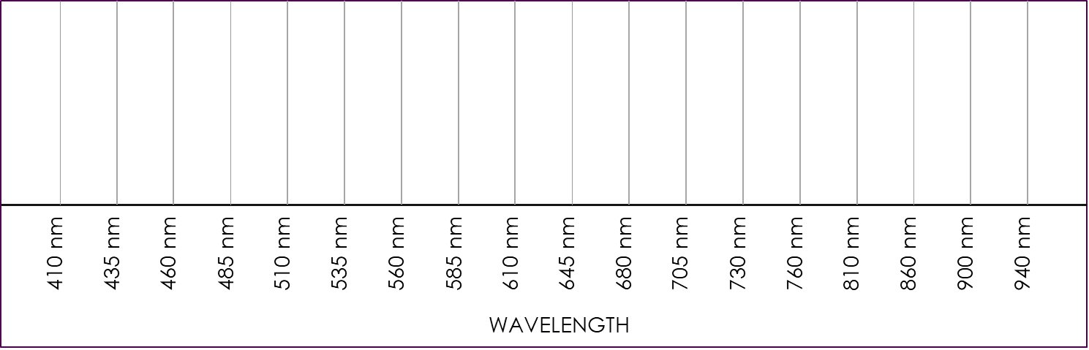
- KNOWN SAMPLE ___________________________________________________
- KNOWN SAMPLE ___________________________________________________
- UNKNOWN SAMPLE

After the lab:
ANALYSIS: Answer the questions below.
- Using the spectra diagrams you created, identify the substance in the unknown sample.
Unknown will be the same as one of the known samples.

- What are two specific limitations (challenges) of the spectrometer you built/used?
- Answers will vary. Examples could include:
  - Small size
  - Low sensitivity
  - Must be connected to a microprocessor (Arduino)
  - Only detects certain wavelengths

- Refer to the limitations you listed above. What do you think an engineer might have to change in order to allow for determining the composition of a star? (list at least two)
- Answers will vary. Examples could include:
  - Increase area/size of sensor
  - Increase sensitivity to low light
  - Integrate with a computer wirelessly
  - Broaden the number of wavelengths detected
  - Enable communication with a telescope

- Analyze the spectra data of our sun and various elements below. What elements are found in our sun?
hydrogen, oxygen, sodium

