Testing Soft Materials Worksheet Answer Key

Instructions: You are an engineer tasked with selecting a material that can best withstand tension (stretching forces) without breaking. You will be given two different materials, and your goal is to determine how much force each material can handle while staying within its elastic limit.

Research
Research soft material properties such as elasticity, tensile strength, and how engineers use stress and strain tests to evaluate soft materials. Write down your notes below.

Potential notes may include:
Elasticity:
- Definition: Elasticity is the ability of a material to return to its original shape after being deformed by an external force. This property is crucial for materials that need to absorb shocks or adapt to changing shapes without permanent damage.
- Importance: High elasticity allows materials to withstand repeated loading and unloading cycles, making them ideal for applications like flexible sensors and cushioning materials.
Tensile Strength:
- Definition: Tensile strength is the maximum amount of tensile (pulling) stress that a material can withstand before failure. It is a critical measure of a material's durability and structural integrity.
- Importance: Materials with high tensile strength can support heavier loads and resist deformation, making them suitable for applications where strength is paramount, such as in structural components and medical devices.
Stress and Strain Tests:
- Stress Tests: Engineers use stress tests to measure how materials respond to applied forces. During these tests, materials are subjected to increasing loads, and their responses are recorded in terms of stress (force per unit area) and strain (deformation per unit length).
- Strain Tests: Strain tests measure how much a material deforms (stretches or compresses) when subjected to stress, providing valuable insights into its mechanical behavior.
- Applications: The results from these tests help engineers evaluate the performance of soft materials under real-world conditions, guiding the design and selection of materials for specific applications, such as in the development of medical implants or soft robotics.

Stress Test
Instructions: You are now going to set up a testing apparatus to conduct stress tests on two materials: polyurethane and clear elastic rubber.
Materials:
- 1 rectangular strip of polyurethane (10 cm x 1 cm x 2 mm)
- 1 rectangular strip of clear elastic rubber (10 cm x 1 cm x 0.5 mm)
- 1 set of weights
- 1 ruler or measuring tape
- 1 lab stand
- 1 clamp (to securely attach the material strip to the lab stand)
- 1 S hook or carabiner (to hang the weights from)
- 1 laptop with access to Excel (or Google Sheets)
- 1 utility knife

Procedure:
- Collect your group’s materials.
- Set up your testing apparatus by doing the following:
  - Secure one end of the polyurethane or clear elastic rubber strip to the lab stand using a clamp or secure knot.
  - Cut a small hole/slit 9 cm from the stop of the strip.
  - Add the hook or carabiner to the bottom of the material strip through the small hole.
- Make sure the testing apparatus is stable using the smallest weight. Do the following:
  - Add the smallest weight to the hook or carabiner.
  - Ensure the material does not swing or move excessively.
  - Ensure the weights hang vertically from the rubber strip.
- Test your first material:
  - With no weights attached, measure the exact length of the material strip. (Note: It should be 10 cm.) Record this in the table below.
  - Start with the smallest weight (e.g., 50 g) and add it to the hook or carabiner.
  - After attaching the first weight, allow the material to stabilize, and then measure the length of the material. Record this value in the table below.
  - Add the next weight, allow the material to stabilize, and then measure the length of the materials.
  - Continue until the material breaks or deforms.
- Test your second material:
  - Follow Steps 4a through 4e.

Table 1: Polyurethane: Results for polyurethane, area = 10 mm * 2 mm = 0.2 cm^2

Weight (g) | Force = 9.8*weight /1000 | Length (mm) | Stress = force/ cross-section area | Stretch ratio = length / original length
0 | 0 | 10 | 0 | 1
200 | 1.96 | 10.2 | 9.8 | 1.02
400 | 3.92 | 10.4 | 19.6 | 1.04
600 | 5.88 | 10.6 | 29.4 | 1.06
800 | 7.84 | 11 | 39.2 | 1.1
1000 | 9.8 | 11.5 | 49 | 1.15

Table 2: Clear elastic rubber: Results for clear elastic rubber, area = 1 mm * 0.5 mm = 0.005 cm^2

Weight (g) | Force = 9.8*weight /1000 | Length (mm) | Stress = force / cross-section area | Stretch ratio = length / original length
0 | 0 | 10 | 0 | 1
50 | 0.49 | 10.5 | 98 | 1.05
100 | 0.98 | 11 | 196 | 1.1
150 | 1.47 | 11.5 | 294 | 1.15
250 | 2.45 | 12 | 490 | 1.2
300 | 2.94 | 12.5 | 588 | 1.25

- Use an Excel spreadsheet to complete the tables above.
- Using Excel, plot the stress vs. stretch for each material.
- Calculate the slope of each plot.

Plot for polyurethane, area = 10 mm * 2 mm = 0.2 cm^2
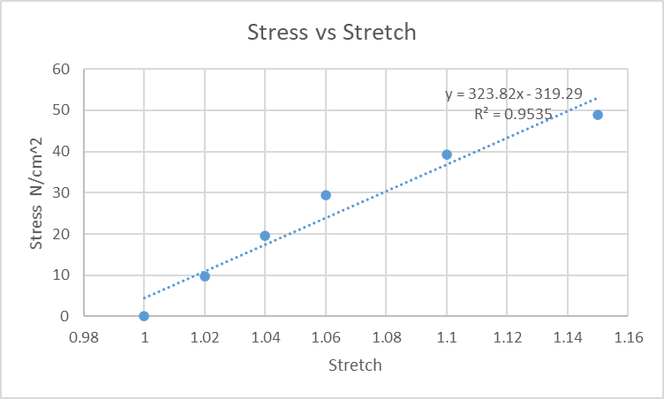

Plot for clear elastic rubber, area = 1 mm * 0.5 mm = 0.005 cm^2
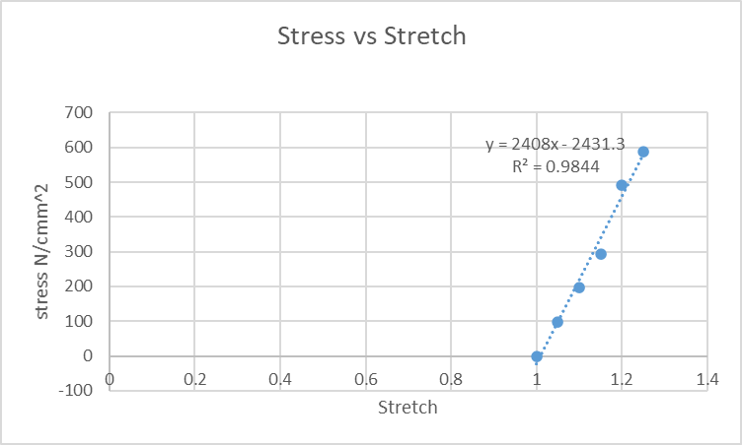

Analysis
      - What worked during the stress tests?
Answers will vary.

      - What didn’t work during the stress tests? Why?
Answers will vary.

      - Which material performed best under stress? Which data supports your answer?
Polyurethane generally exhibits a higher resistance to deformation and maintains lower stress values for larger applied forces compared to clear elastic rubber.

Clear elastic rubber may show more significant stretching and deformation at lower weights due to its smaller cross-sectional area, which can lead to a quicker failure point.

      - Why do you think this material performed better?
Potential answers:
Properties of Polyurethane
- Strength and Durability: Polyurethane is known for its high tensile strength and excellent durability, making it capable of withstanding significant forces before deformation or failure.
- Elasticity: It maintains its shape and returns to its original dimensions after stretching, which is advantageous for applications that require resilience.
- Versatility: Different formulations can enhance specific properties, such as flexibility or rigidity, depending on the intended use.
Properties of Clear Elastic Rubber
- High Elasticity: Clear elastic rubber is highly stretchable and can deform significantly under stress. It is designed to absorb impacts and return to its original shape.
- Lower Tensile Strength: While it can stretch well, it may not have the same tensile strength as polyurethane, meaning it can reach its elastic limit sooner under heavy loads

Improve
- What do you think you would want to improve in this stress test? Setup? Materials? Procedure?

Answers will vary.

- What was the most challenging part of this activity?

Answers will vary.

