Smelling Cancer Cells Worksheet
Cell division, also known as mitosis, and cellular respiration are closely linked. Cells going through division require more energy than cells that are in interphase. Dividing cells build, use, and move many materials to successfully split into two daughter cells. Cancer cells undergo rapid and abnormal cell division; therefore, cellular respiration must happen at an increased rate, and the metabolic activities (building, using materials) are different than in healthy cells. If any metabolic products of any type of cell are volatile (i.e., enter and spread to the air easily), it is possible that dividing cells have a smell.
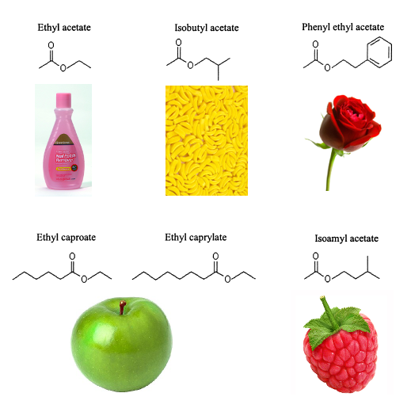
Odor, or smell, is due to molecules in the air that come into contact and stimulate specialized nerve cells that are part of olfactory (smelling) systems. Different odor molecules have different shapes. Each different shape stimulates nerve cells differently and causes a unique pattern of nerve signals to occur in the brain that are perceived as a particular smell. Many types of organisms have a sense of smell, including humans, dogs, fish, and insects—but the structures and level of distinction vary. Insects have a highly evolved sense of smell. Their antennae house olfactory receptors that respond to odors in specific patterns and with much more precision than humans. To the right are the molecules associated with various fruits.
Can insect brains, specifically locust antennae, be used to detect cancerous cells versus healthy cells? If so, could we design an artificial locust brain that would allow us to detect cancer based on someone’s breath? Researchers sought to answer this question with a setup like the one below. In this activity, an artificial locust brain will be constructed, and tests will be performed to determine whether it can differentiate between healthy and cancerous cells.
Locust Brain and Odor Setup Examples of Nerve Signal Patterns
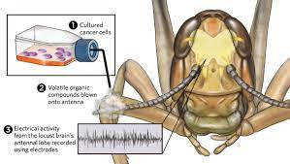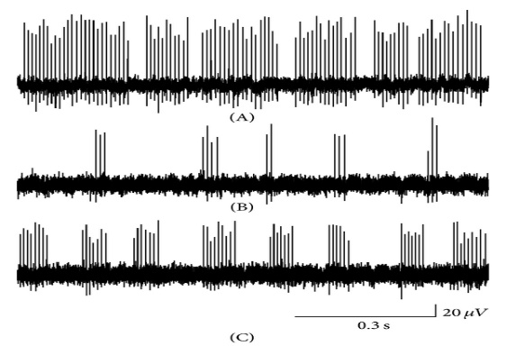
Pre-Lab Questions
- Below are images of a human brain and a fly brain. Write down similarities and differences below.
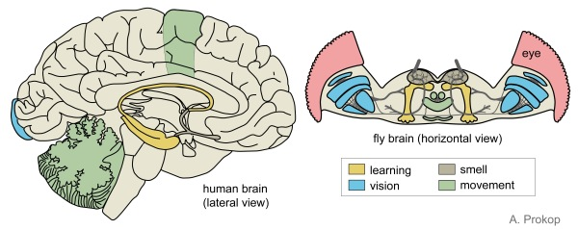

- Fill in the blanks in the cellular respiration equation.

___________ + ________________ ____________ + ______________
Reactants Products

- The table below shows names of molecules released during cell metabolism. Draw hypothetical shapes and nerve signal patterns for each one.

Metabolite Molecule Name | Hypothesized Shape | Hypothesized Nerve Signal Pattern
Acetone
Isoprene
Hexanol
Heptanol

Lab Procedure: Materials

Arduino
wires
sensor
breadboard
resistors
LED light module
control solution
healthy lung cells
healthy throat cells
cancerous lung cells
cancerous throat cells
distilled water

Lab Procedure: Building the Artificial Brain
- Use the schematics below to set up the artificial locust brain.

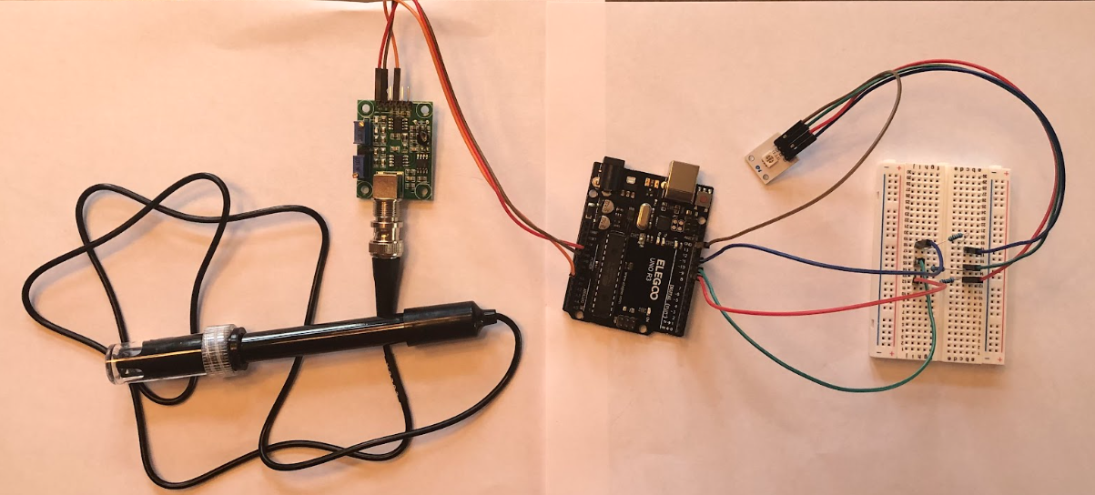
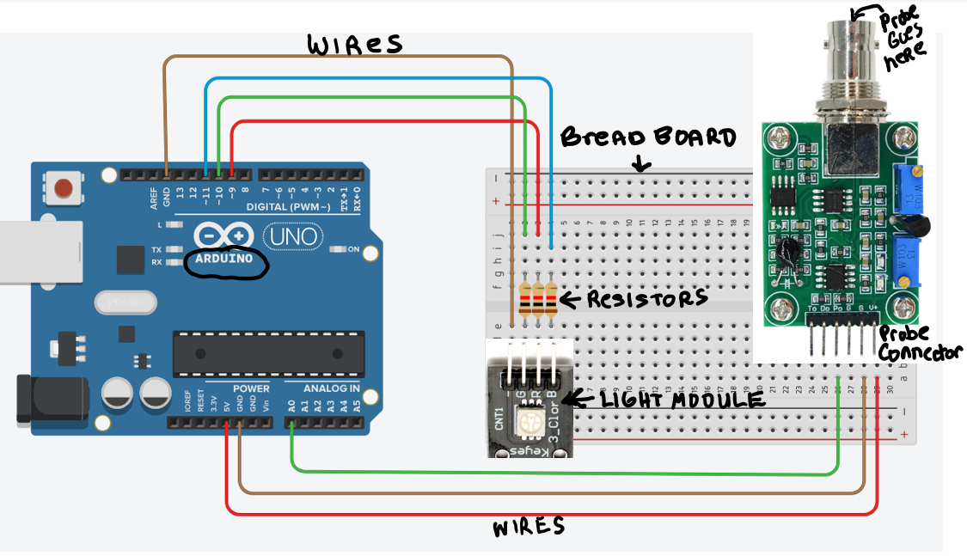
- Go to https://support.arduino.cc/hc/en-us/articles/360019833020-Download-and-install-Arduino-IDE and download the Arduino website software.
- Copy/paste code from Smelling Cancer Arduino Code Document (in Google Classroom) into the IDE-> Select Save. When the Arduino is connected to the computer, the code will automatically upload to it.
- Locate the part of the code that is bolded. This line is the algorithm that calibrates the sensor correctly.
- Attach the Arduino to the computer with the blue cord and upload the code.
- Calibrate sensor: submerge the sensor in the control solution, select _____, & wait until a stable number shows.
- Change/edit code in the bolded part by typing in the digit that needs to be added to the control solution measurement to make it total 7 (e.g., if the sensor measures 3, place a “+4” in the code).
Lab Procedure: Testing
- Clean the sensor by dipping it into the distilled water cup.
- Dip the sensor into the control solution. Use a ruler to determine the depth at which the sensor will give the correct reading, which should be the value you obtained in the calibration step. Record this information in Data Table 1 and in the Control Row of Data Table 2.
- Clean the sensor by dipping it into the distilled water cup.
- Test each solution once, record results, and be sure to clean the sensor with distilled water in between tests.
- Repeat with known sample.
- Go to the class lab table and select 2 unknown samples. Repeat the procedure with these.
Data Table 1: Sensor Calibration & Optimal Depth
Change in Code for Control Value | Minimum Sensor Depth (mm) | Maximum Sensor Depth (mm) | Optimal Depth Range

Data Table 2: Neural Response to Odors Released by Solutions
Solution Type | Trial 1 Results  # measurement  Lighting response | Trial 2 Results  # measurement  Lighting response | Other Comments
Control - No Cells, Neutral Solution
Healthy Lung Cells
Healthy Throat Cells
Cancerous Lung Cells
Cancerous Throat Cells 1
Unknown Sample 1
Unknown Sample 2

Analysis
Discuss with your lab partners: Does there seem to be a pattern of response for cancerous cells versus healthy cells? Write the main points of your discussion below.

Design two graphs to represent the data—one to represent the numerical data, and another to represent the lighting signal data.

Write a Claim, Evidence, Reasoning (CER) for the question above. Can the artificial locust brain detect cancerous cells versus healthy cells?

Are the unknown samples cancerous or healthy? Support your answer with explained evidence.

Wrap-Up Questions
What would be the advantages of testing for cancer with breath contents or urine over blood or tissue tests?

How do you think the probe works? Draw an idea below.

Explain why cancer cells and healthy cells create different odors. Include information about cell division, cellular respiration, metabolism, and molecular structure.

