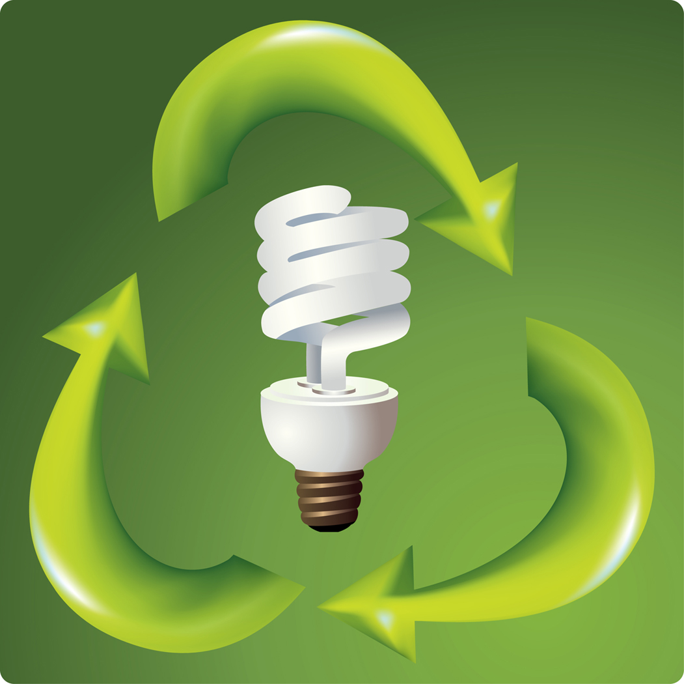
Energy Quiz
Please circle the best answer for each of the following questions about energy.
- True or False: Electricity and heat are both considered forms of energy.

- True or False: Energy conservation is the act of using less energy.

- True or False: People all over the world have electricity in their homes.

- True or False: A fossil fuel is a type of energy source that is made from plants and animals that were living millions of years ago.
TeachEngineering.org – Free STEM Curriculum for K-12

- True or False: Solar energy can be used to cook food, as well as create electricity and hot water.

- Which of the following can be used to create electricity? Circle all that apply.
a. coal d. natural gas
b. wind e. the sun
c. water f. uranium

- Which of the following are ways in which we use energy? Circle all that apply.
a. driving a car d. taking a shower
b. watching TV e. using the lights in our house
c. cooking on the stove f. listening to a portable music player

- Most of the electricity in Colorado comes from ____________.
a. coal c. natural gas
b. wind d. hydroelectric dams

- If fossil fuel energy creates a lot of carbon-dioxide — which can be dangerous to the environment — why don’t we use more renewable energy?
- Renewable energy is not available everywhere.
- Renewable energy is expensive.
- Engineers do not know how to make renewable energy work for all applications.
- Fossil fuel is better at making electricity than renewable energy.

- Categorize the following sources of energy as renewable (R), or non-renewable (N)
____ wind ____ solar
____ oil ____ natural gas
____ water ____ geothermal
____ nuclear ____ coal
____ biomass

