Student Worksheet Answer Key
Pre-Activity
Why do you think it feels colder stepping on the tiles of a bathroom floor than on a mat?
It feels colder because the tiles absorb heat from your body at a higher rate.

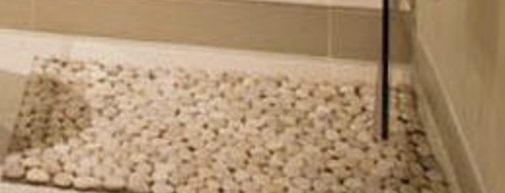

Activity
Specific Heat Capacity Experiment: Part 1
Materials science involves investigating the unique properties of substances, such as boiling point, freezing point, and elasticity. In this activity, you will act as materials engineers conducting research on heat transfer. Your task is to heat two substances—water and oil—and record their temperatures every 30 seconds for 5 minutes. By analyzing the data, you will determine which substance has the greater specific heat capacity. Best of luck with your experiment!

Materials
- 2 200 mL beakers | - 1 hot plate
- 1 cup of vegetable oil | - 1 thermometer
- 1 cup of water | - 1 pair of oven mitts
- 1 timer or stopwatch | - eye protection for each student

Procedure
- Add 1 cup of water to beaker #1.
- Put beaker on hot plate and heat water to a boil.
- As the water heats, take the appropriate measurements outlined in the worksheet.
- Add 1 cup of oil to beaker #2.
- Put beaker on hot plate and heat oil to a boil.
- As the oil heats, take the appropriate measurements outlined in the worksheet.

Complete the tables below for each substance. Note: Values will vary depending on data.
Water
Time (s) | 0 | 30 | 60 | 90 | 120 | 150 | 180 | 210 | 240 | 270 | 300
Temp (℉) | 24.3 | 30.2 | 36.8 | 44.9 | 48.7 | 54.1 | 62.8 | 72 | 77 | 83 | 88

Vegetable oil
Time (s) | 0 | 30 | 60 | 90 | 120 | 150 | 180 | 210 | 240 | 270 | 300
Temp (℉) | 27.2 | 46.6 | 57.5 | 62.7 | 68.3 | 73.9 | 87.9 | 96 | 105.2 | 114.9 | 124.8

Engineers use specific heat capacity when determining which materials to use in the construction of buildings, rockets, and even car engines. This activity will allow you to understand why certain materials are more efficient because of specific heat capacity.

Specific Heat Capacity Experiment: Part 2
Using the data gathered in the tables prior, graph the lines that represent each of the substances using different
colors. To receive full credit, your graph must include a title, have axes clearly labeled, have graphs clearly labeled, and have numbers on your axes. Note: Graphs will vary depending on data.

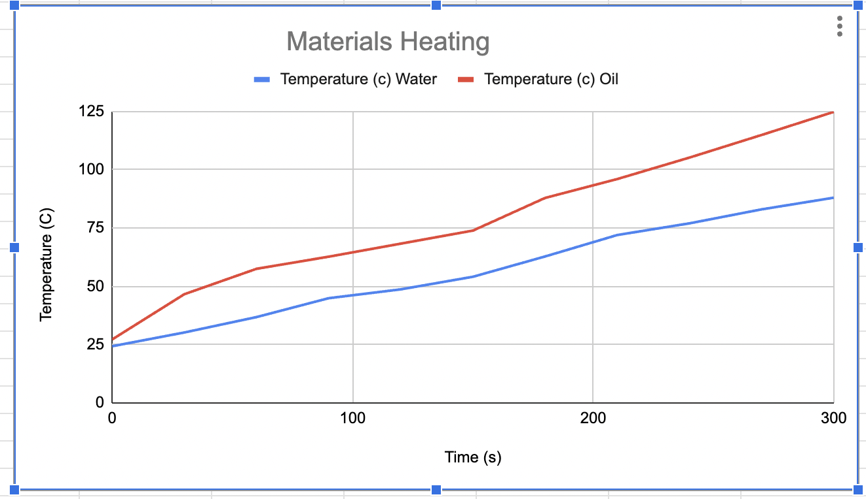

Analysis
Using the data from your specific heat capacity experiment conducted with your teammates, answer the following questions.

            - What are some trends you observe looking at your graph?
The oil line is much steeper. The graphs show that the temperature is rising faster for the oil in the same amount of time.

            - Which substance heated up quicker? Use your data from your graph to justify your answer.
The oil heated up quicker. We can see this because the line of the oil is above that of the water.

Specific heat energy is the quantity of heat required to raise the temperature of one gram of a substance by one degree Celsius. As engineers, it is important to know the difference between high specific heat vs. low specific heat. Substances with high specific heat will take longer to heat up; in other words, they will require more energy to heat them up. By contrast, low specific heat means that a substance will heat up faster.
            - Which of the two substances has a higher specific heat capacity? Explain your answer.
Water must have a higher specific heat capacity because it takes longer to heat up.

Reflection Writing Prompt
- In 7-10 sentences, explain why it feels colder touching a doorknob vs the wall of your classroom. Be sure to use your findings from the experiment above to justify your explanation.
When you touch the doorknob, it takes heat faster from your body. The doorknob being metal makes it a better conductor compared to the wall. The feeling of coldness from the doorknob comes as a result of your body losing heat.

- When would an engineer need to know the specific heat of a material? Give an example.
Engineers need to know about specific heat in order to understand how different materials heat up. When building a house, it’s important to use materials that will work well in either keeping a room cool or that will keep warmth in the home.

Extension
- For this extension, you will be solving for the heat energy added to both water and oil. Will the numbers be the same or different? Why?
They will be different, because they have different specific heat capacities.

- Look up the specific heat for water and oil. Write it down below.

Specific heat of water =___4.186J/g°C______ Specific heat of oil =__1.67J/g°C_______

- Looking at your data from the table, solve for the change in temperature for both water and oil.

∆T of water =_____63.7°C____________ ∆T oil =____97.6°C___________

- Solve for Heat (Q) using the formula Q=mc∆T for water and oil below.

Water: | Oil:
m= 100g  ∆T= 63.7°C  c= 4.186J/g°C  Q=?  Q=mc∆T  Q= (100g)(4.186J/g°C)( 63.7°C)  Q= 26,664.82J | m= 100g  ∆T= 97.6°C  c= 1.67J/g°C  Q=?  Q=mc∆T  Q= (100g)(1.67J/g°C)( 97.6°C)  Q= 16,2999.2J

- Were the heat values you solved for the same? ____NO_______

- If yes, explain why. If not, explain why not.
They had different specific heat capacities and different changes in temperature.

- Why is it important to repeat an experiment many times in science?
It is important to repeat an experiment to confirm your data predictions. This also helps in decreasing errors in the experiment.

