**Engineering Design Challenge Worksheet**

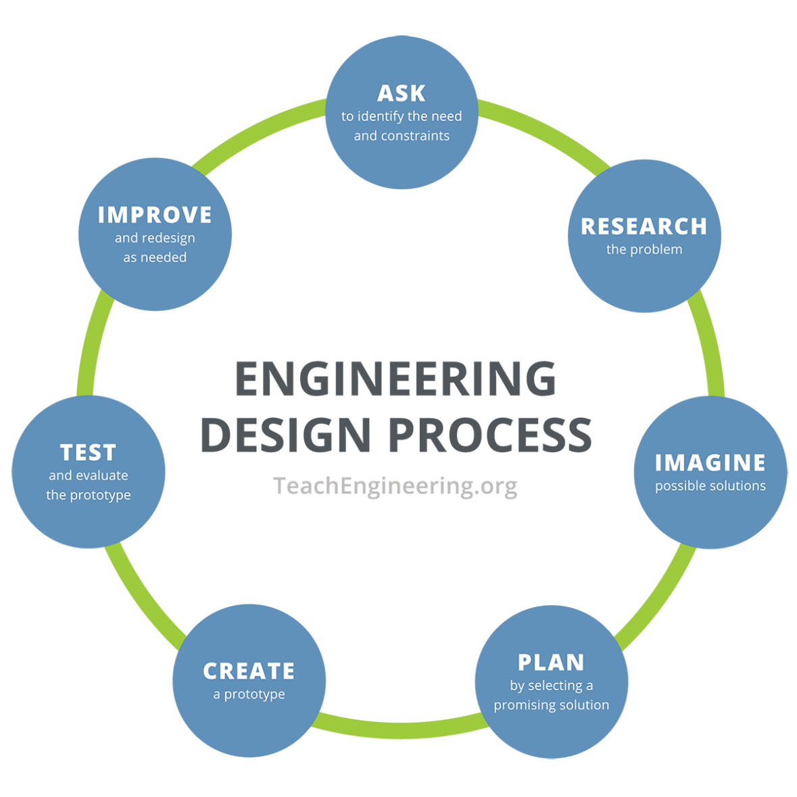**Instructions:** Using the engineering design process, you and your team will act as materials engineers who are tasked with designing a more energy-efficient cooking system to reduce energy waste when heating liquids.

1. **Ask** – Identify the need and constraints of your problem.

____________________________________________________________________________

____________________________________________________________________________

____________________________________________________________________________

____________________________________________________________________________

1. **Research** –What do we know about specific heat capacity? What did we learn in the water versus oil specific heat capacity activity?

____________________________________________________________________________

____________________________________________________________________________

____________________________________________________________________________

____________________________________________________________________________  
  
____________________________________________________________________________

____________________________________________________________________________

____________________________________________________________________________

1. **Imagine** – Individually sketch out four possible solutions.

|  |  |
| --- | --- |
| a. | b. |

|  |  |
| --- | --- |
| c. | d. |

1. **Plan** – Have each team member share their ideas. As a team, select ONE solution. This can be one specific solution or a mixture of ideas. Draw your team’s solution in the box below. Make sure to identify which materials you will be using.

|  |
| --- |
|  |

1. **Create** – Build your prototype as shown in your group’s drawings.
2. **Test** – Test your design and then answer the following questions.

What worked in your design, and why?

____________________________________________________________________________

____________________________________________________________________________

____________________________________________________________________________

____________________________________________________________________________

____________________________________________________________________________

What did not work in your design, and why?

____________________________________________________________________________

____________________________________________________________________________

____________________________________________________________________________

____________________________________________________________________________

____________________________________________________________________________

What features worked best in your classmates’ designs?

____________________________________________________________________________

____________________________________________________________________________

____________________________________________________________________________

____________________________________________________________________________

____________________________________________________________________________

1. **Improve** –Based on your testing and your classmates’ designs and results, how would you improve your design? Why?

____________________________________________________________________________

____________________________________________________________________________

____________________________________________________________________________

____________________________________________________________________________

____________________________________________________________________________

____________________________________________________________________________

____________________________________________________________________________

1. **(optional) Iterate** – Make changes and retest your updated prototype.

Did your changes improve your prototype? How?

____________________________________________________________________________

____________________________________________________________________________

____________________________________________________________________________

What worked in your updated design, and why?

____________________________________________________________________________

____________________________________________________________________________

____________________________________________________________________________

What did not work in your updated design, and why?

____________________________________________________________________________

____________________________________________________________________________

____________________________________________________________________________