**Pre-Assessment**

**The Immune Response**

**How are antibodies made? A simplified view of the humoral immune response:**

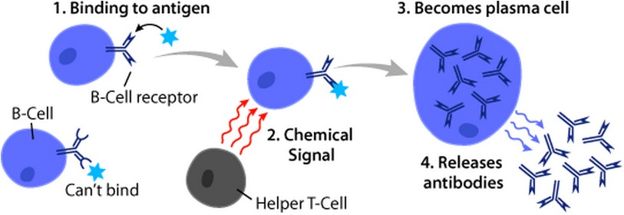

Figure 1. [B cell action](https://en.wikipedia.org/wiki/B_cell#/media/File:B_cell_function.png) (Wikipedia)

Our blood is made of plasma, red blood cells, white blood cells, and platelets. There are many types of white blood cells, some of which are responsible for what we call the humoral immune response. In this response, B cells use receptor proteins on their membranes to recognize an antigen. Upon encountering the antigen, chemical signals from other immune cells direct B cells to become plasma cells (Figure 1). Plasma cells can clone themselves and begin to make free antibodies that are specific to the antigen and will circulate throughout the body. The free antibodies become important components of the immune response, as they attack and neutralize the pathogens (Figure 2). Attachment to antigens by antibodies prevents the pathogen from attacking new cells, and signals other immune cells to destroy them.

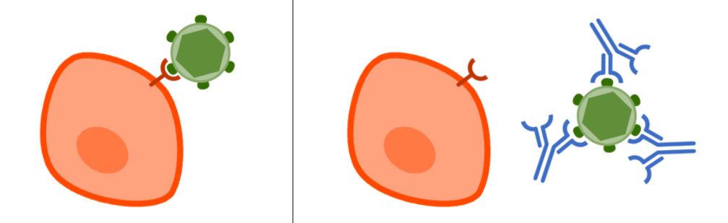

Figure 2: [B cell receptor recognizing a pathogen and free antibodies neutralizing its antigens](https://commons.wikimedia.org/wiki/File:NAb_esquema.jpg) (Wikimedia Commons)

**How do antibodies recognize an antigen?**

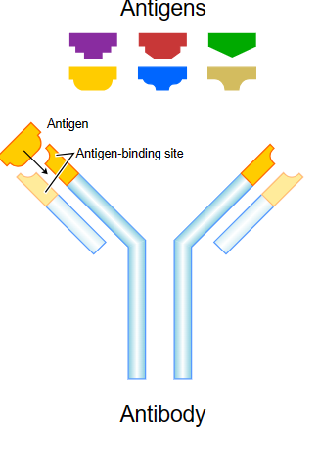To attach to and neutralize a pathogen, the antibody must have a region that is structurally and chemically compatible with the antigens. Chemical interactions between the antigen and antibody allow recognition and binding. The shape of the antibody binding site is especially important and determines the antibodies’ specificity to its antigen.

Figure 3: Six different antigens, of which only one can be identified by the antibody binding site; [Fvasconcellos](https://commons.wikimedia.org/wiki/User:Fvasconcellos) May 6, 2007 (Wikimedia Commons)

**The Enzyme-Linked Immunosorbent Assay (ELISA)**

An ELISA is a test developed to identify the presence of an antigen. The test uses basic principles of immunology: Antigens are recognized by antibodies, and each antibody is highly specific to one antigen.

There are various kinds of ELISA tests, but for simplicity’s sake we will focus on one type: a sandwich ELISA. In this type of ELISA, a 96-well plate (Figure 4) is prepared by adding capture antibodies that bind to the bottom of each of the wells (Figure 5.1). These Y-shaped antibodies have been produced in laboratory animals and are highly specific to one antigen of interest. A patient’s blood plasma (or other body fluid, such as saliva or mucus) is prepared and introduced into the wells. If the antigen of interest is present, the antibody in the well will capture the antigen (Figure 5.2).

Secondary antibodies, also known as detection antibodies, are added next (Figure 5.3). Detection antibodies are also specific to the antigen and will bind to the antigen that is already immobilized by the primary antibody. A series of washes of all the wells is performed between all steps to ensure that excess and unbound molecules are removed. Bound molecules will remain in the plate after a wash is performed. Next, the detection antibody is linked to an enzyme—or another antibody linked to an enzyme is added (Figure 5.4). The last step entails the addition of a substrate that will react in the presence of the enzyme. The reaction creates a signal in the form of a color change (Figure 5.5). The intensity of the color is related to the concentration of the antigen-antibody complex bound to the plate. The color signal of each well can be measured using a spectrophotometer, and results can be used to determine the concentration of antigen in each of the wells.

Figure 4: [ELISA plate](https://commons.wikimedia.org/wiki/File:ELISA_TMB.jpg) (Wikimedia Commons) 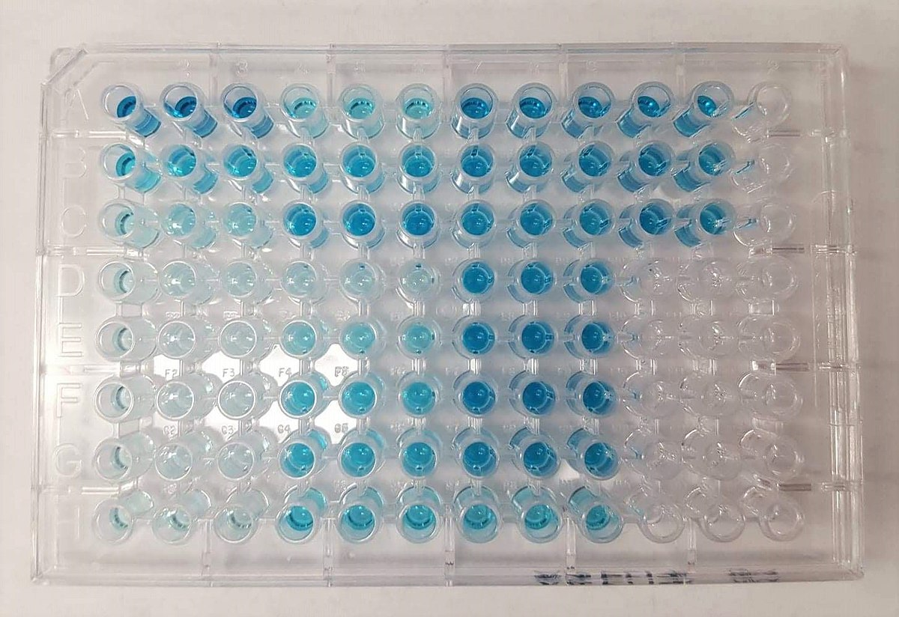

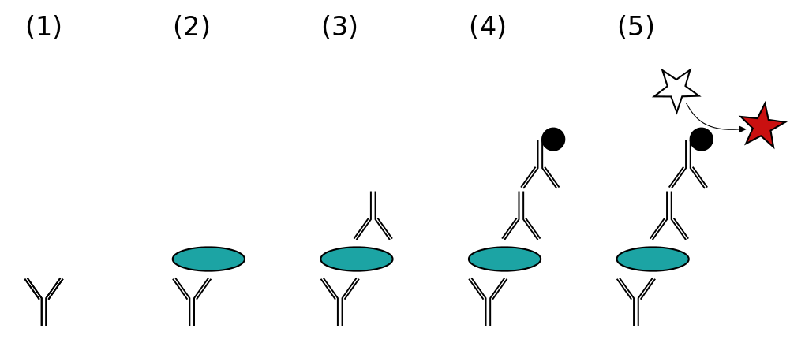

Figure 5. Y-shaped antibodies capture and detect an antigen (green) in a plate. The sandwich immobilizes the antigen. The substrate (star) is catalyzed by the enzyme (black), which produces a color change. [Sandwich ELISA model](https://commons.wikimedia.org/wiki/File:ELISA-sandwich.svg) (Wikimedia Commons)

**Antigen Rapid Tests**

A rapid test is a type of point of care (POC) device. It is very much a sandwich ELISA built on a different platform. On these devices, a patient’s fluids are added and allowed to flow through a porous capillary paper (Figure 6.1). The pad inside the device has different reaction centers, one of which is a region with free antibodies conjugated with a signal particle (Figure 6.2). If antigens are present in the fluid, the free antibodies and signal particles will bind to the antigen (Figure 6.3). The signal-antibody-antigen complex will flow laterally to another region, where a primary antibody is immobilized to the device. When the antigen-antibody complex flows through this test region, the immobilized antibodies will capture the antigens along with the signal molecules, and trap them in place (Figure 6.4). The signal particles will react with other molecules to produce a color visible as a line on the test region (T). Antibodies and signal molecules that are not captured on the test region move on to the control region (C), either because they are in excess or because they do not have antigens to be captured in the test region. In the control region, they are captured by secondary antibodies (Figure 6.5). This control region produces a line that verifies the validity of the test (C). Primary antibodies and signal molecules must produce a color change in the control line, regardless of antigen presence or absence. If no color is produced, it can be concluded that one of the components of the ELISA is faulty and the test is inconclusive.

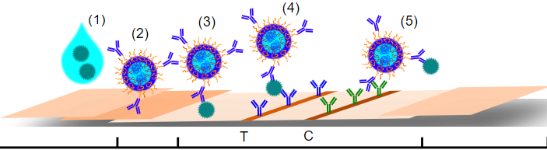

Figure 6: Scheme of a lateral flow immunoassay with antibody-antigen-antibody sandwich configuration. [MoritzOfScience](https://commons.wikimedia.org/wiki/File:Lateral_flow_immunoassay_-_general_layout.svg), June 23, 2021 (Wikimedia Commons)

|  |
| --- |
| **Antibodies, Antigens, and Basics of the Immune Response** |
| 1. What is the role of B cells in the immune response? 2. How do B cells recognize a foreign antigen or pathogen? 3. What do all antibodies have in common? How do they differ from one another? 4. What are antigens? Why might we need to measure the concentration of an antigen? 5. What role do antibodies have in our bodies? What role do they play in immunoassays? 6. Based on your understanding of how immunoassays work, describe one engineering   challenge in the development of devices used to measure antigens and antibodies. |