Telescope Activity Worksheet Answer Key
Ask
Overview: Telescopes and similar instruments allow us to explore the night sky and see what lies beyond. With different types and sizes, telescopes can capture images of the moon, planets, galaxies, nebulae, and more. In this activity, you will become an astronomical instrument engineer and:
- Design and build a telescope.
- Capture images through the telescope using your smartphone.
- Collaborate with classmates to identify which telescope features produce the best images.

Research
Introduction to Refracting Telescopes
Please watch this video: https://www.youtube.com/watch?v=5v7bN13PjZ8) and then answer the questions below:
- What does long-distance viewing rely on? What part of the telescope can do this?
Long-distance viewing relies on gathering as much light as possible and increasing the apparent size of the distance object. The lenses of the telescope can help us do this.

- What is the focal point of a lens?
The focal point is where the light rays from a lens meet before diverging out again.

- What two types of lenses does a telescope use?
A telescope has an objective lens and an eyepiece lens.

Please watch this video: https://www.youtube.com/watch?v=abCykcw5os8 and then answer the questions below:
- How can you make sure the focal lengths overlap?
You can make the focal lengths overlap by moving the eyepiece lens back and forth until it is focused correctly.

- Why do we need to take pictures from the refracting telescope and turn them 180 degrees?
We need to take pictures from the refracting telescope and turn them 180 degrees because they’ll be upside down; the virtual image created by the objective lens is upside down, so the one seen by the eyepiece will be too.

- How can you determine the magnification of an image from your telescope?
To determine the magnification of an image from your telescope, you can use the ratio of the focal length of the objective lens divided by the focal length of the eyepiece lens.

Telescope Diagram
In the space below, draw an accurate diagram of how a refracting telescope works, including the path that rays of light take from one end of the telescope to the other.
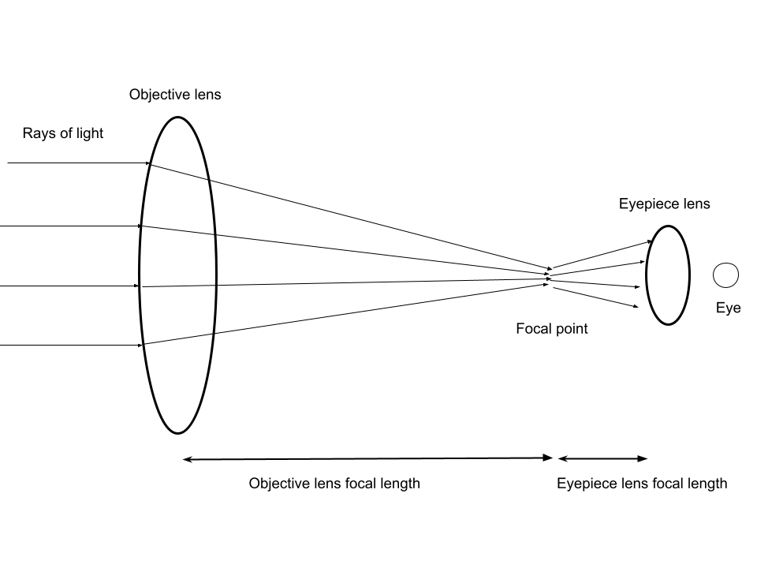

Imagine
Telescope Brainstorming
Sketch your telescope design in the space below. Make sure to label what materials you will be using.
Sketches will vary.

Plan
Maximize Magnification
Before you build your telescope, you need to find the ideal distance between the two lenses to maximize magnification. To do that, follow the directions below:
- Gather the following materials from the materials table:
- 1 double convex lens
- 1 double concave lens
- several sheets of black paper
- 1 meter stick
- Hold the double concave lens (the thick one) in front of your eye, and the double convex lens (the thin one) further out while focusing on the red lightbulb source.
- Move the double convex lens back and forth until the light source is as big as possible.
- Have your partner use a meter stick to measure the distance between both lenses.
- Note the focal length of each lens, as well as the distance measured in the space below.

Lens Specifications
Double Concave Lens Focal Length (mm): 150 mm

Double Convex Lens Focal Length (mm): 500 mm

Distance Between Lenses (mm): Varies, typically 250 mm - 500 mm
Sketch Design and Plan Your Telescope
Draw your telescope design in the space below incorporating the necessary focal length. Make sure to label what materials you will be using.
Sketches will vary.

Create
With your partner, spend the remainder of today building your telescope based on your design drawing.

Test
Once built, coordinate with your partner to take the telescope home and take two types of images of the moon:
- One image with only your smartphone
- One image with your smartphone aided by the telescope

In the space below, document both sets of images and write a short reflection on your procedure to capture the images.
Images of the Moon With and Without Telescope
Example of Image Without Telescope:  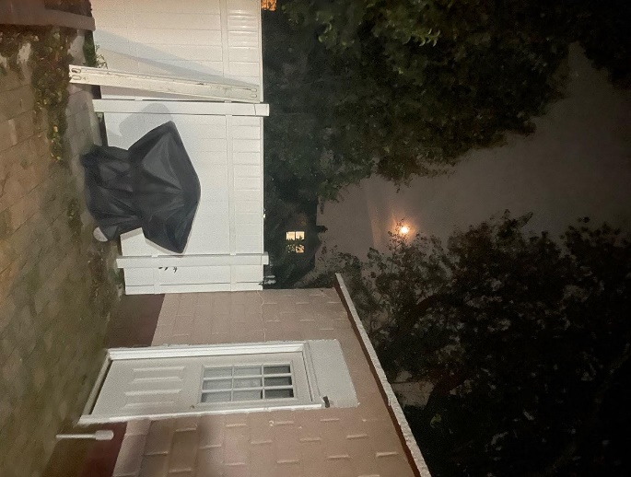 | Example of Image With Telescope:  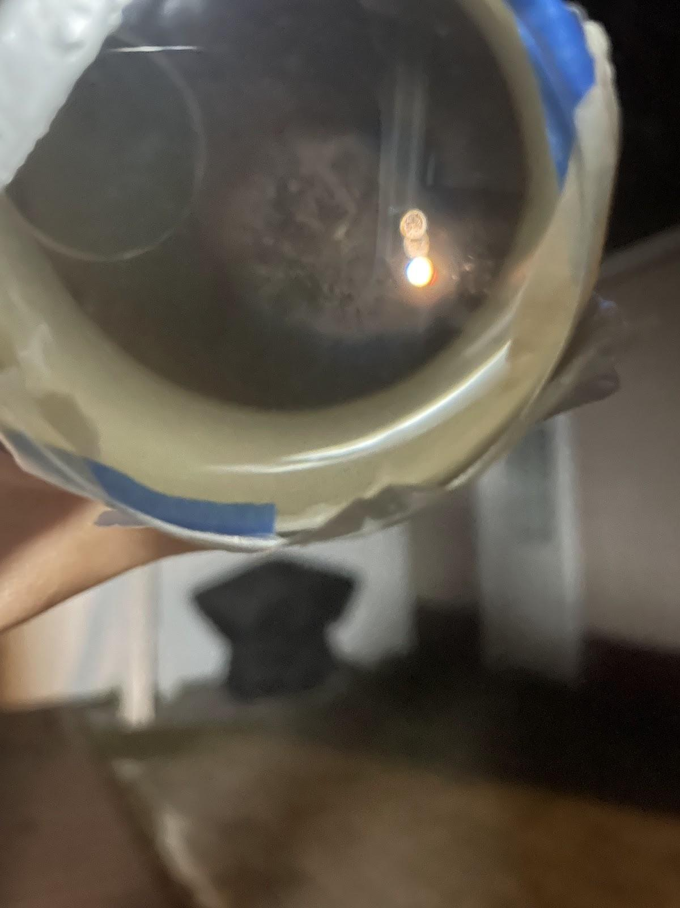
Based on your testing, answer the following questions:

- Write your procedure for capturing your images here.
Example response:
“It was pretty challenging to find the right spot to take the picture of the moon, since it was shown as an inverted image. To begin, the first step was going out of the house and adjusting the angle my arm would be set on in order to capture the moon. Then, it was time to finally take the pic. I held my phone with one hand while focusing on the moon with the telescope in my other hand, making sure to carefully align the two to get that perfect shot.”

- Write down specific details about your captured images. What did you observe?
Example response:
The moon was an inverted image when viewed through the smartphone aided by the telescope.
The moon was smaller when viewed through just the smartphone.
The moon had less detail when viewed through the smartphone.

- What worked?
Answers will vary.

- What didn’t work?
Answers will vary.

Improve/Reflect
For this last part, we are going to be comparing our images class-wide. As we do this, think about the following questions and write your response beneath each question:
- Who took the best images?
Answers will vary.

- How does their telescope differ from yours, or—if this is yours—why did you design it the way you did?
Answers will vary.

- If you were to continue refining your telescope design, what might be your next steps for a clearer image of the moon?
Answers will vary.

Rubric
Not Yet | Proficient | Exceeding Proficiency
 | - Demonstrates a solid understanding of telescope components and their assembly (85%).
 | - Aligns the telescope accurately for moon observation, consistently achieving clear views (85%).
 | - Captures high-quality pictures of the moon, showcasing good clarity, composition, and detail (85%).
Overall Rating:

