Part 6B: Arduino Touch-Activated Buzzer Challenge Answers

Example of setup of circuit for touch-activated buzzer with Arduino:

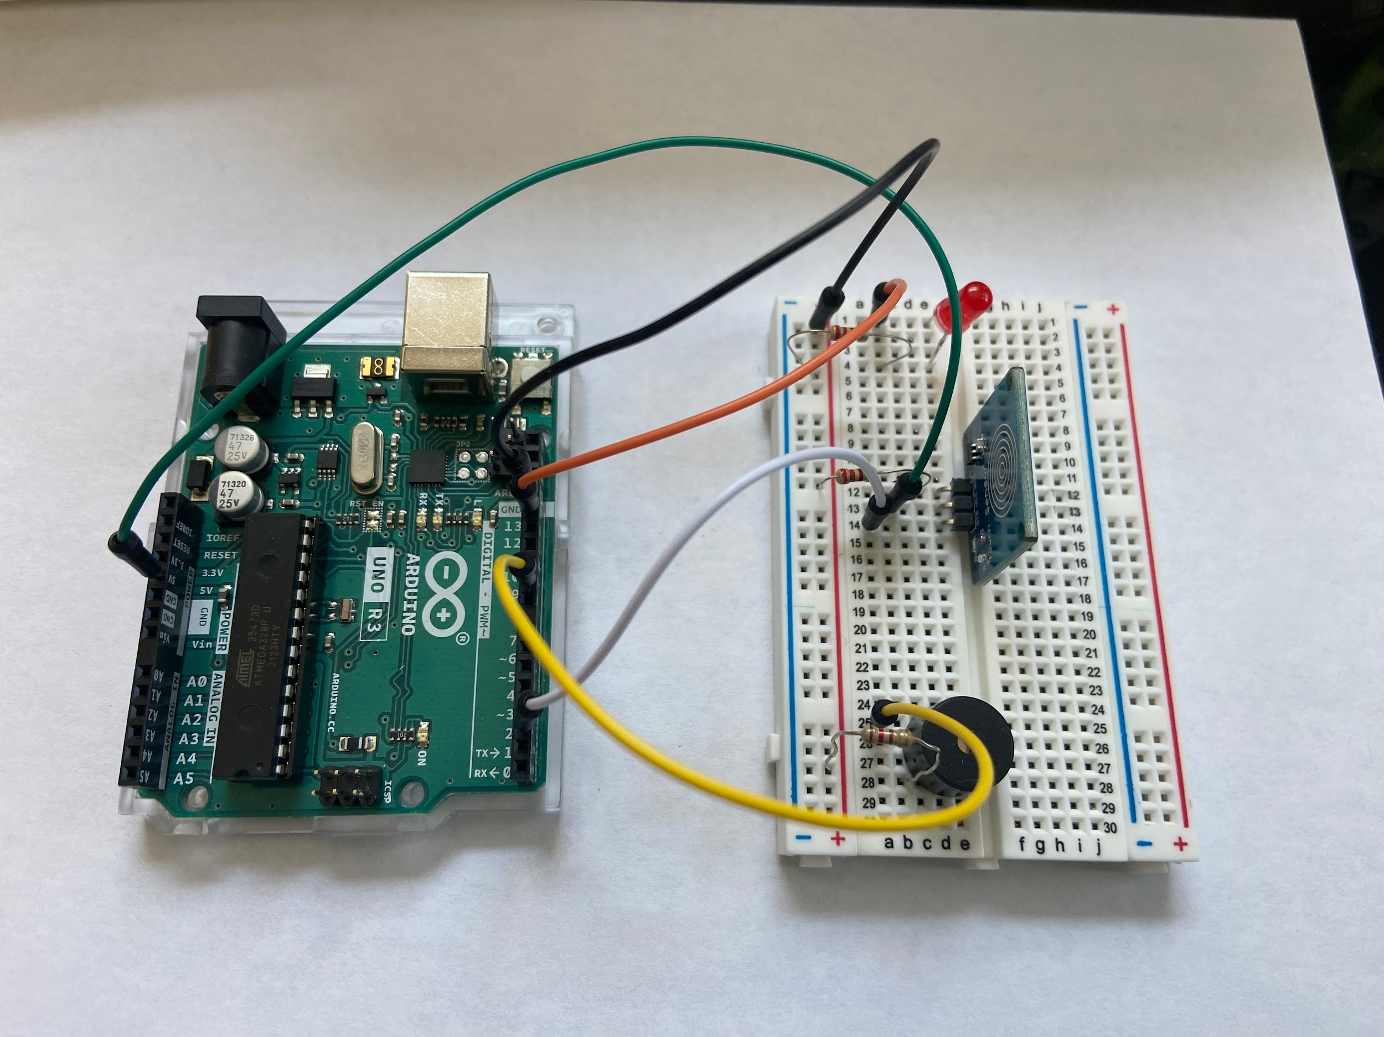

Example of possible code for touch-activated buzzer with Arduino:

// Capacitive Touch Sensor triggers buzzer and LED when pressed

// When Sig Output is high, touch sensor is being pressed and buzzer emits sound

#define

ctsPin 2 // Pin for capacitive touch sensor
int ledPin = 13; // pin for the LED
const int buzzer = 9; //pin for buzzer

void setup()

{

Serial.begin(9600);

pinMode(ledPin, OUTPUT);
pinMode(ctsPin, INPUT);
pinMode (buzzer, OUTPUT);

}

void loop()

{

int ctsValue = digitalRead(ctsPin);

if (ctsValue == HIGH)

{

digitalWrite(ledPin, HIGH);

Serial.println("TOUCHED");

tone(buzzer, 1000); // send 1KHz sound signal
delay(1000); // . . . for 1 sec
noTone(buzzer); // Stop Sound
delay(1000); // . . . for 1 sec

}

else{

digitalWrite(ledPin,LOW);

Serial.println("not touched");

}

delay(500);

}

