Part 6A: Arduino Traffic Light Challenge Answers

Example of circuit for running a stop light with breadboard and Arduino:

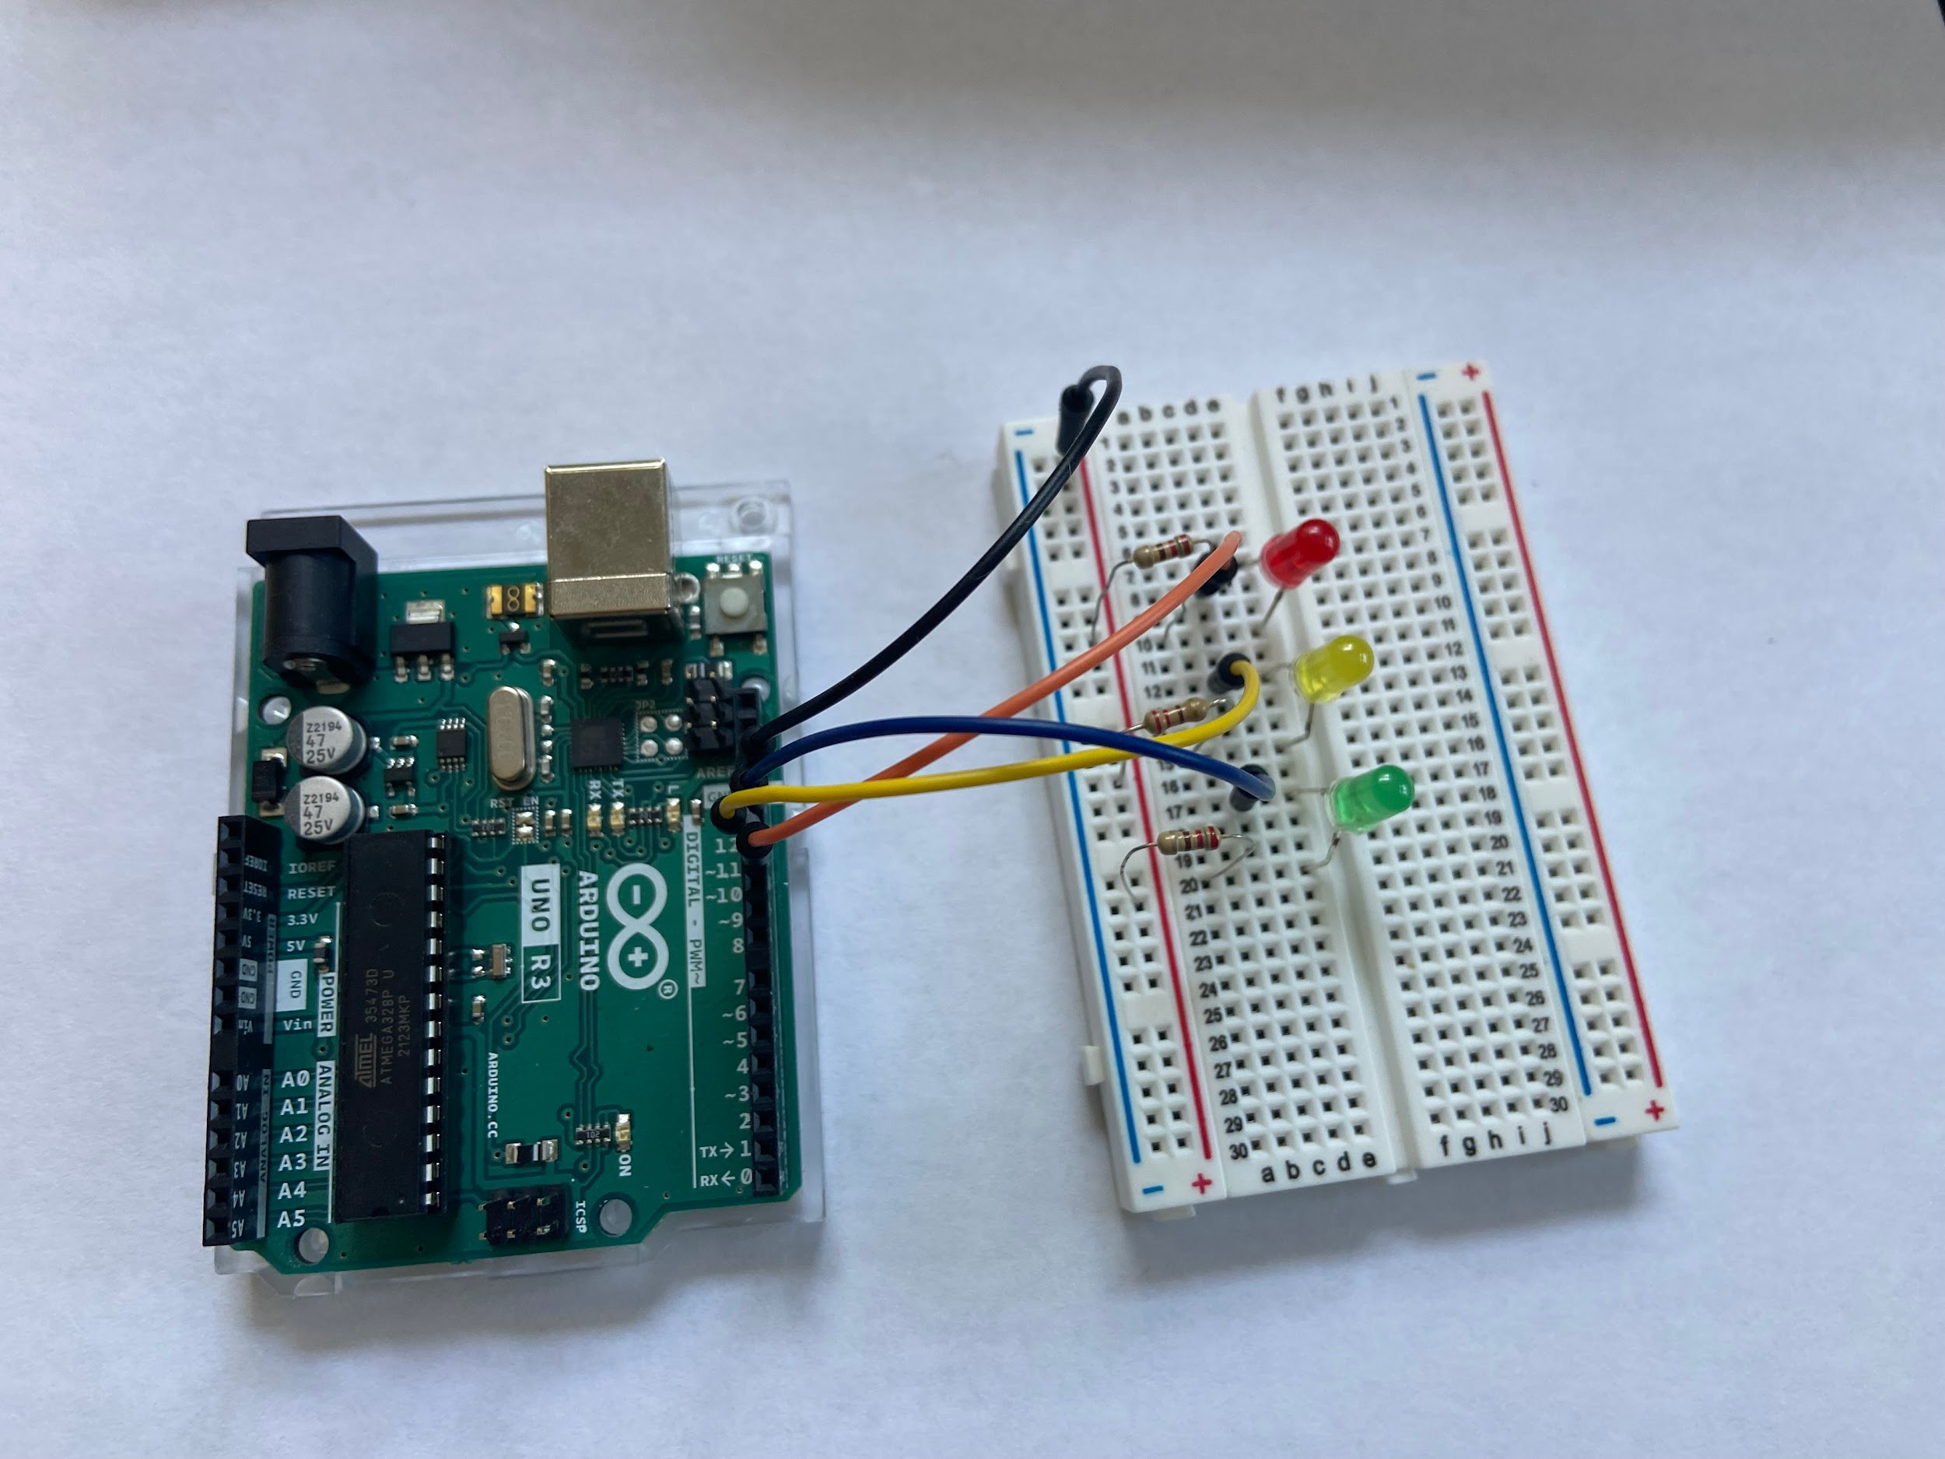
Red light—connected to pin 11
Yellow light—connected to pin 12
Green light—connected to pin 13
Black wire—connected to ground and red/+ on breadboard

Example of coding for running a traffic light with Arduino:

(Other possibilities exist. If the lights work, it’s good code!)

/*
Activity 6a: Traffic Light
Turn on a green external LED on for 5 seconds then off for 7 seconds, then a yellow external LED for two seconds then off for 10, then a red external LED turns on for 5 seconds then off for 7 seconds, repeatedly.
*/
// Identify the digital pin to which each LED is connected:
int led = 11;//green light
int led2 = 12;//yellow light
int led3 = 13;//red light

// The setup() routine runs only once:
void setup() {
// Set the digital pin as an output.
pinMode(led, OUTPUT);
pinMode(led2, OUTPUT);
pinMode(led3, OUTPUT);

}
// The loop routine runs over and over again forever:
void loop() {
digitalWrite(led, HIGH);
digitalWrite(led2, LOW);
digitalWrite(led3, LOW);
delay(5000);

digitalWrite(led, LOW);
digitalWrite(led2, HIGH);
digitalWrite(led3, LOW);
delay(2000);

digitalWrite(led, LOW);
digitalWrite(led2, LOW);
digitalWrite(led3, HIGH);
delay(5000);

}

