Part 5: Arduino Buzzer

Introduction:
In this activity you will construct a circuit and program the Arduino to connect to a Piezo buzzer. The goal is to have the buzzer sound after the code has been downloaded to the Arduino.

Required materials:
- laptop with USB port
- Arduino Uno
- USB 2.0 cable, type A/B
- 100 ohm resistor
- mini breadboard
- Piezo buzzer
- 2 jumper wires

Setup of circuit:
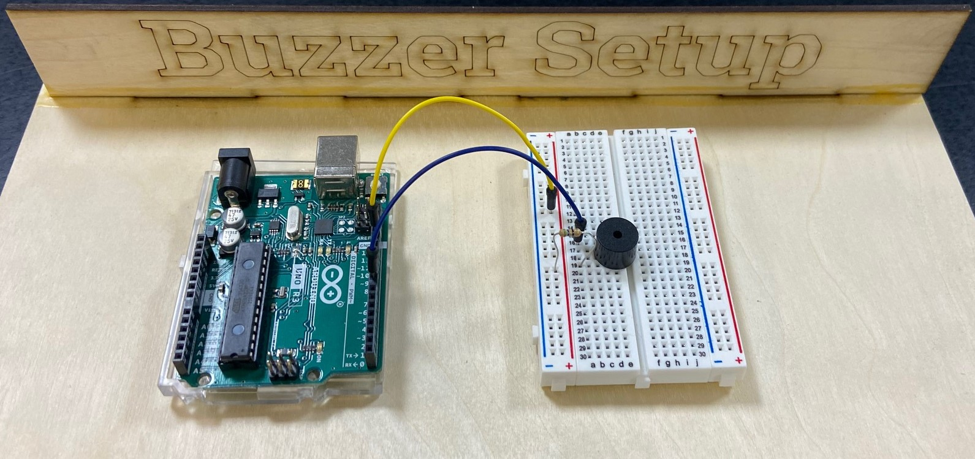

Wiring hint:
Connect the short leg of the buzzer in the same row as the resistor and the long leg in the row with the wire connected to pin 9.

Connecting the buzzer through the Arduino:

- Once you have the circuit built, copy the following code into a new sketch.

const int buzzer = 9; //buzzer to arduino pin 9

void setup(){
pinMode(buzzer, OUTPUT); // Set buzzer - pin 9 as an output
}

void loop(){
tone(buzzer, 1000); // Send 1KHz sound signal...
delay(1000); // ...for 1 sec
noTone(buzzer); // Stop sound...
delay(1000); // ...for 1 sec
}

- Compile and download the code to the Arduino.
- Show your teacher and get checked off for successfully completing this task.
- Modify the tone and length of the sound emitted by the buzzer and get this checked off by the teacher.
- Name your sketch Buzzer and save it to your desktop folder.
- For fun, try modifying and downloading the code for Melody from the Example Programs (Example Programs to Digital to toneMelody) to see how a variety of sounds can be created with the buzzer.

