**Part 4: Arduino Touch Sensor**

**Introduction:**

In this activity you will construct a circuit and program the Arduino to connect the touch sensor and a single LED. The goal is to have the LED flash when you place your finger on the touch sensor.

**Required materials:**

* laptop with USB port
* Arduino Uno
* USB 2.0 cable, type A/B
* LED
* 2 220 ohm resistors
* mini breadboard
* touch sensor
* 4 jumper wires

**Setup of circuit:**

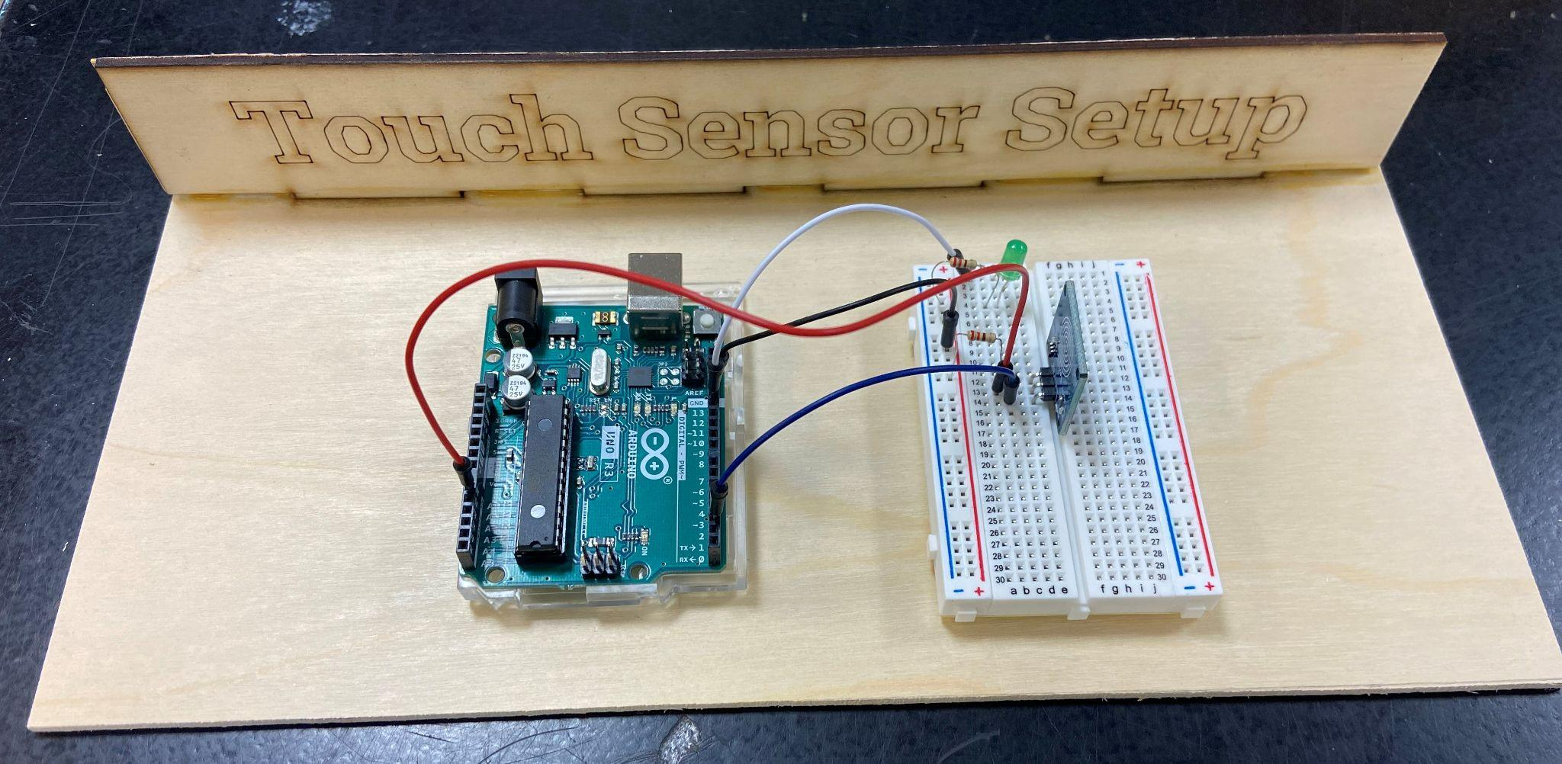

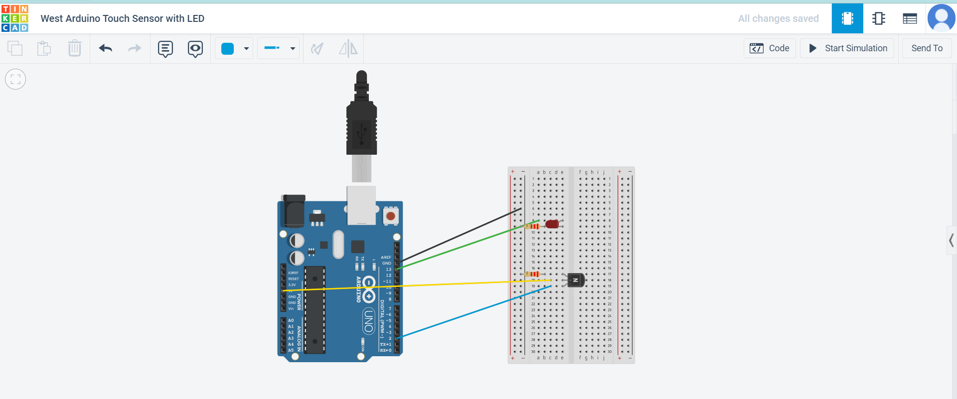

**Connecting the touch sensor and LED through the Arduino:**

1. Once you have the circuit built, copy the following code into a new sketch.

// Capacitive Touch Sensor

// When Sig Output is high, touch sensor is being pressed

#define ctsPin 2 // Pin for capacitive touch sensor

int ledPin = 13; // pin for the LED

void setup()

{

Serial.begin(9600);

pinMode(ledPin, OUTPUT);

pinMode(ctsPin, INPUT);

}

void loop()

{

int ctsValue = digitalRead(ctsPin);

if (ctsValue == HIGH)

{

digitalWrite(ledPin, HIGH);

Serial.println("TOUCHED");

}

else{

digitalWrite(ledPin,LOW);

Serial.println("not touched");

}

delay(500);

}

1. Compile and download to the Arduino.
2. Click on the magnifying glass in the upper-right corner to open the Serial Monitor. 
3. Press the touch sensor again, and the message in the Serial Monitor on the bottom of the screen should change from “Not Touched” to “Touched.”
4. Show your teacher and get checked off for successfully completing this task.
5. Name your sketch **TouchSensor** and save it to your desktop folder.