Part 3: Arduino 2 LEDs Blink

Introduction:
In this activity you will construct a circuit and program the Arduino to turn two LEDs on and off opposite each other. The goal is to have the two LEDs flash on and off, alternating with each other, and try modifying the length of time each one stays on and off.

Required materials:
- laptop with USB port
- Arduino Uno
- USB 2.0 cable, type A/B
- 2 LEDs
- 2 220 ohm resistors
- mini breadboard
- 3 jumper wires

Setup of circuit:

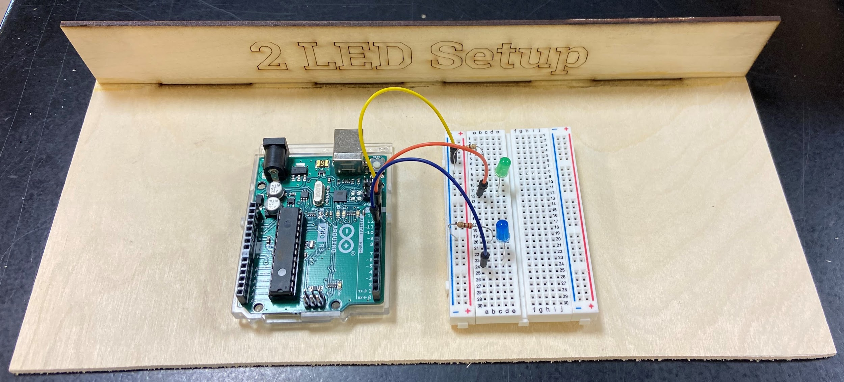
Wiring hints:
Add to your already constructed circuit for the single LED.

Add a second 220 ohm resistor from the blue/- column on the breadboard to a nearby row.

Connect the short leg of the second LED in the same row as the second 220 ohm resistor and the long leg in the row with the wire connected to the pin of your choice on the Arduino. (This pin number will be used in the coding section as well.)

Coding two LEDs through Arduino:

- Follow the teacher's instructions to modify your code for one LED to control two LEDs, or watch this video.

Video instructions for Modifying Code to Control 2 LEDs

- Once you successfully get your two LEDs to blink on and off alternately, get checked off by the teacher.

- Modify the length of time each light stays on and off. Have this checked by the teacher.

- Name your sketch 2LEDs.Blink and save it in your folder on the desktop.

