**Part 2: Arduino LED Blink**

**Introduction:**

In this activity you will construct a circuit and program the Arduino to turn an LED on and off. The goal is to have the LED flash on and off and modify the length of time this takes.

**Required materials:**

* laptop with USB port
* Arduino Uno
* USB 2.0 cable, type A/B
* LED
* 220 ohm resistor
* mini breadboard
* 2 jumper wires

**Setup of circuit:**

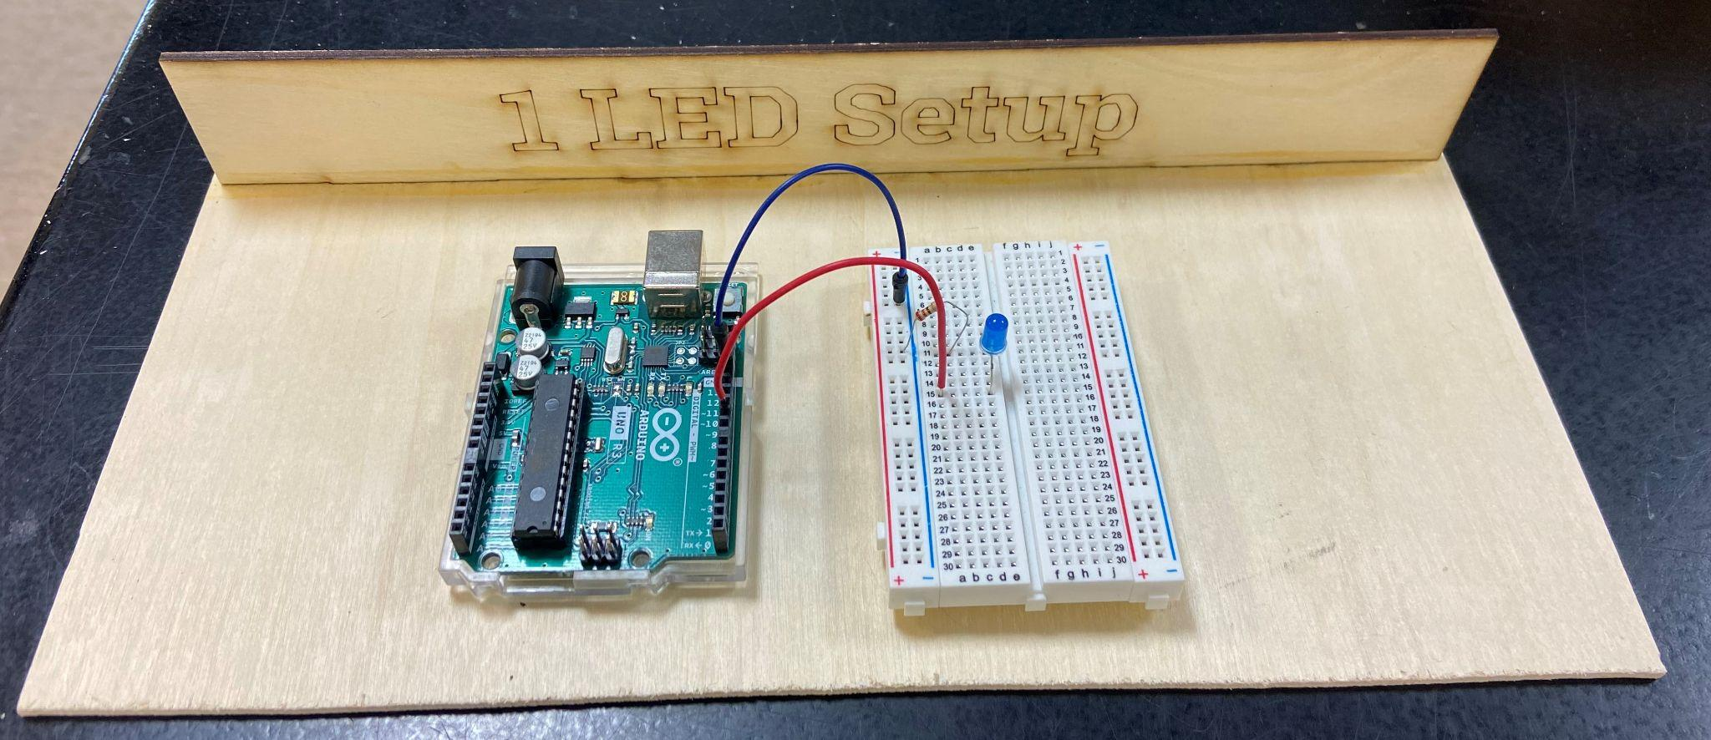

***Wiring hints:***

*Connect the first wire from the GND (ground pin) on the Arduino to the blue/- column on the left side of the Arduino.*

*Attach the 220 ohm resistor from blue/- column to any row on the left side.*

*Connect the short leg of the LED in the same row as the resistor and the long leg in the row with the second wire connected back to pin 11.*

**Code for connecting one LED through Arduino:**

1. Create a new sketch in Arduino (make sure all of the code is removed, and then copy and paste the following code into the sketch):

Activity 2: LED_Blink

Turns on an external LED on for one second, then off for one second, repeatedly.

*/

// Identify the digital pin to which the LED is connected:

int led = 11;

// The setup() routine runs only once:

void setup() {

// Set the digital pin as an output.

pinMode(led, OUTPUT);

}

// The loop routine runs over and over again forever:

void loop() {

digitalWrite(led, HIGH);

delay(1000);

digitalWrite(led, LOW);

delay(1000);

}

1. Compile and download to the Arduino through the USB cable. Once you have the light blinking, have your teacher check off your setup.
2. Modify the length of time the light stays on and off (change the number in parentheses after “delay,'' then compile and download new code). Show the teacher your modifications for credit.
3. Name your sketch **LED.Blink** and save your code to the folder on your desktop.