Build an Electrophoresis Box - Lab Sheet

The purpose of this lab activity is to build an electrophoresis box. Electrophoresis means to move using electricity. Molecules will move through an agarose gel matrix (Figure 1) in which an electric field is created, such that the molecules will separate based on size and charge. All charged molecules will move in the electric field; the negatively charged molecules will move toward the positive side (anode), and the positively charged molecules will move toward the negative side (cathode). As the molecules move through the gel matrix, smaller molecules will move farther than larger molecules in a given amount of time (Figure 2). Research scientists use this technique to separate different DNA fragments or protein molecules from each other.
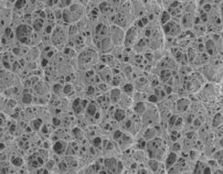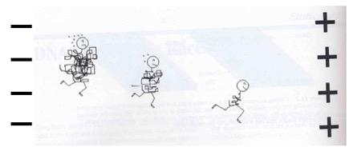
Figure 1: Image of agarose gel Figure 2: Molecules of different sizes moving through gel matrix

Materials for this activity (everything bolded is provided in the kit). Note: Save all materials, including paper clips and tips, in case you need to rerun the activity or for future experiments:
- a source of electricity (9-volt battery)
- a tray to cast and run the gel (medium-sized weigh boat)
- electrodes to create the anode and cathode poles (paper clips)
- connection from the poles to the power (alligator clips and wire)
- agarose gel (0.8% agarose in TBE)
- an electrically conductive buffered solution (TBE)
- a way to create wells in the agarose for your charged molecules samples (comb)
- charged molecules (dyes)
- pipette and tips for adding dyes to the wells of the gel

Step 1: Making the comb
Using some kind of flexible plastic, such as the lid to a margarine or yogurt container, draw a rectangle that is about 5.5 cm by 3 cm (1A), and cut out the rectangle.
1A 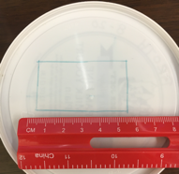

Then make tick marks beginning at 0.5 cm, then 0.2 cm, along the 5.5 cm side of the plastic, so that you wind up with eight 0.5 cm ticks (1B).
1B 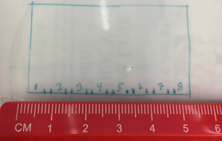
For each of the tick marks, draw a line that is 1.5 cm long (1C).
1C 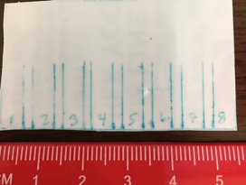
The eight 0.5 cm segments will be the teeth of the comb, and the 0.2 cm segments cut out will make the spacers between the teeth of the comb (1D). Cut and remove each of the spacers. Draw a line about 0.5 cm from the bottom of the teeth to indicate how deep your wells need to be.
1D 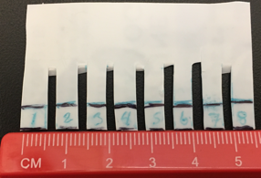
You now have the comb to create your wells in the agarose gel. You may need to trim a little off the sides if the comb is wider than the weigh boat, but you can determine that when you construct the electrophoresis box. You may also need to trim a little off the top if it is too long. Check to ensure that all of the teeth are aligned, and straighten any that are crooked.

Step 2: Making the electrophoresis box
The electrophoresis unit generally has a tray with electrodes for creating the electric field to run the gel, and a separate smaller gel casting tray that fits inside the gel running tray. For simplicity and ease, you will cast the gel and run it in the same tray.
1. Open two paper clips by bending one side of each to a right angle and then bending the other side to a right angle, and then putting a small out-of-plane bend on the top of the straight side (2A).
2A 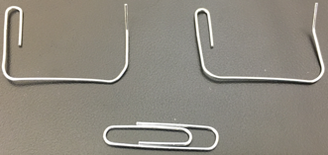
2. Attach the electrodes (paper clips) to either end of the tray (weigh boat). Use a binder clip to attach the paper clip, on the small out-of-plane bend, to the weigh boat. The long side of the paper clip will sit at the bottom of each side of the tray. Make sure the bottom pieces are straight; see red arrow below (2B).
2B 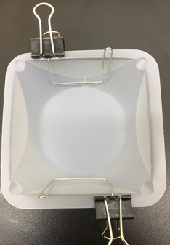

3. Using two paper clips at either end of the comb, attach the comb to the tray, taking care that the teeth of the comb do not touch the bottom of the tray (2C). The teeth of the comb will make wells (holes) in the gel for your sample. The electrophoresis box is now complete.
2C 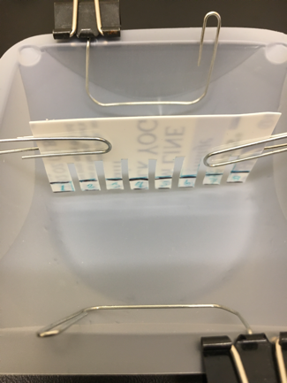

Step 3: Mixing the TBE buffer and making the agarose gel
Making TBE solution
Tris base, borate, and EDTA are combined to make the TBE solution (in a zip-close bag labeled TBE). Empty a 500 mL (16.9 oz.) water bottle and clearly label it TBE solution/DO NOT DRINK. You may be able to use the label from the chemical bag for your bottle label. Add the contents of the TBE zip-close bag to the 500 mL bottle, fill the bottle to the top with water* (500 mL), cap, and mix gently until completely dissolved. *If you have deionized water, use that to make the solution (this is the kind of water you would use in your iron or humidifier); otherwise, tap water will work.

Making agarose gel
1. Obtain a clean clear glass jar (1 cup volume or larger) for mixing and melting your agarose gel. Label it with a marker (if available): 0.8% Agarose in TBE, or use the label from the agarose chemical bag.
2. Add all of the agarose solid (smaller zip-close baggie labeled “Agarose”) to the jar.
3. Use a measuring cup and add ½ cup of TBE solution to the agarose (3A). Notice the agarose does not dissolve in the TBE. The mixture needs to be heated and melted to go into solution.
3A 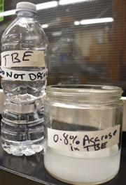
4. Microwave the jar with agarose + TBE for one minute. DO NOT PUT A LID ON THE JAR!
5. CAUTION: The contents will be very hot! Let the jar with hot agarose sit in the microwave for 30 seconds before you pick it up. Use a potholder (oven mitt) to carefully remove the hot agarose from the microwave.
6. Remove the agarose and gently swirl the jar, being careful not to cause the contents to overflow. There will likely be some agarose that has not completely dissolved (3B; zoom in to see the undissolved agarose). Microwave the contents for another 30 seconds, and let it sit in the microwave for another 30 seconds before removing it.
3B 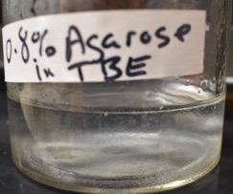
7. After letting the jar sit, carefully remove the jar using a potholder (oven mitt) and swirl gently. The agarose should look clear, like water, when it is 100% dissolved. Keep microwaving in 30-second intervals until the agarose is as clear as water, with no undissolved agarose (3C).
3C 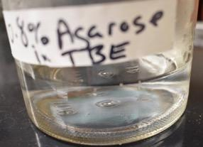

Step 4: Casting the gel
1. Make sure the comb is not touching the bottom of the electrophoresis tray (2C).
2. Let the microwaved agarose cool for a few minutes, and then pour the agarose steadily into the tray, so that the agarose covers about 1/3 of the bottom of the comb, approximately 0.5 cm.
4A 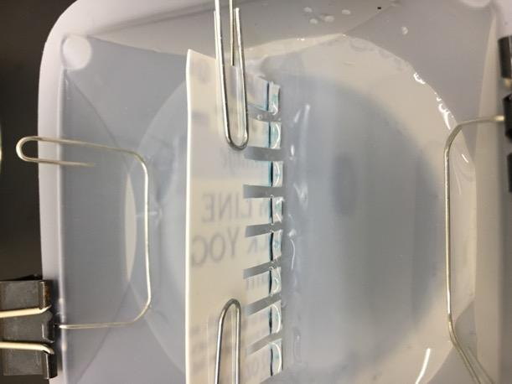
3. Let the agarose solidify for about 15 minutes, and then gently lift the comb out of the gel, being careful not to disturb the gel. The agarose will appear translucent (harder to see through than when it was transparent like water) Note the little wells (holes) in the gel where the teeth of the comb were. These wells are where you will place your charged molecule samples (4B; wells are circled in red).
4B 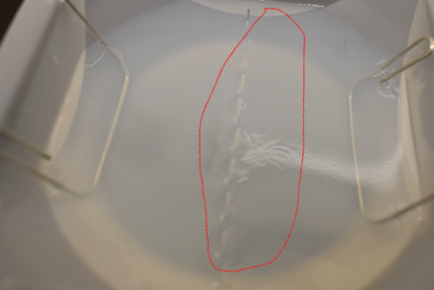

Step 5: Loading samples into the gel
1. A precision instrument called a pipettor is used to add small amounts of samples to a gel. These are usually adjustable from less than a microliter (μL) to 1,000 μL or 1 mL. You will use the disposable tips used with these instruments attached to a disposable transfer pipette (5A).
5A 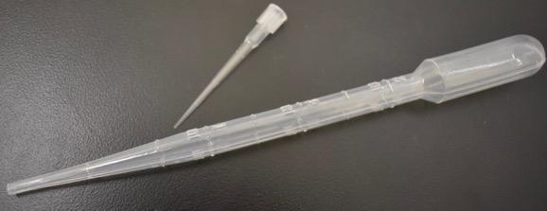
2. Practice pipetting with a disposable tip with water first to see how much pressure you need to add sample to the tip. If you look at the tip you will see gradations; the first is 2 μL, the next is 10 μL. You will want to use the second gradation for the amount of sample to add to the gel. Twist the disposable tip onto the end of the transfer pipette so that it is tightly attached (pull on the attached tip to confirm that it is tightly attached). Practice pipetting with water to learn how much pressure you need to fill the tip to the 10 μL mark (5B). You should barely need to push on the bulb.
5B 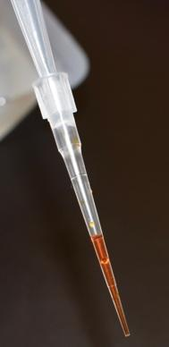
3. BE EXTREMELY CAREFUL to not over-pipette your samples (overfill the wells). Pipette 10 μL of sample #1 to one of the wells; be sure to write down which well it is. Do the same with the remaining samples, keeping track of which sample is in which well. Make sure your tip is just inside the well, but not touching the bottom of the well, when you release the sample (5C); you do not want to tear the gel.
5C 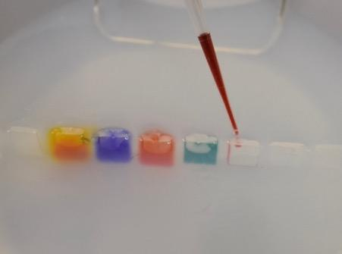
4. Gently squeeze the transfer pipette to release the sample; do not release the bulb until the tip is out of the gel.

Step 6: Run the gel
1. Once the five dye samples have been added to five different wells, carefully pour TBE to cover the gel. Do not pour directly over the wells, as the samples could be displaced out of the wells (6A).
6A 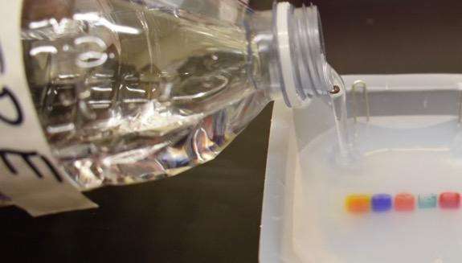
2. Attach three 9-volt batteries to each other by connecting the negative (cathode) terminal of one battery to the positive (anode) terminal of another, and then the positive terminal of the first battery to the negative terminal of a third battery. This will create a 27-volt power source (6B). Attach one of the colored wires with alligator clips to the exposed negative terminal, and the other colored wire to the exposed positive terminal. Write down which wire is attached to which terminal. The charge of each terminal is written on the side of the battery.
6B 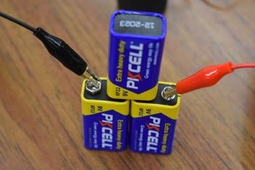
3. Attach one of the colored wires with an alligator clip to one of the binder clip/paper clip electrodes. Attach the other colored wire to the other binder clip/paper clip electrode (6C).
6C 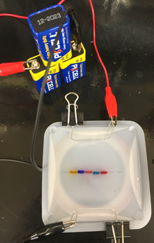
4.Draw a schematic of your setup (6D), and be sure to designate which electrode is positively charged and which is negatively charged (you will find this on the side of the battery). The voltage from the battery will create the electric field and allow the charged molecules to move. Because each battery is only 9 volts, the total voltage is 27 volts; this will not move as quickly as it would in a lab where a 100- to 120-volt charge is used.

6D 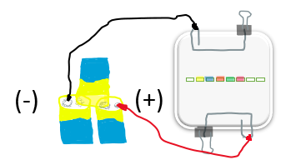

Step 7: Observations
Make observations every 5-10 minutes while the gel is running.
1. Record the time of your observation, and describe what you observe happening at the electrodes and with the various dyes.
2. The dyes are molecules of different size and charges. Once the dye molecules are moving out of the wells and through the gel, you will be able to determine what their charges and relative sizes are.
3. After running the gel for 20-30 minutes, fill out the data table below
A. Identify which dyes have a positive (+) and which have a negative (-) charge.
B. Rank the relative size of the positively charged molecules, with #1 being the smallest dye molecule, #2 the next largest, and so on. Do the same with the negatively charge molecules, with #1 being the smallest of these molecules, #2 the next largest, and so on.

Dye | + or - charge | Rank/size
#1 Yellow
#2 Blue
#3 Light Red
#4 Green
#5 Dark Red

4. Explain your thinking for how you assigned those size rankings for each of the dyes.
5. Describe two concepts that you found most interesting about constructing and using your own gel electrophoresis apparatus.
6. This technology is used in many research labs. Generally, researchers are not running different charged dye samples. Conduct a search on the Internet and describe three uses for this technology.
7. Save all of your electrophoresis box materials and use them in another activity.

