Engineering an Electrophoresis Gel Box - Experimental Procedure Instructions

Day 1
Making the Comb
- Use a plastic top of a container to make the comb first. Make sure the width of the comb is appropriately sized relative to the gel box.
- Cut the teeth of the comb to be 5 mm in width, with a 2 mm separation between each tooth. The number of teeth can vary, depending on the width of the gel box (weigh boat). Make sure to have at least four teeth for four wells, one for each color of food dye.
- Make sure the comb sits atop or can be attached to the weigh boat with paper clips and the teeth jut down to within 5 mm of the bottom of the gel box (weigh boat).

Making the Agar Gel
- Add 0.1 g of baking soda to 50 mL of distilled water in a flask. Swirl it by hand.
- Add 0.5 g of agar to the flask with the water and baking soda. Swirl by hand.
- Microwave the solution until it is clear. Be careful not to let the solution boil. Microwaves vary, so pay close attention while microwaving. (Suggestion: Microwave at 20-second intervals until the solution is clear.)
- Pour the gel from the flask into the weigh boat.
- Insert the comb into the gel, resting the sides of the comb on the sides of the weigh boat, approximately 25% from one end of the weight boat. Leave room to cut out ends of gel for wiring for electrical current.
- Let the agar solution cool for at least 15 minutes. Note: It may take up to two hours to cool.
- Thoroughly rinse and dry out the flask that held the gel.

Preparing the Buffer
- Add 0.1 grams of baking soda to 50 mL of distilled water in a flask.
- Pour up to 25 mL of buffer to cover the gel with a thin layer of buffer to protect the buffer overnight.
- Place the gel, covered with buffer, into a bag, or cover it with aluminum foil or plastic wrap. Then store it at room temperature or refrigerate it.
- Thoroughly clean up the workstation.

Day 2
Preparing the Gel for Testing
- Take the gel molds out of the plastic bags, or uncover them.
- Pull the comb out of the gel creating the wells. Make sure to pull the comb straight up gently.
- Use the spatula to cut the ends of the gel and to remove excess gel to make space for the electrodes.
- Cut the 1 mm stainless steel wire to make the cathode (negative) for the gel box.
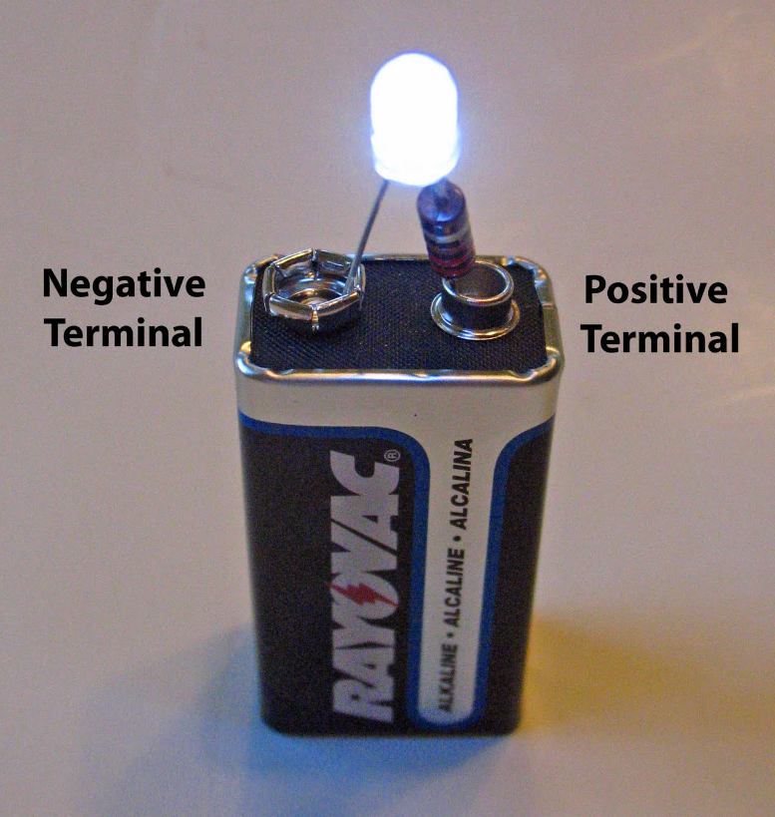
- Cut the 1 mm stainless steel wire to make the anode (positive) for the gel box.
- Fill the gel box and cover the gel entirely with buffer. This should be about an additional 25 mL of buffer.
- Shape and place the 1 mm stainless steel wires into the buffer solution at the ends of the gel box where the excess gel was removed with the spatula, contouring the wire to fit the gel box configuration AND having some wire hanging over to connect to the alligator clips.
- Daisy chain 3-5 batteries together to create the power source. Do this by connecting the cathode of one 9-volt battery to the anode of another 9-volt battery and make a triangle shape.
- Connect the anode (positive) end of the battery to the anode end of the stainless steel wire (end furthest from the wells) with one alligator clip.
- Connect the alligator clip to the cathode end of the stainless steel wire (end closest to the wells).
- DO NOT connect the alligator clip to the batteries yet.

Preparing the Food Coloring Samples
- Fill a beaker with water.
- Use a 1 mL eyedropper/micropipette and place 3 mL of water into four reservoirs of the plastic well spot plate.
- Add 0.5 mL of corn syrup to each well that has water in it. Note: It will be challenging to add the corn syrup because of its viscosity. Once added to the water, mix it into the water. It will take time to go into solution.
- Add two drops of one color of food dye to each well, for a total of four wells with four different colors.

Loading the Samples
- Use a different eyedropper/micropipette to load the samples into the wells.
- Fill wells to the top with a few drops of the samples, being careful not to overload the wells.
- Make a diagram of which sample colors were loaded into which well.

Run the Electrophoresis Gel
- Connect the alligator clip at the cathode (negative) end of the stainless steel wire to the cathode end of the batteries. This will complete the sample and provide electricity to the gel.
- Let the gels run for at least one hour.
- Observe the gel during this time.
- Record results on worksheet below.
- Disconnect the alligator clip from the batteries at the cathode end of the gel box after one hour.
- Let gels sit overnight.
- Make observations on the third day.
- Answer the reflection questions.
- Turn in worksheet with recorded results, as well as answers to the reflection questions, to your teacher.

Gel Template

Gel Results

Reflection Questions
- Explain what causes the food coloring (DNA) to move down the gel. Be specific about the charge of the colors and electrical charge of the batteries.

- Explain why some colors (DNA) move farther down the gel than others. Think at the molecular level.

- Explain how a gel electrophoresis can be used to solve a crime.

