Distance and Displacement Worksheet

Section 1: (Pre-Activity, pairs, 20 mins)
In the figures below, measure the distance and displacement from xi (facing the direction of the arrow) to xf in cm.
Who is completing each row? | Path | Answers (Write below)
Partner A | xi  xf | Distance:  Displacement:
Partner B | xi  xf | Distance:  Displacement:
Partner A | xi  xf | Distance:  Displacement:
Partner B | xi  xf | Distance:  Displacement:

Section 2: Distance and Displacement Map ‒ Explore! (Individual, 25 mins):
On the map below, trace the path (rough sketch) it would take for you to walk from your home to East Boston High School.
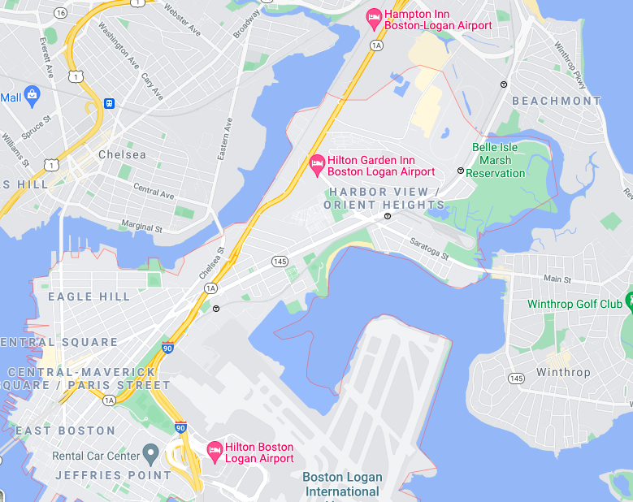

3. Walking Route | 4. Bus Route
Distance:  Displacement: | Distance:  Displacement:
5. What do you notice about the distance traveled while walking versus taking the bus? Why do you think these numbers are different?

6. What do you notice about the displacement? Why do you think this is?

Section 3: Design Challenge (Pairs or groups of 4, 35 mins)
You just ordered some pizza to be delivered to your home. Coincidentally, your partner ordered some too! The pizza shop guarantees that for every minute your pizza is late, you will receive a dollar. You and your partner have a bet that your pizzas will arrive at your homes in the shortest amount of time.
Goal: Create a maze so complex that your partner takes a long time to figure out how to get home.
Task: Design a path for your partner’s delivery to follow that ensures the longest time possible. Remember, the goal is for your route to take the shortest time on the map that your partner designed for you.
To Win: The person whose route takes the shortest time to finish their partner’s maze wins.
Constraints:
- Your maze must have a successful route that starts at the pizza shop and ends at the house.
- Your route must fit in the map below.
- Your maze must have at least five possible routes that lead to dead ends.
You have 12 minutes to design your route.
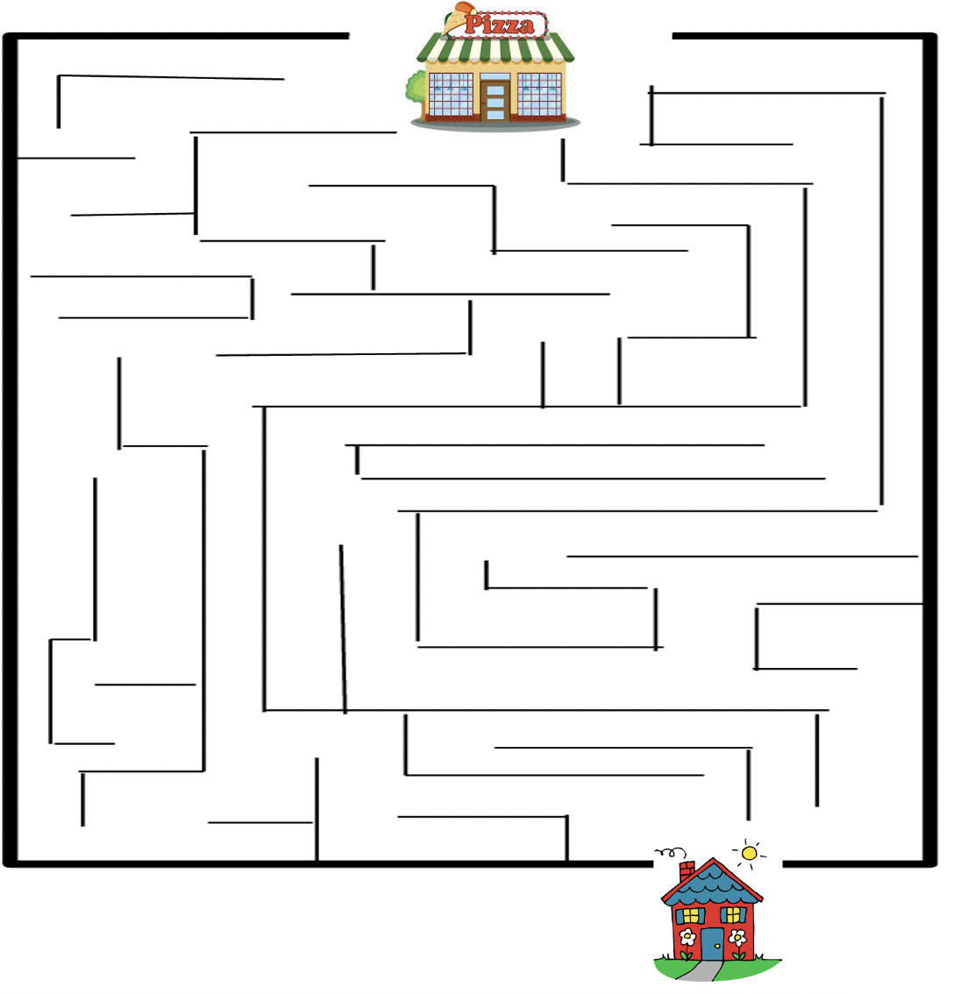

Give your map to your partner for them to trace a path. Time how long it takes to draw the path. You should do the same with your partner’s map.

Fill out the table below for your delivery (traveling on your partner’s map). You have 10 minutes to complete the section below.

Distance (cm): | Displacement (cm): | Time (s):

- Whose route drawn traveled the shortest distance? _____________________
- Whose route drawn had the shortest displacement? _____________________
- Whose route drawn involved travel for the shortest time? __________________
- Whose route won? ________________

Reflection Questions (10 min)
- What did you like about today’s activity?

- What is one suggestion or question you have for today’s class?

- What is one thing you learned?

Exit Ticket (5 min)
- You are hanging out at your friend’s house after school when your mom calls you and asks you how far you are from your house to pick you up. Do you tell her your distance or displacement? Explain why.

